ALBEMARLE-PAMLICO
NATIONAL ESTUARY PARTNERSHIP

Annual Work Plan
under the
Cooperative Agreement Between
The United States Environmental Protection Agency
and
North Carolina Department of Environment and Natural Resources
in
Cooperation with the
Commonwealth of Virginia
for
October 1, 2015 - September 30, 2016

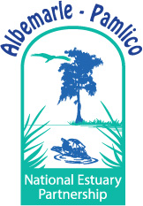

Approved By
APNEP Policy Board on
March 27, 2015
DENR Green Square
Raleigh, NC

U.S. EPA Agreements CE 00D20614 & CE 95451210
March 27, 2015

TABLE OF CONTENTS

CONTENTS & CONTACTS 2

INTRODUCTION 4

AUTHORITY 6

FY 2015 PROJECTS & ACTIVITIES 8

FY 2016 PROPOSED PROJECTS & ACTIONS 28

ADMINISTRATION AND FINANCIAL 35

ESTIMATED FEDERAL COST SHARE (Budget) 42

TRAVEL 45

APPENDIX A: 2013 Program Review 48

APPENDIX B: Giattina / NCDENR- 2014 Memo 57

APPENDIX C: 2012-22 CCMP Goals and Outcomes 58

CONTENTS & CONTACTS

Required Cooperative Agreement Related Contents in this Document:
- A progress report detailing accomplishments in FY 2015 is provided on pages 8 through 27.
- The FY 2015-16 Proposed Work Plan items are presented on pages 28 through 33.
- The FY 2015-16 Proposed Work Plan budget is presented on page 42.
- Administrative and financial information items are presented on pages 35 through 47.

Purpose: The purpose of this cooperative agreement is to provide support to the North Carolina Department of Environment and Natural Resources (NCDENR) from the US Environmental Protection Agency (EPA) for continuing implementation of the unique management strategies and actions recommended in the Albemarle-Pamlico National Estuary Partnership’s (APNEP) 2012-2022 Comprehensive Conservation and Management Plan (CCMP) and support for the APNEP mission to identify, restore and protect the significant resources of the region.

Funding: This work plan and the associated grant application represent a funding request of $600,000 for year 2 (10/1/15-9/30/16) under a cooperative agreement CE-0D20614 for the time period of October 1, 2014 to September 30, 2019.

The existing Cooperative Agreement CE-95451210 will expire on September 30, 2016 and all remaining funds will be directed towards CCMP implementation projects. All required match under this agreement was met by September 30, 2014.

Period of Performance:
The period of performance under the current Cooperative Agreement CE- CE-0D20614 is from October 1, 2014 through September 30, 2019.
The period of performance under the current Cooperative Agreement CE-95451210 is from October 1, 2009 through September 30, 2016.

Principal Contacts:

EPA Project Officer APNEP Director Policy Board Chair
Rhonda Evans William L. Crowell, Jr. Tom Allen
US EPA Region IV Albemarle-Pamlico NEP A-238 Brewster Bldg.
61 Forsyth Street 1601 Mail Service Center East Carolina University
Atlanta, GA 30303 Raleigh, NC 27699-1601 Greenville, NC 27858
(404) 562-9369 (919) 707-8633 (252) 328-6624

INTRODUCTION
The Albemarle and Pamlico Sounds comprise the nation’s largest lagoonal estuarine system. The system is composed of eight sounds and five major river basins draining over 30,000 square miles of watershed in North Carolina and Virginia. The sounds, rivers, creeks, wetlands and terrestrial areas provide habitat for an abundance of animal and plant species. People depend on the system for residential and resort development, food, recreation, mining, forestry, agriculture, business, and industry.

The Albemarle-Pamlico National Estuary Partnership (APNEP) is a part of the U.S. Environmental Protection Agency’s (EPA) National Estuary Program (NEP). It was one of the first programs established under amendments to the Clean Water Act in 1987. APNEP’s initial Comprehensive Conservation and Management Plan (CCMP) was ratified by the Governor of North Carolina and approved by the EPA in November 1994. The APNEP Policy Board approved a revised CCMP in March 2012. The CCMP advances an ecosystem-based management (EBM) paradigm and is intended as a practical, cost-effective and equitable approach to managing the valuable resources of the Albemarle-Pamlico region.

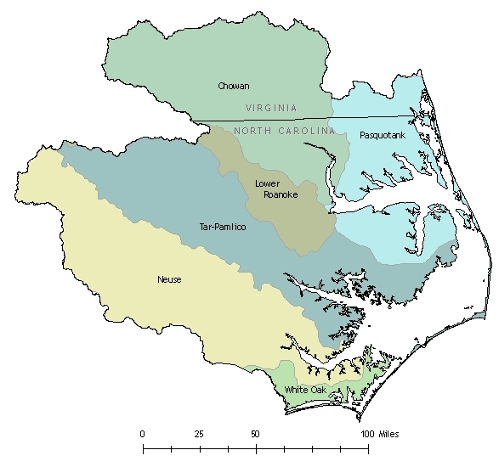

Ecosystem-Based Management Approach

Ecosystem-based management (EBM) is based on the tenet that managing natural resources from a systems perspective increases the likelihood of success by forging more effective connections among humans, nature, science, and management actions. Before 2012, APNEP worked with limited resources to integrate and implement EBM concepts and tools within the program and with its local, state, and federal partners, albeit in a piecemeal fashion. Given the relative complexity and increased resources required up front to implement EBM in full, APNEP staff began actively working toward a paradigm change in 2008 with the APNEP Policy Board, advisory committees, and partners.

This activity culminated in March 2012 with the adoption of a new CCMP based on EBM principles to replace the original 1994 CCMP. As implementation of this FY 2015 Work Plan begins, APNEP anticipates completing the development of its ecosystem indicators and monitoring strategy to support the new EBM-based CCMP. With a new CCMP established for a ten-year planning horizon, this work plan includes a proposal to support activities of the CCMP Implementation Workgroups for actions that support the desired ecosystem and management outcomes.

Ecosystem-Based Management (EBM) is a management approach¹ that:

- Is concerned with the ecological integrity that sustains both human and natural resources systems.

- Integrates ecological, social, and economic goals and recognizes humans as key components of the ecosystem.

- Considers ecological, not just political, boundaries.

- Addresses systems and the complexity of natural processes and uses adaptive management to reduce risks related to decisions and actions.

- Engages multiple stakeholders in a collaborative process to define problems and find solutions providing mutual benefit.

http://www.ebmtools.org/about_ebm.html

AUTHORITY

Federal Water Pollution Control Act
The National Estuary Program (NEP) was established by Congress in 1987 to improve the quality of Estuaries of National Significance. The Federal Water Pollution Control Act (33 U.S.C. 1251 et seq.), Section 320 directs EPA to develop plans for attaining or maintaining water quality in an estuary. This includes: protection of public water supplies; the protection and propagation of a balanced, indigenous population of shellfish, fish, and wildlife; allowance of recreational activities in and on water; and control of point and nonpoint sources of pollution to supplement existing controls of pollution. Each program establishes a Comprehensive Conservation and Management Plan (CCMP) to meet the goals of Section 320.

Comprehensive Conservation and Management Plan
In 1987, Congress designated the Albemarle-Pamlico Estuarine System as an Estuary of National Significance and thus began a comprehensive study effort, entitled the Albemarle-Pamlico Estuarine Study (APES). The result of this process was the APNEP CCMP. The initial CCMP was developed over a seven-year period by representatives from private and public sectors, including government, industry, business, environmental interest groups, and municipal officials. The plan is a guide for environmental stewardship of the Albemarle-Pamlico estuarine system. The CCMP reflects the input of people from the region that will be affected by the plan's recommendations. The CCMP seeks to balance the need for economic growth in region with the need to secure the environmental future of the region. Approved on March 14, 2012, the new CCMP replaces the original 1994 document.

North Carolina Governor’s Executive Order #133
On November 5, 2012, North Carolina Governor Beverly Eaves Perdue issued Executive Order # 133: Albemarle-Pamlico National Estuary Partnership. This Executive Order was developed after more than two years of program review and ecosystem assessment and the development of a new CCMP. This Executive Order replaced Executive Order #122 (2007) and provided the operational advisory framework for the partnership office and support for the EBM approach. A copy of the current Executive Order is available from the APNEP office at 1601 MSC, Raleigh, NC 27699 and at www.apnep.org

APNEP Office
The APNEP Office coordinates and facilitates the implementation and advancement of the CCMP, the APNEP mission, and the activities of the Policy Board and Advisory Committees. The APNEP Office serves as a conduit for information between the Policy Board, Advisory Committees, state and federal agencies, local governments, tribes, academia, and the public. The main office is located in the Office of Land and Water Stewardship within the Offices of the Secretary of the NC Department of Environment and Natural Resources in Raleigh, North Carolina, with additional program personnel in Washington and Greenville, North Carolina and Virginia Beach, Virginia.

Policy Board
This Policy Board is the main advisory body for APNEP. It was established by Executive Order (#133) to advise, guide, evaluate and support the CCMP implementation process and advance the CCMP and its management actions, and to ensure the highest level of collaboration, coordination and cooperation among state and federal agencies, local governments, the public and various interest groups. The Policy Board consults with the advisory committees and the APNEP Office for recommendations pertaining to implementation of CCMP actions at the regional and local levels and the coordination and development of research and monitoring priorities. A major duty of the Policy Board is to evaluate the relevance of the CCMP and to make recommendations to address emerging issues that may affect the significant natural resources of the Albemarle-Pamlico estuarine system. The Policy Board, in cooperation with the APNEP Office, develops an annual report, budget and work plan.

Science and Technical Advisory Committee
A Science and Technical Advisory Committee (STAC) was established to provide independent advice to the Policy Board and the Implementation Committee on scientific and technical issues, including ecosystem assessment and monitoring in support of CCMP implementation. The revised STAC held its first meeting during November 2012 in Manteo, North Carolina.

Implementation Committee
An Implementation Committee is currently being established to work with the Policy Board on CCMP implementation. The Implementation Committee will be comprised of representatives from the implementation workgroups, each of which will advance a discrete set of related CCMP actions. Members of the Implementation Committee will serve as liaisons to agencies, organizations, and other workgroups regarding CCMP implementation. Information on each of the implementation workgroups may be found on the APNEP website (www.apnep.org ).

FY 2015 PROJECTS & ACTIVITIES
The following provides an update on activities and projects that APNEP has been involved in since the last annual work plan report (May 10, 2014). All projects that involved contracts or grants are summarized in the table on pages 38 - 40.

APNEP Administration & Indirect Costs (ongoing)
For more detail see Administration and Financial section.

CCMP Component: All

CCMP Actions: All

CCMP Outcome: All

Intended Programmatic Output: Program administration, partnership building, CCMP implementation

Intended Programmatic Outcome: CCMP implementation

Status: Ongoing
Estimated Cost: $272,805 direct and $27,558 indirect cost @23.7%

Advisory Board and Committees Support
The key element of CCMP implementation is active citizen participation through its Management Conference (the Policy Board and each of the two Advisory Committees). Funds were used to support meetings, speakers, and materials as needed.
CCMP Component: All
CCMP Actions: All

CCMP Outcome: All

Programmatic Output: Partnership building, outreach, prioritizing CCMP implementation

Programmatic Outcome: Renewed public involvement

Status: Ongoing, Implementation workgroups and committee being formed
Estimated Cost: $ 2,000
Estimated Leverage: To be determined

Implementation Workgroup: Contaminants
The Contaminant Management Workgroup is studying and will recommend appropriate nutrient standards for North Carolina’s estuaries. This work will advance according to North Carolina’s Nutrient Criteria Development Plan using the Albemarle Sound as a pilot study area. Risk assessments for metals and emerging contaminants are in their formative stages.
CCMP Components: Identify, Protect, Restore, Monitor

CCMP Actions: A2.4, A2.5, C1.1, C1.2

CCMP Outcomes: 1a, 1b, 3b, 3c, 1d

Intended Programmatic Output: Reports and recommendations

Intended Programmatic Outcome: Risk assessments, increased monitoring
Status: Ongoing
Estimated Cost: Staff time
Estimated Leverage: To be determined

Implementation Workgroup: Oysters
The Oyster Workgroup is externally facilitated by the N.C. Coastal Federation, which has been actively involved with APNEP and others in oyster restoration efforts since the late 1990’s. Members participating with this workgroup are pursuing initiatives aligned with both the 2015 North Carolina Oyster Blueprint and APNEP’s Comprehensive Conservation and Management Plan (CCMP). APNEP was one of the co-sponsors of the N.C. Oyster Summit and is providing staff support for the development of a website, databases, and environmental indicators to support oyster restoration in the Albemarle-Pamlico region.
CCMP Components: Restore, Monitor

CCMP Actions: C5.1, C5.2, C5.3

CCMP Outcomes: 2b

Intended Programmatic Output: Reports, recommendations, and restoration activities

Intended Programmatic Outcome: Risk assessments, increased monitoring
Status: Ongoing
Estimated Cost: Staff time
Estimated Leverage: To be determined

Implementation Workgroup: Flows
APNEP’s Flows Workgroup will address ecological flows issues in APNEP’s coastal region in support of a prior effort led by the N.C. Department of Environment and Natural Resources. This work entails identifying appropriate ecological flow requirements for the sounds and coastal rivers of the APNEP region and working with regulatory partners to ensure in-stream flows are maintained.
CCMP Components: Identify, Protect, Engage

CCMP Actions: A3.3, D3.2

CCMP Outcomes: 2a, 2b, 3a, 2b

Intended Programmatic Output: Reports and recommendations

Intended Programmatic Outcome: Risk assessments, increased monitoring
Status: Pending
Estimated Cost: Staff time
Estimated Leverage: To be determined

Implementation Workgroup: Education and Engagement
APNEP facilitates an Education and Engagement Workgroup to support its partners in their estuarine and watershed-themed education and outreach programming. The workgroup provides an avenue for exploring education partnerships among APNEP partners and as a forum to share best practices.
CCMP Components: Engage

CCMP Actions: D1.1, D2.2, D2.3

CCMP Outcomes: 1a, 1b, 1d, 1e, 2a,1c, 2b, 2c, 3b

Intended Programmatic Output: Reports and recommendations

Intended Programmatic Outcome: Risk assessments, increased monitoring
Status: Ongoing
Estimated Cost: Staff time
Estimated Leverage: To be determined

Implementation Workgroup: Submerged Aquatic Vegetation
Since preliminary discussions among its agency partners began in 2001, APNEP has supported a collaboration among partners that aims to promote the conservation of SAV along the entire coast of North Carolina and southeastern Virginia. This partnership has been meeting regularly since 2004 and was formalized through a Memorandum of Agreement in late 2006.
CCMP Components: Protect, Restore, Monitor

CCMP Actions: B2.2, C3.3

CCMP Outcomes: 2a, 2b, 3d

Intended Programmatic Output: To be determined

Intended Programmatic Outcome: To be determined
Status: Ongoing
Estimated Cost: Staff Time
Estimated Leverage: To be determined

Watershed Field Coordinator - Virginia (Ongoing)

The APNEP Watershed Field Coordinator for Virginia provides coordination and support to APNEP, NC DENR and the Virginia Department of Environmental Quality enhances CCMP implementation in the Roanoke, Chowan and Pasquotank river basins. APNEP supports one-half of this position for at least 20 hours per week. 2014 was the final year of direct funding support from APNEP. Virginia Department of Environmental Quality will continue to partner with APNEP without funding. Dr. Dana Gonzalez.

CCMP Component: All

CCMP Actions: All

CCMP Outcome: All

Programmatic Output: Program administration, reports, leverage, presentations

Programmatic Outcome: CCMP implementation and program support

Status: In progress ( no longer funded by APNEP)
Estimated Cost: $ 20,000
Estimated Leverage: $ 24,000

2014 Teacher Institute
APNEP partnered with the UNC Institute for the Environment and other partners to offer a four-day teacher training institute in July 2014 at the N.C. Botanical Garden. Approximately 25 school teachers were provided with curriculum training in earth and environmental sciences with hands-on activities, local site visits, and specific content to support inquiry, experiential, and research-based instruction on estuarine and water resources.

CCMP Components: Engage

CCMP Actions: D 2.1, 2.2, 2.3

CCMP Outcomes: 1a, 1b, 1c, 1d, 1e, 2a, 2b, 2c, 3b
Intended Programmatic Output: 25 teachers trained in environmental education, water quality, and watersheds

Intended Programmatic Outcome: Increased environmental education activities in North Carolina schools
Status: Ongoing APNEP program (2014 session complete)
Estimated Cost: $ 10,403
Estimated Leverage: $ 11,000

2015 Teacher Institute
APNEP is partnering with the UNC Institute for the Environment and other partners to offer a four-day teacher training institute in July 2015 at the Trinity Center in Salter Path, NC. Approximately 25 school teachers will be provided with curriculum training in earth and environmental sciences with hands-on activities, local site visits, and specific content to support inquiry, experiential, and research-based instruction on estuarine and water resources.

CCMP Components: Engage

CCMP Actions: D 2.1, 2.2, 2.3

CCMP Outcomes: 1a, 1b, 1c, 1d, 1e, 2a, 2b, 2c, 3b
Intended Programmatic Output: 25 teachers trained in environmental education, water quality, and watersheds

Intended Programmatic Outcome: Increased environmental education activities in North Carolina schools
Status: Ongoing APNEP program (2013 session complete)
Estimated Cost: $ 10,403
Estimated Leverage: $ 11,000

Integrating Digital Learning & Experiential Learning: The Science of the NC Coast
APNEP is working with the NC Center for the Advancement in Teaching (NCCAT), NC Coastal Federation and others to support a professional development seminar at the NCCAT facility on Ocracoke Island. This five day, four night session will be open to all K-12 public school teachers across the state of NC.

CCMP Components: Engage

CCMP Actions: D 2.1, 2.2, 2.3

CCMP Outcomes: 1a, 1b, 1c, 1d, 1e, 2a, 2b, 2c, 3b

Programmatic Output: Workshop,

Intended Programmatic Outcome: Trained teachers
Status: In Progress
Estimated Cost: $4,000
Estimated Leverage $5,000

Shad in the Classroom 2014
This collaborative project continues to provide students with an understanding of the science process, an inspiration for careers in science, and a desire to protect our waterways through hands-on experience raising American shad from egg to releasable fry. This is a collaboration led by the North Carolina Museum of Natural Sciences. The project also involves a tour of underserved communities and schools along the Roanoke River, dubbed Roanoke River Days, which includes hands-on educational activities and the showing of the original movie “We are the River” in a geodome.
CCMP Components: Engage, Restore

CCMP Actions: D 2.1, 2.2, 2.3

CCMP Outcomes: 1a, 1b, 1c, 1d, 1e, 2a, 2b, 2c, 3b

Intended Programmatic Output: Increased community involvement in water quality and habitat protection

Intended Programmatic Outcome: Educational program, restoration activities
Status: Ongoing project (2014 session complete)
Estimated Cost: $ 39,004
Estimated Leverage: $ 12,000

Shad in the Classroom 2015
Continuation of the collaborative project continues to provide students with an understanding of the science process, an inspiration for careers in science, and a desire to protect our waterways through hands-on experience raising American shad from egg to releasable fry. This is a collaboration led by the North Carolina Museum of Natural Sciences.
CCMP Components: Engage, Restore

CCMP Actions: D 2.1, 2.2, 2.3

CCMP Outcomes: 1a, 1b, 1c, 1d, 1e, 2a, 2b, 2c, 3b

Intended Programmatic Output: Increased community involvement in water quality and habitat protection

Intended Programmatic Outcome: Educational program, restoration activities
Status: Ongoing project
Estimated Cost: $ 39,004
Estimated Leverage: $ 12,000

NC Division of Water Resources Project WET Facilitator Workshop
APNEP supported the Project WET Facilitator Training Workshop that provides educators with background information and quality environmental education activities focused on water quality, invasive species, and water resources. By hosting their own subsequent Project WET workshops, these trained facilitators then pass skills on to other educators who will teach students in their area. This increases the environmental literacy of not only those attending the training, but countless others in their community. More information on the North Carolina Division of Water Resource’s Project Wet program is available at http://www.ncwater.org/education_and_technical_assistance/Project_WET/
CCMP Components: Engage

CCMP Actions: D1.1, D2.2, D2.3

CCMP Outcomes: 1a, 1b, 1c, 1d, 1e, 2a, 2b, 2c, 3b

Intended Programmatic Output: Environmental education training

Intended Programmatic Outcome: Increase public awareness and involvement
Status: Complete
Estimated Cost: $ 2,000
Estimated Leverage: $ 5,568

Scientific Research and Education Network
SciREN, the Scientific Research and Education Network, connects educators with research scientists to provide students with relevant learning experiences. APNEP attended two SciREN events, held in Raleigh and Pine Knoll Shores. Combined, APNEP reached more than 500 teachers to demonstrate newly developed lesson plans, offer enrichment materials for their classrooms, and highlight APNEP’s other opportunities for teachers including a lesson plan database and other training opportunities.
CCMP Components: Engage

CCMP Actions: D2.2

CCMP Outcomes: 1c, 1e, 2a, 2b, 2c, 3b

Intended Programmatic Output: Report and recommendations

Intended Programmatic Outcome: Engaged educational community
Status: Pending
Estimated Cost: $500
Estimated Leverage: To be determined

Oyster Summit 2015
APNEP co-hosted the North Carolina Oyster Summit, attended by government, non-government, and university organizations that are working to restore oyster populations in North Carolina. The work focused on how oyster restoration and management activities have progressed in the last 20 years and can serve as a platform for future restoration and management activities. APNEP staff members also presented at the summit and facilitated a discussion of online and data resources need to support oyster restoration efforts.
CCMP Components: Identify, Protect, Restore, Engage

CCMP Actions: A1.1, A1.2, C5.1, C5.2, C5.3, E1.1

CCMP Outcomes: 1a, 1b, 1c, 1d, 1e, 2a, 2b, 2c, 3a, 3b, 3c, 3d

Intended Programmatic Output: Knowledge transfer, restoration and management activities

Intended Programmatic Outcome: Improved effectiveness of oyster restoration and management activities
Status: In progress
Estimated Cost: $ 4000
Estimated Leverage: $ 4000

NC Division of Marine Fisheries Recreational Water Quality Monitoring
APNEP is providing bridge funding to the N.C. Division of Marine Fisheries’ Recreational Water Quality Monitoring Program for the continuation of water quality monitoring near recreational areas. The program tests bacterial concentrations in coastal recreational waters to protect public health. The program is responsible for notifying the public when bacteriological standards for safe bodily contact have been exceeded. The program also has an educational component that accompanies the testing. Their educational campaign informs the public how bacteria enter coastal waters and actions that can help prevent it.

CCMP Components: Monitor, Engage

CCMP Actions: D2.3, E1.1, E2.1, E2.2

CCMP Outcomes: 1a, 1b, 1c, 1d, 1e, 2a, 2b, 2c, 3a, 3b, 3c, 3d

Intended Programmatic Output: Monitoring data

Intended Programmatic Outcome: CCMP Implementation, integrated monitoring strategy
Status: In progress
Estimated Cost: $ 20,000
Estimated Leverage: $ 283,000

Survey of Submerged Aquatic Vegetation in Albemarle Sound
APNEP is supporting a boat-based SAV survey in Albemarle and Roanoke Sounds. The purpose of the survey is threefold: (1) to delineate the extent of SAV along shore-parallel transects (2) to use the data collected select 20 sentinel sites in the Sound and establish a polygon size appropriate for long-term observation; and (3) to compare two types of SONAR data collected along some representative transects. Boat-based methods supplement remote-sensing efforts for detecting SAV, where turbidity and other environmental factors can limit detection.

CCMP Components: Identify, Monitor

CCMP Actions: A1.1

CCMP Outcomes: 1a, 1b, 1c, 1d, 1e, 2a, 2b, 2c, 3a, 3b, 3c, 3d

Intended Programmatic Output: Public outreach and involvement

Intended Programmatic Outcome: CCMP Implementation, increased environmental awareness
Status: In Progress
Estimated Cost: $ 41,007
Estimated Leverage: $ Pending

Submerged Aquatic Vegetation Mapping & Monitoring
APNEP continued to lead and support the mapping and assessment of Submerged Aquatic Vegetation (SAV) in the AP region via remote sensing. As part of a second SAV mapping cycle (2012-2014), APNEP contracted with NCDOT Photogrammetry staff to (1) acquire aerial imagery in May 2013 along the barrier islands from Nags Head south to Cedar Island and from Cape Lookout west to White Oak River then (2) map SAV bed extent using these images.

CCMP Components: Identify, Monitor

CCMP Actions: A1.1,

CCMP Outcomes: 1a, 1b, 1c, 1d, 1e, 2a, 2b, 2c, 3a, 3b, 3c, 3d

Intended Programmatic Output: Map, report

Intended Programmatic Outcome: New information for decision-makers
Status: In Progress
Estimated Cost: $128,500
Estimated Leverage: $100,000

NC Catch Estuary Placemats
APNEP provided support for the printing of NC Catch restaurant placemats. NC Catch is a non-profit organization that is comprised of local Catch groups focused on connecting consumers and businesses with year-round access to high-quality seafood. The placemats will educate people on the importance and benefits of the estuary as well as supporting locally caught seafood. The placemats will be distributed to restaurants throughout the APNEP region. An image of the placemat is available on the APNEP website at http://portal.ncdenr.org/c/document_library/get_file?uuid=06a5c1a2-9603-4fb2-8de9-385d246c0344&groupId=61563.

CCMP Components: Engage

CCMP Actions: D1.1, D2.3

CCMP Outcomes: 1a, 1b, 1c, 1d, 1e, 2a, 2b, 2c, 3a, 3b, 3c, 3d

Intended Programmatic Output: Engagement materials on stewardship

Intended Programmatic Outcome: Increase in citizen action to protect the AP region, improved water quality.
Status: Complete
Estimated Cost: $ 2,000
Estimated Leverage: $ 2,000

Heritage Trail Map Printing

APNEP provided support for outreach materials educating people on a community heritage trail along the Outer Banks byway. A partnership between APNEP, NC Catch, the Outer Banks Scenic Byway, and the Core Sound Waterfowl Museum and Heritage Center, the focus of the project is to raise awareness of the traditional communities, deep-rooted heritage, and historical maritime activities along the scenic byway.

CCMP Components: Engage

CCMP Actions: D1.5, D2.1

CCMP Outcomes: 1e, 2a

Intended Programmatic Output: New opportunities for public to explore AP region

Intended Programmatic Outcome: Increased public awareness and engagement
Status: Complete
Estimated Cost: $ 2,000
Estimated Leverage: $4,900

Ecosystem Services Assessment of the Albemarle-Pamlico Region
APNEP will issue a Request for Proposals for a study estimating the value of services provided by the Albemarle-Pamlico ecosystem and associated costs incurred as a result of ecosystem degradation.
CCMP Components: Engage, Identify

CCMP Actions: D3.1

CCMP Outcomes: 1a, 1b, 1d, 1e, 2a, 2b, 2c, 3a, 3c, 3d

Intended Programmatic Output: Report and recommendations

Intended Programmatic Outcome: More efficient and effective CCMP implementation, improved communications
Status: New (RFP pending)
Estimated Cost: $80,000
Estimated Leverage: To be determined

NC Oyster Restoration Assessment
APNEP will issue a Request for Proposals for a cost-benefit analysis of North Carolina’s oyster restoration efforts. The study will examine the ecosystem service benefits of oysters as well as the costs incurred by the Division of Marine Fisheries and other agencies and organizations to enhance their populations. Recommendations for the programs within current budget will be sought to maximize the overall benefit to the citizens of North Carolina.
CCMP Components: Engage, Identify, Restore

CCMP Actions: D3.1, C5.3

CCMP Outcomes: 1a, 1b, 1c, 1d, 1e, 2a, 2b, 2c, 3a, 3b, 3c, 3d

Intended Programmatic Output: Report and recommendations

Intended Programmatic Outcome: More efficient and effective CCMP implementation, improved communications
Status: New (RFP pending)
Estimated Cost: $35,000
Estimated Leverage: To be determined (in-kind from NC DMF)

North Carolina River Basin Booklets and Posters
The purpose of the program is to illustrate the connections between people's everyday choices and the quality of natural resources as well as give citizens a sense of place within the natural environment. These materials, provided by the N.C. Office of Environmental Education and Public Affairs, are a popular teaching resource. They provide general ecological information about river basins in North Carolina, highlight specific river basins within the Albemarle-Pamlico watershed, and promote environmental education and ecotourism opportunities at environmental education centers throughout the region.
CCMP Components: Engage

CCMP Actions: D2.3, D1.1, D1.5

CCMP Outcomes: 1a, 1b, 1c, 1d, 1e, 2a

Intended Programmatic Output: River basin booklets

Intended Programmatic Outcome: Increased awareness
Status: Pending
Estimated Cost: $5,000
Estimated Leverage: $5,000 (in-kind from NC OEEPA)

APNEP/Sea Grant Fellowship
APNEP and the North Carolina Sea Grant (NCSG) College Program are jointly supporting the 2015 Graduate Fellowship in Estuarine Research. The fellowship provides funding for graduate students based in North Carolina and Virginia with an opportunity to conduct applied research within the North Carolina portion of the APNEP management boundary. Fellows must conduct research that addresses focus areas identified in NCSG’s Strategic Plan and management actions identified in APNEP’s Comprehensive Conservation and Management Plan.
CCMP Components: Identify

CCMP Actions: To be determined

CCMP Outcomes: To be determined

Intended Programmatic Output: Report, maps, data

Intended Programmatic Outcome: Increased capacity to address CCMP implantation actions
Status: Pending
Estimated Cost: $5,000
Estimated Leverage: $5,000

Remote Detection of Chlorophyll a levels in Albemarle Sound
The objective of this project is to provide a ten-year time series representation of harmful algal blooms (HABs) in the Albemarle-Pamlico National Estuary as a general illustration of their spatial and temporal extent. Organizations concerned with enhancing water quality throughout the Albemarle and Pamlico Sounds will be able to use this information along with in situ water sample data to better evaluate the relationships between the HABs and other environmental factors. The project is currently being conducted by NASA Langley’s DEVELOP program with USGS and APNEP staff as clients.
CCMP Components: Identify, Restore, Monitor

CCMP Actions: A1.1, C1.1, C1.2, E1.2

CCMP Outcomes: 1a, 1b, 1c, 1d, 1e, 2a, 2b, 2c, 3a, 3b, 3c, 3d

Intended Programmatic Output: Report and recommendations

Intended Programmatic Outcome: Greater understanding of HAB in system
Status: In Progress
Estimated Cost: $0
Estimated Leverage: To be determined

Wetlands Extent Indicator Development
This project, entitled “Evaluating how NASA Earth Observations Can be Applied to Rapidly Detect Change in Wetland Types at Regional Scales,” aims to evaluate how open-source imagery from Landsat 8 and other remote sensing platforms can be applied to routinely assess a wetlands indicator for the Albemarle-Pamlico watershed. The project is being conducted by NASA Langley’s DEVELOP program with APNEP staff and partners, including NOAA, as clients.
CCMP Components: Identify, Monitor

CCMP Actions: A1.1, A2.2, A3.1, E1.2, E2.1

CCMP Outcomes: 1a, 1b, 1c, 1d, 1e, 2a, 2b, 2c, 3a, 3b, 3c, 3d

Intended Programmatic Output: Report and recommendations

Intended Programmatic Outcome: Assessment of wetlands in program area
Status: Pending
Estimated Cost: $0
Estimated Leverage: To be determined

Neuse River Estuary Modeling and Monitoring Project (ModMon)
ModMon is a collaborative effort between the University of North Carolina and the North Carolina Department of Environmental and Natural Resources. It supports North Carolina’s needs for space and time-intensive monitoring and assessment of water quality and environmental conditions; including nutrient-eutrophication dynamics, algal blooms, hypoxia, fish kills and related issues. ModMon is the main source of data for calibration, verification and validation of water quality models being used to adaptively test and manage the Total Maximum Daily Load (TMDL) for the Neuse River Estuary (NRE). ModMon also serves State and federal agencies as a ground-truthing data source for aircraft and satellite-based remote sensing of chlorophyll, turbidity and harmful algal blooms.
CCMP Components: Identify, Monitor

CCMP Actions: A1.1, A2.2, A3.1, E1.2, E2.1

CCMP Outcomes: 1a, 1b, 1c, 1d, 1e, 2a, 2b, 2c, 3a, 3b, 3c, 3d

Intended Programmatic Output: Report and recommendations, monitoring support to NC DWR

Intended Programmatic Outcome: Greater understanding of environmental condition
Status: Pending
Estimated Cost: $35,000
Estimated Leverage: $105,000

Habitat Enhancement at Goose Creek State Park
APNEP purchased 300 bald cypress trees that were planted at Goose Creek State Park. Upland longleaf pine habitat is slowly transitioning to wetland habitat in this area. Bald cypress trees provide soil stabilization and water filtration in the area, benefiting water quality in the adjacent Pamlico River.
CCMP Components: Protect, Restore

CCMP Actions: B1.3, C1.3, C2.3

CCMP Outcomes: 2a, 2b, 3b, 3d

Intended Programmatic Output: Tree planting

Intended Programmatic Outcome: Habitat restoration, increased awareness
Status: Complete
Estimated Cost: $153
Estimated Leverage: (10hrs- volunteer rate)

Habitat Enhancement at Dismal Swamp State Park
APNEP purchased 3,000 Atlantic white cedar trees to be planted at Dismal Swamp State Park by volunteers. Among other benefits, white cedar ecosystems stabilize stream flows, temporarily store floodwaters, help protect against the effects of drought, and purify water. Their decomposing needles also cause the characteristically acidic and tea-colored water that comes from these swamps. Ultimately, this water makes its way into the Albemarle Sound. This project also compliments the restoration of peatland hydrology underway in the swamp, which is one of the largest forested peatland blocks in the country.
CCMP Components: Protect, Restore, Engage

CCMP Actions: B1.3, C1.3, C2.3, D1.1, D2.1

CCMP Outcomes: 1a, 1b, 1d, 1e, 2a, 2b, 3b, 3d

Intended Programmatic Output: Tree planting

Intended Programmatic Outcome: Habitat restoration, increased awareness

Status: Pending
Estimated Cost: $675
Estimated Leverage: (100hrs- volunteer rate)

Aquatic Invasive Species Monitoring and Outreach
APNEP has partnered with N.C. Sea Grant and the Chowan-Edenton Environmental Group (CEEG) to raise awareness of local aquatic invasive plants and engage the community in citizen monitoring efforts. APNEP partnered with NC Sea Grant and NCSU in the development of an educational video on this topic that has been shown to county leaders throughout the Chowan River basin. An app has been developed by Sea Grant to facilitate citizen monitoring and planning is underway with Sea Grant and the N.C. Division of Water Resources to expand the capacity of both governmental and citizen monitoring efforts for invasive aquatic plants throughout the Albemarle-Pamlico region.
CCMP Components: Protect, Engage, Monitor

CCMP Actions: D1.3, E1.3, D1.1, B2.6

CCMP Outcomes: 1a, 1b, 1c, 1d, 1e, 2a, 2b, 2c, 3a, 3b, 3c, 3d

Intended Programmatic Output: Report and recommendations

Intended Programmatic Outcome: Greater understanding of environmental condition
Status: Pending
Estimated Cost: $35,000
Estimated Leverage: To be determined

Hyde County Resilience Planning
APNEP has provided staff expertise and support for an effort led by N.C. Sea Grant, Georgia Sea Grant, and Stetson University in Hyde County, NC to develop a community resilience and adaptation plan. Hyde County has sought the team’s expertise on topics including coastal flooding and storm resilience. Facilitated community engagement through the Vulnerability, Consequences and Adaptation Planning Scenarios, or VCAPS, process has been completed and a spatially explicit cost-benefit analysis of various planning scenarios is underway. The analyses will provide the basis for policy recommendations for Hyde County’s communities in the form of tailored resilience and adaptation plans.
CCMP Components: Identify, Engage

CCMP Actions: A2.2, A2.3, D1.2, D3.1, D3.3

CCMP Outcomes: 1a, 1b, 1c, 1d, 1e, 2a, 2b, 2c, 3a, 3b, 3c, 3d

Intended Programmatic Output: Report and recommendations

Intended Programmatic Outcome: Higher community resilience
Status: Pending
Estimated Cost: $35,000
Estimated Leverage: To be determined

Atlantic Coastal Fish Habitat Partnership (ACFHP)
APNEP is member of ACFHP, a coast-wide partnership of fish habitat resource managers, scientists, and communications professionals from 32 different state, federal, tribal and non-governmental agencies who have established a commitment to work together for the benefit of aquatic resources. The mission of ACFHP is to accelerate the conservation, protection, restoration, and enhancement of habitat for native Atlantic coastal, estuarine-dependent, and diadromous fishes through partnerships between federal, tribal, state, local, and other entities.
CCMP Components: Restore

CCMP Actions: C4.1, C4.2, C4.3, C4.4

CCMP Outcomes: 2a, 2b

Intended Programmatic Output: Habitat restoration

Intended Programmatic Outcome: Improved partner coordination,
Status: Ongoing
Estimated Cost: $0
Estimated Leverage: To be determined

Atlantic Estuarine Research Society (AERS) Spring Conference
APNEP was a sponsor of the AERS Spring Conference in Wanchese, NC. AERS brings together students, scientists, managers, and educators from the states of DE, MD, NC, NJ, PA, and VA and Washington, DC to discuss estuarine and coastal environmental issues and policies.
CCMP Components: Identify, Engage

CCMP Actions: A2.3, D1.2

CCMP Outcomes: 1a, 1b, 1c, 1d, 1e, 2a, 2b, 2c, 3a, 3b, 3c, 3d

Intended Programmatic Output: Report and recommendations

Intended Programmatic Outcome: Increased awareness
Status: Pending
Estimated Cost: $250
Estimated Leverage: To be determined

Mattamuskeet Crab Research and Outreach
APNEP is planning to support further ecological research led by Duke University aimed at understanding blue crab migration patterns in and around Lake Mattamuskeet. This research informs decisions by managers at Mattamuskeet National Wildlife Refuge as they manage the flow of water in and around the lake. The research effort also engages students from the nearby Mattamuskeet School to capture, measure, sex, and weigh crabs. A teacher workshop will also be held, leveraging prior APNEP-supported efforts to develop blue crab lesson plans.
CCMP Components: Identify, Engage

CCMP Actions: D2.1, D2.2

CCMP Outcomes: 1c, 1e, 2a, 2b, 2c, 3b

Intended Programmatic Output: Report and recommendations

Intended Programmatic Outcome: Increased awareness and engagement
Status: Pending
Estimated Cost: $4,000
Estimated Leverage: $4,000

Chowan (VA) River Basin Booklets
Working with members of the Albemarle-Chowan Watershed Roundtable, APNEP played a key role in developing the Chowan River Basin booklet for Virginia. Building upon the success of North Carolina’s program, this resource is freely available to support watershed education throughout schools in the Virginia’s Chowan River Basin. The booklet is also packed with interesting facts and highlights the area’s natural attractions, serving as a resource for local citizens and businesses.
CCMP Components: Engage

CCMP Actions: D2.2

CCMP Outcomes: 1c, 1e, 2a, 2b, 2c, 3b

Intended Programmatic Output: Report and recommendations

Intended Programmatic Outcome: Increased awareness and engagement
Status: Pending
Estimated Cost: $35,000
Estimated Cost: $35,000

NC Coastal Habitat Protection Plan Implementation Support
The NC Coastal Habitat Protection Plan (CHPP), adopted by Coastal Resources, Environmental Management and Marine Fisheries Commissions, has seen routine development since its implementation began in 2004. While differences in scope, geography and mission exist, implementation of APNEP’s CCMP and the CHPP are complimentary. Jimmy Johnson, North Carolina’s Coastal Habitats Coordinator, serves a joint detail with APNEP and the NCDENR Office of Land and Water Stewardship. This role ensures that both plans are implemented in a coordinated and integrated fashion. APNEP provided scientific and technical support for the development of the CHPP’s Strategic Habitat Areas (SHAs), which are derived via expert opinion and a conservation prioritization process. The Strategic Habitat Areas are a component of the CHPP and are meant to designate high quality habitat areas for fisheries management.

CCMP Components: Identify, Protect, Restore

CCMP Outcomes: 1a, 1b, 1c, 1d, 2a, 2b, 2c, 3b, 3c, 3d

Intended Programmatic Output: CHPP annual report, SHA designations

Intended Programmatic Outcome: Coordinated regulation across NC state agencies to improve estuarine habitats
Status: In Progress
Cost: Staff Time
Estimated Leverage: To be determined

Citizens’ Monitoring Network
The APNEP Citizens’ Monitoring Network (CMN) is a network of private citizens who monitor surface water quality in the Albemarle-Pamlico estuary and its tributaries. For FY 2014, operation of the CMN (including Coordinator, equipment, supplies, office and lab space and indirect costs) continued under voluntary leadership at East Carolina University (ECU). The CMN maintained its current participating citizens’ monitoring efforts. APNEP expenditures covered the costs of chemical supplies, and ECU covered operational expenses.

CCMP Components: Engage, Monitor

CCMP Actions: D1.1, E1.3

CCMP Outcomes: : 1a, 1b, 1c, 1d, 1e, 2a, 2b, 2c, 3a, 3b, 3c, 3d

Intended Programmatic Output: Database of citizen-collected monitoring information

Intended Programmatic Outcome: Partnership building, outreach, CCMP implementation and prioritization
Status: In progress
Estimated Cost: $ 1,000
Estimated Leverage:: $ 10,000
Chowan Healthy Waters Initiative
APNEP is continuing to partner with Virginia Commonwealth University and VA Department of Conservation and Recreation, as well as other state agencies on both sides of the border to implement actions to protect high quality waters. Identification of these pristine waters is a necessary first step in the ultimate preservation of these valuable areas by land trusts and other organizations.

CCMP Components: Identify, Protect, Engage

CCMP Actions: A1.1, B1.3, D1.2

CCMP Outcomes: 1a, 1b, 1c, 1d, 1e, 2a, 2b, 2c, 3a, 3b, 3c, 3d

Intended Programmatic Output: New partnerships and activities in VA and NC focused on protecting high quality waters

Intended Programmatic Outcome: Maintain good water quality
Status: Ongoing
Estimated Cost: Staff Time
Estimated Leverage: To be determined

Integrated Monitoring Strategy (Delayed)
An integrated monitoring strategy is an essential component of APNEP’s ecosystem-based management approach. Upon completion, the monitoring strategy will provide resource managers and other partners with cost and information quality (uncertainty) alternatives to facilitate the selection of monitoring protocols to be included in the next monitoring deliverable: the integrated monitoring plan. This project was placed on hold pending completion of the first phase of indicator development, including target values.

CCMP Component(s): Monitor

CCMP Actions: E1.1, E1.2, E1.3, E2.1, E2.2

CCMP Outcomes: 1a, 1b, 1c, 1d, 1e, 2a, 2b, 2c, 3a, 3b, 3c, 3d

Intended Programmatic Output: Document, functional workgroups

Intended Programmatic Outcome: Integrated monitoring strategy to support ecosystem-based management through the CCMP
Status: Pending
Estimated Cost: Staff Time
Estimated Leverage: To be determined

CCMP/Monitoring Workshops
A series of workshops will be structured to develop priorities among scientists, managers, policy makers, and citizens on how ecological monitoring should be targeted to best support APNEP indicator tracking of CCMP ecosystem outcomes. This project was placed on hold pending completion of the first phase of indicator development, including target values.

CCMP Component: Monitor

CCMP Actions: E1.1, E1.2, E1.3, E2.1, E2.2

CCMP Outcome: 1a, 1b, 1c, 1d, 1e, 2a, 2b, 2c, 3a, 3b, 3c, 3d

Intended Programmatic Output: Indicators, Integrated Monitoring Strategy

Intended Programmatic Outcome: Detection of environmental changes in support of CCMP implementation

Status: Pending
Estimated Cost: $ 4,000
Estimated Leverage: Pending

Albemarle Sound Monitoring Project (USGS)
APNEP is partnering with the US Geological Survey’s North Carolina Water Science Center on a four-year pilot project in the Albemarle Sound as part of the National Monitoring Network for estuarine systems. The project began in FY 2012 and has multiple goals including: 1) Conduct an inventory of current monitoring projects, 2) Define critical management questions of interest for the Albemarle Sound, 3) Implement a pilot monitoring program in the Albemarle Sound that can help answer an identified management question of interest, and 4) Create a GIS portal to display monitoring data in the sound. APNEP anticipates that the insights gained in supporting this project will benefit the development of an integrated monitoring strategy for the entire APNEP study area. The final report is available at http://nc.water.usgs.gov/projects/asnmn/reports.html.

CCMP Component(s): Monitor

CCMP Actions: E1.1, E1.2, E2.1

CCMP Outcomes: 1a, 1b, 1c, 1d, 1e, 2a, 2b, 2c, 3a, 3b, 3c, 3d

Intended Programmatic Output: Summary report, data

Intended Programmatic Outcome: Integrative monitoring in AP region
Status: Complete
Estimated Cost: Staff Time
Estimated Leverage: To be determined

AmeriCorps 2014
APNEP supported an Education and Outreach Assistant through the AmeriCorps Mountains to the Sea Program administered by the NC Office of Environmental Education and Public Affairs. The Education and Outreach Assistant developed materials and organized activities that educate the public in the APNEP region about the significant natural resources within the region and APNEP activities that are underway to identify, protect, and restore them. The targeted audience for the assistant included underserved populations within the APNEP region. One highlight of the AmeriCorps project was the Pocosin Project, an environmental education effort to raise awareness about pocosins and their importance for biodiversity, ecosystem services, and water quality.

CCMP Components: Engage

CCMP Actions: D1.1, D1.2, D2.1, D2.2, D2.3

CCMP Outcomes: 1a, 1b, 1c, 1d, 1e, 2a, 2b, 2c, 3a, 3b, 3c, 3d

Intended Programmatic Output: Education and outreach materials, environmental education programs

Intended Programmatic Outcome: Increased public awareness and involvement
Status: Complete
Estimated Cost: $ 6,400
Estimated Leverage: To be determined

AmeriCorps 2015
APNEP will host and support an Education and Outreach Assistant in Raleigh through AmeriCorps Project GEOS administered by the Conservation Trust for North Carolina. Planned initiatives include enhancement of APNEP’s video outreach capabilities as well as education and outreach events for underserved populations. APNEP has also partnered with the Pamlico-Tar River Foundation and Partnership for the Sounds to support a second AmeriCorps member in Washington, NC. This member will be engaged in photography and videography on APNEP’s behalf while also supporting APNEP’s mission through PTRF and PfS education initiatives.

CCMP Components: Engage

CCMP Actions: D1.1, D1.2, D2.1, D2.2, D2.3

CCMP Outcomes: 1a, 1b, 1c, 1d, 1e, 2a, 2b, 2c, 3a, 3b, 3c, 3d

Intended Programmatic Output: Education and outreach materials, environmental education programs

Intended Programmatic Outcome: Increased public awareness and involvement
Status: In Progress
Estimated Cost: $ 12,000
Estimated Leverage: $6,000

Albemarle-Chowan Watershed Roundtable
Watershed roundtables consist of stakeholders who have a vested interest in their communities and are concerned about local water quality. The Albemarle-Chowan Watershed Roundtable engages stakeholders in the Virginia portions of the Chowan and Pasquotank river basins to collaborate on issues concerning water quality, habitat, and other natural resources within these watersheds. In FY 2014 the Roundtable supported a regional water quality celebration, continued support for the Chowan River basin booklet, and river shoreline restoration project in Southampton County, VA. The Roundtable’s area of geographic interest is the Virginia portion of APNEP’s management region.

CCMP Components: Engage , Restore

CCMP Actions: D1.2, C1.3

CCMP Outcomes: 1a, 1b, 1c, 1d, 2a, 2b, 2c, 3a, 3b, 3c, 3d

Intended Programmatic Output: To be determined

Intended Programmatic Outcome: To be determined
Status: In progress
Estimated Cost: Staff Time
Estimated Leverage: $10,000

Saltwater Connections
Saltwater Connections is a regional initiative aimed at sustaining livelihoods, cultural heritage, and natural resources along the coast, from Hatteras Island to Ocracoke and Carteret County. The Saltwater Connections Resource Team’s approach to growing sustainable communities is modeled after Handmade in America’s Small Town Revitalization Program, an asset-based economic development project in western North Carolina. The goal for this community vitalization process is to leverage assets, whether cultural, architectural or human, in order to build a complete community vitalization plan. More information is available at www.saltwaterconnections.org

CCMP Components: Engage

CCMP Actions: D1.5

CCMP Outcomes: 1e

Intended Programmatic Output: Trail maps, community engagement opportunities

Intended Programmatic Outcome: Increased awareness and engagement
Status: In progress
Estimated Cost: Staff Time
Estimated Leverage: To be determined
North Carolina Catch
North Carolina Catch supports the work of the four local seafood promotion initiatives that stretch from Currituck County to Brunswick County. Carteret Catch, Ocracoke Fresh, Brunswick Catch, and Outer Banks Catch have emerged as the buoys and markers that guide consumers to local fish and shellfish sources. The groups help educate consumers on the culinary and nutritional rewards of choosing local seafood, as well as the economic, cultural, and ecological benefits for local communities and for the state. North Carolina Catch is a nonprofit umbrella organization that ties the work of the local groups together to foster collaboration, to strengthen communication, and to enhance a statewide and national presence. Jimmy Johnson serves as President of the N.C. Catch Board of Directors. More information is available at http://www.nccatch.org/
CCMP Components: Engage

CCMP Actions: D2.3

CCMP Outcomes: 1a, 1b, 1d

Intended Programmatic Output: Marketing materials

Intended Programmatic Outcome: Informed seafood consumers who understand connections between local seafood and habitats.
Status: In progress
Estimated Cost: $400, Staff Time
Estimated Leverage: To be determined

North Carolina Watershed Restoration and Improvement Team
The NC Watershed Restoration and Improvement Team (WRIT) is a working group composed of experts from NCDENR, the NC Department of Agriculture and Consumer Services and the NC Wildlife Resources Commission. Its mission is to "strengthen partnerships in order to enhance each agency’s ability to carry out its own water-related goals and activities to improve watershed functions throughout North Carolina." The team provides a forum for managers to share insights and work collaboratively on watershed issues. The team has also focused restoration efforts in four sub-watersheds in North Carolina, including one in the Roanoke River basin.

CCMP Components: Engage

CCMP Actions: B1.3, B1.4, B1.5, C1.3, C2.1, D1.2

CCMP Outcomes: 2a, 2b, 3b, 3d

Intended Programmatic Output: Interagency cooperation

Intended Programmatic Outcome: More efficient leveraging of agency resources
Status: In progress
Estimated Cost: Staff Time
Estimated Leverage: To be determined

North Carolina Watershed Stewardship Network
The Watershed Stewardship Network (WSN) is a working group that includes representatives from state and local government, academic institutions, non-profit organizations, and private industry. The mission of the WSN is to empower more effective watershed stewardship because water is critical to economic, environmental, and community health. The purpose of the group is to identify, include, link, and serve watershed stakeholders in North Carolina. Additional information is available at http://www.ces.ncsu.edu/depts/agecon/WECO//NCWatershedStewardshipNetwork.htm

CCMP Components: Engage

CCMP Actions: D1.1, D1.2, D2.2, D2.3, D3.1

CCMP Outcomes: 1a, 1b, 1c, 1d, 1e, 2a, 2b, 2c, 3a, 3b, 3c, 3d

Intended Programmatic Output: Workshops, online tools, environmental programs

Intended Programmatic Outcome: Improved environmental stewardship and watershed health
Status: In progress
Estimated Cost: Staff Time
Estimated Leverage: To be determined

Barriers to Restoration Activities Study
This study examines various policy and regulatory obstacles to restoration efforts in North Carolina. Recommendations will be offered regarding potential legislative or policy tools that can enhance APNEP’s ability to work with partners on restoration efforts. This project is the subject of a client-based research project with the University North of Carolina at Chapel Hill. The final report is pending and will be posted at http://portal.ncdenr.org/web/apnep/reports

CCMP Components: Restore

CCMP Actions: C1.3, 2.1, 2.2, 2.3

CCMP Outcomes: 2a, 2b, 3a, 3b, 3d

Intended Programmatic Output: Report

Intended Programmatic Outcome: Proposed policy recommendations and policy amendments, improved restoration capacity and outcomes.
Status: Complete
Estimated Cost: Staff Time
Estimated Leverage: To be determined

Southeast Natural Resource Leadership Group Pilot Project Development
The Southeast Natural Resource Leadership Group (SENRLG) is comprised of the regional principals of federal natural resource agencies across the Southeast that have undertaken the development of a Landscape Conservation and Restoration Pilot Project (LCRPP) to support climate change adaptation efforts in conservation and restoration in the Southeast that would illustrate how the agencies could coordinate and leverage federal agency mandates and resources to enhance natural resource management. Climate change risks were selected as the point of focus for targeting program resources on the landscape and the focus is the North Carolina coastal area of the Albemarle-Pamlico estuary. The final SENRLG report was released late in 2012. APNEP will work with SENRLG to provide guidance and assistance for a project that supports implementation of the CCMP if initiated by SENRLG. No activity occurred thus far this year.
More information is available at http://www.epa.gov/region04/topics/envmanagement/senrlg/index.htm
The initial project report is available at http://portal.ncdenr.org/c/document_library/get_file?uuid=dd0f0bf5-2725-4ecc-8985-746ee7b1dd29&groupId=61563
CCMP Components: To be determined

CCMP Actions: To be determined

CCMP Outcomes: To be determined

Intended Programmatic Output: To be determined

Intended Programmatic Outcome: To be determined
Status: No action thus far in FY 2015 (Federal lead)
Estimated Cost: Staff Time
Estimated Leverage: To be determined

North Carolina Clean Water Management Trust Fund Project
APNEP is working with the North Carolina Clean Water Management Trust Fund (CWMTF) to implement a project to provide water quality improvement projects in one or more of the APNEP river basins. The project will be used as part of the 1:1 non-federal match for the FY 2015 section 320 grant. The APNEP director serves half time as deputy director of the CWMTF. The Coastal Habitats Coordinator also assists in review applications to CWMTF for projects within the APNEP program area. Additional information is available at http://www.cwmtf.net/
CCMP Components: Protect, Restore

CCMP Actions: To be determined

CCMP Outcomes: To be determined

Intended Programmatic Output: To be determined

Intended Programmatic Outcome: To be determined
Status: Pending
Estimated Cost: Staff Time
Status: Pending
Estimated Cost: Non-federal match
Estimated Leverage: $449,599

Wetlands Monitoring
APNEP has supported a N.C. State University effort to sustain North Carolina’s wetland monitoring program after its discontinuation by the State of North Carolina. APNEP provided an initial support letter for this funded grant and has committed to supporting the effort through the promotion of wetland partnerships, service on the project’s technical working group, and assistance with monitoring efforts in the APNEP region.

CCMP Components: Monitor

CCMP Actions: A1.1, E1.1

CCMP Outcomes: 1a, 1b, 1c, 1d, 1e, 2a, 2b, 2c, 3a, 3b, 3c, 3d

Intended Programmatic Output: Data, report, maps

Intended Programmatic Outcome: Greater understanding of environmental condition
Status: Ongoing
Estimated Cost: Staff Time
Estimated Leverage: $568,951 over three years

FY 2015-16 PROPOSED PROJECTS & ACTIONS

Projects for FY 2015-16 will continue to support the APNEP’s ecosystem-based management program to guide implementation of the 2012 CCMP. The EPA allocation to APNEP for this time period is set a $600,000.

APNEP Administration & Indirect Costs (ongoing)
For more detail see Administration and Financial section.

CCMP Component: All

CCMP Actions: All

CCMP Outcome: All

Intended Programmatic Output: Program administration, partnership building, CCMP implementation

Intended Programmatic Outcome: CCMP implementation

Status: Ongoing
Estimated Cost: $408,910 direct and $71,090 indirect cost @22.4% (see indirect costs page 35).

Advisory Board and Committees Support (ongoing)
The key element of CCMP implementation is active citizen participation through the Policy Board and each of the two Advisory Committees under Executive Order #133, as well as the implementation workgroups. Funds will be used to support meetings, speakers, and materials as needed.
CCMP Component: All
CCMP Actions: All

CCMP Outcome: All

Intended Programmatic Output: Partnership building, outreach, prioritizing CCMP implementation

Intended Programmatic Outcome: New and greater public involvement, estuarine indicator development

Status: Ongoing
Estimated Cost: $ 2,500
Estimated Leverage: To be determined

APNEP 2015 Symposium
APNEP plans to host a symposium in New Bern, NC in November 2015. This symposium will feature guest speakers, discussion panels, and various sessions to examine the status of the Albemarle-Pamlico Estuarine System’s natural habitats and resources, discuss progress made, and discuss challenges ahead for protection and restoration. The proceedings from the past conferences are available at http://portal.ncdenr.org/web/apnep/conferences?p_p_id=15

CCMP Components: All

CCMP Actions: All

CCMP Outcomes: All
Intended Programmatic Output: Symposium

Intended Programmatic Outcome: Elevated program profile, facilitation of working relationships among committees and partners.
Status: Complete
Estimated Cost: $ 13,000

CCMP Implementation Projects (new)

The APNEP Policy Board will work with the Advisory Committees and associated workgroups to identify projects that need financial support or administrative support from APNEP. The Policy Board will evaluate the requests and administer the funding for priority projects and activities.

CCMP Component: All

CCMP Actions: All

CCMP Outcome: All

Intended Programmatic Output: Program administration, partnership building, CCMP implementation

Intended Programmatic Outcome: CCMP implementation
Status: New
Estimated Cost: $ 50,500
Estimated Leverage: $ 30,000

2016 Teacher Institute (ongoing)
APNEP will again work with partners to offer a teacher training institute in summer of 2016. Approximately 25 public school teachers will be provided with curriculum training in earth and environmental sciences with hands-on activities, site visits, and specific content to support inquiry, experiential, and research-based instruction on estuarine and water resources. UNC Institute of the Environment has been the lead over the past few years. We expect this partnership to continue.

CCMP Components: Engage

CCMP Actions: D 2.1, 2.2, 2.3

CCMP Outcomes: 1a, 1b, 1c, 1d, 1e, 2a, 2b, 2c, 3b
Intended Programmatic Output: 25 teachers trained in environmental education, water quality, and watersheds

Intended Programmatic Outcome: Increased environmental education activities in North Carolina schools
Status: Ongoing APNEP program
Estimated Cost: $ 22,000
Estimated Leverage: $ 12,000

Shad in the Classroom (ongoing)
APNEP will continue to support this collaborative project that provides students with an understanding of the scientific process, an inspiration for careers in science, and a desire to protect our waterways through hands-on experience raising American shad from egg to releasable fry. This is a collaboration led by, the NC Museum of Natural Sciences. The objective of this project is to build an understanding of the life history of shad and an appreciation for our natural world. The project also involves a tour of underserved communities and schools along the Roanoke River, dubbed Roanoke River Days, which includes hands-on educational activities and the showing of the original movie “We are the River” in a geodome.

CCMP Components: Engage, Restore

CCMP Actions: D 2.1, 2.2, 2.3

CCMP Outcomes: 1a, 1b, 1c, 1d, 1e, 2a, 2b, 2c, 3b

Intended Programmatic Output: Increased community involvement in water quality and habitat protection

Intended Programmatic Outcome: Educational program, restoration activities
Status: Ongoing APNEP partner project (5th year)
Estimated Cost: $ 22,000
Estimated Leverage: $ 14,000

Submerged Aquatic Vegetation Monitoring (ongoing)
In coastal waters of the A-P region, submerged aquatic vegetation (SAV) is widely recognized for many important ecological functions. Currently, there are no long-term SAV monitoring programs established in the region that can provide reliable quantitative data on its status and trends.

CCMP Components: Identify, Monitor

CCMP Actions: A1.1, E1.1, E2.1

CCMP Outcomes: 1a, 1b, 1c, 1d, 1e, 2a, 2b, 2c, 3a, 3d, 3c, 3d

Intended Programmatic Output: Essential environmental data collection, Public outreach and involvement

Intended Programmatic Outcome: CCMP Implementation, increased environmental awareness
Status: Ongoing
Estimated Cost: Staff Time
Estimated Leverage: $ 20,000

Americorps Members
APNEP plans to seek outreach assistance through the AmeriCorps again. The member will develop materials and organize activities that educate the public in the APNEP region about the significant natural resources within the region and APNEP activities that are underway to identify, protect, and restore them.

CCMP Components: Engage

CCMP Actions: D1.1, D1.2, D2.1, D2.2, D2.3

CCMP Outcomes: 1a, 1b, 1c, 1d, 1e, 2a, 2b, 2c, 3a, 3b, 3c, 3d

Intended Programmatic Output: Education and outreach materials, environmental education programs

Intended Programmatic Outcome: Increased public awareness and involvement
Status: In progress
Estimated Cost: $ ~10,000 from Implementation Projects
Estimated Leverage: To be determined

Integrated Monitoring Strategy (ongoing)
A continuing priority for APNEP is to facilitate the establishment of an integrated monitoring strategy to detect, measure, and track changes in the ecosystem. Much preparatory work has already been conducted by the APNEP resource monitoring and assessment teams and these teams’ contributions will be essential to complete the strategy. Upon completion, the strategy will provide resource managers and other partners with cost and information quality (uncertainty) alternatives that will facilitate the selection of a set of monitoring protocols to be included in the APNEP integrated monitoring plan.

CCMP Component(s): Monitor

CCMP Actions: E1.1, E1.2, E1.3, E2.1, E2.2

CCMP Outcomes: Integrated monitoring strategy

Intended Programmatic Output: Document, functional workgroups

Intended Programmatic Outcome: Integrated monitoring strategy to support ecosystem-based management through the CCMP
Status: New
Estimated Cost: Staff Time
(Potential use of some implementation funds)
Estimated Leverage: To be determined

Albemarle Sound Nutrient Criteria Development (ongoing)

APNEP is leading an effort to review the nutrient criteria that protect our estuaries under the Clean Water Act. This review will be conducted by an interdisciplinary working group in close partnership with the N.C. Division of Water Resources, the U.S. Environmental Protection Agency, and other partners as part of the North Carolina Nutrient Criteria Development Plan. The initial focus will be on Albemarle Sound, where lessons learned will be applied to all of North Carolina’s estuarine waters. If justified by the review, amendments to North Carolina’s nutrient criteria will be proposed by NC DWR for consideration by the Environmental Management Commission.

CCMP Components: Restore

CCMP Actions: C1.1, C1.2

CCMP Outcomes: 1a, 1b, 1d, 3b, 3c

Intended Programmatic Output: Recommendations to NC DWR for nutrient criteria for Albemarle Sound

Intended Programmatic Outcome: Maintain & restore good water quality
Status: New
Estimated Cost: Staff Time
(Potential use of some implementation funds)
Estimated Leverage: To be determined

Chowan Healthy Waters Initiative (ongoing)
APNEP will continue to partner with Virginia Commonwealth University and the VA Department of Conservation and Recreation, as well as other state agencies on both sides of the border to implement action to protect high quality waters. Identification of these pristine waters is a necessary first step in the ultimate preservation of these valuable areas by land trusts and other organizations.

CCMP Components: Identify, Protect, Engage

CCMP Actions: A1.1, B3.2, D1.2

CCMP Outcomes: 1a, 1b, 1c, 1d, 1e, 2a, 2b, 2c, 3a, 3b, 3c, 3d

Intended Programmatic Output: New partnerships and activities in VA and NC focused on protecting high quality waters

Intended Programmatic Outcome: Maintain good water quality
Status: Ongoing
Estimated Cost: Staff Time
Estimated Leverage: To be determined

Albemarle-Chowan Roundtable (ongoing)
Watershed roundtables consist of stakeholders who have a vested interest in their communities and are concerned about local water quality. The Albemarle-Chowan Watershed Roundtable engages stakeholders in the Virginia portions of the Chowan and Pasquotank river basins to collaborate on issues concerning water quality, habitat, and other natural resources within these watersheds.

CCMP Components: Engage

CCMP Actions: D1.2

CCMP Outcomes: 1a, 1b, 1c, 1d, 2a, 2b, 2c, 3a, 3b, 3c, 3d

Intended Programmatic Output: To be determined

Intended Programmatic Outcome: To be determined
Status: In progress
Estimated Cost: Staff Time
Estimated Leverage: To be determined

Saltwater Connections (ongoing)
Saltwater Connections is a regional initiative aimed at sustaining livelihoods, cultural heritage, and natural resources along the coast, from Hatteras Island to Ocracoke and Carteret County. The Saltwater Connections Resource Team’s approach to growing sustainable communities is modeled after Handmade in America’s Small Town Revitalization Program, an asset-based economic development project in western North Carolina. The goal for this community vitalization process is to leverage assets, whether cultural, architectural or human, in order to build a complete community vitalization plan.

CCMP Components: Engage

CCMP Actions: D1.2

CCMP Outcomes: 1a, 1b, 1c, 1d, 2a, 2b, 2c, 3a, 3b, 3c, 3d

Intended Programmatic Output: To be determined

Intended Programmatic Outcome: To be determined
Status: In progress
Estimated Cost: Staff Time
Estimated Leverage: To be determined

North Carolina Catch (ongoing)
North Carolina Catch supports the work of the four local seafood promotion initiatives that stretch from Currituck County to Brunswick County. Carteret Catch, Ocracoke Fresh, Brunswick Catch, and Outer Banks Catch have emerged as the buoys and markers that guide consumers to local fish and shellfish sources. The groups help educate consumers on the culinary and nutritional rewards of choosing local seafood, as well as the economic, cultural, and ecological benefits for local communities and for the state. North Carolina Catch is a nonprofit umbrella organization that ties the work of the local groups together to foster collaboration, to strengthen communication, and to enhance a statewide and national presence. Jimmy Johnson serves as President of the N.C. Catch Board of Directors. More information is available at http://www.nccatch.org/
CCMP Components: Engage

CCMP Actions: D1.2, D2.3,

CCMP Outcomes: 1d

Intended Programmatic Output: Marketing materials

Intended Programmatic Outcome: Informed seafood consumers who understand connections between local seafood and habitats.
Status: In progress
Estimated Cost: Staff Time
Estimated Leverage: To be determined

Watershed Restoration and Improvement Team (ongoing)
The Watershed Restoration and Improvement Team (WRIT) is a working group composed of experts from the NC Department of Environment and Natural Resources, the NC Department of Agriculture and Consumer Services and the NC Wildlife Resources Commission. Its mission is to "strengthen partnerships in order to enhance each agency’s ability to carry out its own water-related goals and activities to improve watershed functions throughout North Carolina." The team provides a forum for managers to share insights and work collaboratively on watershed issues. The team has also focused restoration efforts in four sub-watersheds in North Carolina, including one in the Roanoke River basin. Actions in FY2015 have been very limited.
CCMP Components: Engage , Protect, Restore
CCMP Actions: C2.1, D1.2, also supports B1.3, B1.4, B1.5, C1.3
CCMP Outcomes: 1a, 1b, 1c, 2a, 2b, 2c, 3a, 3b, 3c, 3d
Intended Programmatic Output: To be determined
Intended Programmatic Outcome: To be determined
Status: In progress
Estimated Cost: Staff Time
Estimated Leverage: To be determined

Implementation of APNEP Communications Strategy
APNEP will update its core communications, education, and outreach strategies through its two-year Communications Strategy. APNEP implements this plan in furtherance of its mission and in accordance with its CCMP. Communications efforts are prioritized and linked to CCMP objectives, actions, and associated environmental outcomes. Expected in FY 2015 is an overhaul of APNEP’s website, reconsideration of social media strategies in light of new and changing tools and methods, and the incorporation of video into APNEP’s outreach and education efforts.
CCMP Components: Identify, Protect, Restore, Engage, Monitor

CCMP Actions: All

CCMP Outcomes: All

Intended Programmatic Output: Public outreach and involvement

Intended Programmatic Outcome: CCMP Implementation, increased environmental awareness, increase program awareness
Status: Ongoing
Estimated Cost: Staff time
Estimated Leverage: To be determined

North Carolina Watershed Stewardship Network
The Watershed Stewardship Network (WSN) is a working group that includes representatives from state and local government, academic institutions, non-profit organizations, and private industry. The mission of the WSN is to empower more effective watershed stewardship because water is critical to economic, environmental, and community health. The purpose of the group is to identify, include, link, and serve watershed stakeholders in North Carolina.

CCMP Components: Engage

CCMP Actions: D1.1, D1.2, D2.2, D2.3, D3.1

CCMP Outcomes: 1a, 1b, 1c, 2a, 2b, 2c, 3a, 3b, 3c, 3d

Intended Programmatic Output: Workshops, online tools, environmental programs

Intended Programmatic Outcome: Improved environmental stewardship and watershed health
Status: In progress
Estimated Cost: Staff Time
Estimated Leverage: To be determined

North Carolina Clean Water Management Trust Fund Projects
APNEP will work with the North Carolina Clean Water Management Trust Fund (CWMTF) to implement a project to provide water quality improvement projects in one or more of the APNEP river basins. The project will be used as part of the 1:1 non-federal match for the FY 2014 section 320 grant.
CCMP Components: To be determined

CCMP Actions: To be determined

CCMP Outcomes: To be determined

Intended Programmatic Output: To be determined

Intended Programmatic Outcome: To be determined
Status: Pending
Estimated Cost: Staff Time
Estimated Leverage: $ 510,376

ADMINISTRATION AND FINANCIAL

APNEP ADMINISTRATION
APNEP staff is responsible for the coordination, planning and successful completion of APNEP functions, including Policy Board and Advisory Committee meetings, APNEP forums and other APNEP-sponsored/partner events. In addition, staff monitors, and often becomes involved in, activities of state resource management agencies that relate to CCMP implementation, APNEP’s mission, and the Albemarle-Pamlico watershed or estuary. Staff also attends meetings, conferences and workshops in order to stay apprised of technological advancements that may prove beneficial in the APNEP region and the partnership. Although the Policy Board and Advisory Committees are instrumental in identifying local environmental issues and prioritizing management actions within each basin, most management actions are implemented by various state agencies on a local, basinwide, regional or statewide basis and require staff involvement and interactions.

Indirect Costs
Under the Draft FY2015-16 negotiated indirect cost agreement between NCDENR and the US EPA, the Office of Land and Water Stewardship proposed rate is 22.4% of all salaries supported by this federal grant. Estimated indirect costs will be $71,090 based on the indirect rate for grant-supported salaries. For the purposes of this budget the rates was applied to all positions funded under the 320 grant regardless of the position being currently created or occupied.

Administrative Costs
Overall administration costs for FY 2016 are estimated at approximately $408,910 and include salaries, potential 2% increase, benefits, longevity pay, equipment, supplies, office and office and storage space rent, IT services and phone, and training and development.

Personnel*
Presently, the APNEP staff consists of the APNEP office in Raleigh, with the Director, Program Scientist, Policy and Engagement Manager, and Project Coordinator. The APNEP office in Washington, NC houses the North Carolina Watershed Field Representative.

APNEP Director
The Director administers and coordinates program activities and CCMP implementation, involving interaction with numerous federal and state resource management agencies, universities, interest groups, and the general public. This position manages the post-CCMP grants and associated contracts, provides staff support to the APNEP Policy Board and Advisory Committees, and represents APNEP at local, state, regional and national meetings. Dr. Bill Crowell has been the Director since June 2002.

As of January 1, 2013 the Director position was changed to include duties associated with administration of the NC Clean Water Management Trust Fund (CWMTF). The change was supported by Jim Giattina, Director of the Water Protection Division for EPA Region IV (Appendix B). As a result of this change the Director position is now joint-funded by EPA and NCDENR.

Although the position is currently budgeted at half time, budgeting for 2015-16 included the position at full-time as changes are anticipated during the year the may move the position back to full time service.

Program Scientist
The Program Scientist assists the Director with CCMP administration. This position helps design and implement a comprehensive monitoring strategy and reporting process, guides the Scientific and Technical Advisory Committee (STAC), and reviews project proposals and reports for merit. This position provides staff support to the Policy Board and Advisory Committees. Dr. Dean Carpenter has served in this role since November 2003.

Policy and Engagement Manager
The Policy and Engagement Manager leads public/community relations and knowledge concerning issues relating to the Albemarle-Pamlico region; facilitates CCMP implementation; develops and guides educational and outreach programs; promotes dialogue between local government officials and private citizens; and serves as a liaison for various APNEP workgroups and committees. Jim Hawhee has served in this role since April 2014. Mr. Hawhee previously served in APNEP from November 2010 to July 2013.

Project Manager
The Project Manager assists the Director to administer the 320 Grant and coordinate and manage contracting and associated activities within NCDENR. The position also guides and tracks CCMP implementation, involving interaction with numerous federal and state resource management agencies, universities, interest groups, and the general public, and provides staff support to the Policy Board and Advisory Committees. This position also manages the program’s GIS functions. Position has been vacant since August 2014.

Education and Outreach Coordinator (New)
The Education and Outreach Coordinator supports APNEP education and public outreach activities. The position implements educational and outreach programs; promotes dialogue between local government officials and private citizens; and provides liaison responsibility for the Citizens’ Monitoring Network. This position also provides valuable staff support to the Policy Board and other advisory committees. This is a new position remains unfilled, as NCDENR has not approved its creation in FY2015-15 workplan and grant.

Ecosystems Analyst (New)
The Ecosystem Analyst will coordinate with members of APNEP’s staff and contributing scientists and managers to analyze and report upon metrics of environmental health within the Albemarle-Pamlico Estuarine System. Responsibilities include: working with partner agencies and researchers to analyze and report upon indicators of watershed and estuarine health, including identification of monitoring gaps, facilitating and supporting APNEP committees and working groups, and maintaining a current geospatial database and online geospatial products.
This position will provide valuable staff support to the Policy Board and other advisory committees. The Policy Board created the position on September 26, 2014. This is a new position remains unfilled, as NCDENR has not approved its creation.

Coastal Habitats Coordinator
This position provides an essential function as an APNEP liaison to local governments and state agencies. The Coastal Habitats Coordinator (NC) provides coordination and support to local governments and state agencies to enhance CCMP implementation. This position also provides staff support to the Policy Board and Advisory Committees. Jimmy Johnson has served in this role since January 2006. This position also provides support for CWMTF project applications and awardees in the APNEP region. This position is funded by NC DENR and provides a portion of the non-federal match for the 320 grant.

Note: All positions are administrated in compliance with North Carolina Office of State Personnel rules and policies.

TABLE of CONTRACTS and GRANTS
APNEP established and managed many contracts in FY 2014-15. Descriptions of these items are discussed in the Projects and Activities section of this report.

The following table provides an overview of all active and completed contracts to local entities since the last grant applicant / annual report in May 2

GRANTS TO LOCAL ENTITIES

Active or completed: April 30, 2014 to March 20, 2015
See narrative for comprehensive list of partnerships and activities

Project  Title | Funded  Amount | Project Leader | Purpose | Deliverables | Completion Date | Status
Watershed Coordinator (VA) | $30,405  (2013-14) | VA. Dept. Conservation & Recreation | Fund Watershed Coordinator  in  VA-NC Shared river basins | Program support,  Reports | September 2014 | Complete
Citizens’ Monitoring Network | $1,000 | East Carolina University | Outreach / Monitoring | Program Admin.,  Reports | Ongoing | In Progress
Teacher Institute 2014 | $11,000 | UNC Institute for the Environment | Develop and Implement a Teacher Institute for up to 24 teachers | Week long Institute,  Report | Sept. 2014 | Complete
Teacher Coastal Institute 2015 | $25,000 | UNC Institute for the Environment | Develop and Implement a Teacher Institute for up to 24 teachers | Week long Institute,  Report | Sept. 2015 | In Progress
Shad in the Classroom 2014 | $30,000 | Friends of the NC Museum of Natural Sciences | Students will raise American Shad in the classroom from egg to releasable fry | Teacher workshop, Shad Release, Podcasts & Film | June 2014 | Complete
Shad in the Classroom 2015 | $30,000 | Friends of the NC Museum of Natural Sciences | Students will raise American Shad in the classroom from egg to releasable fry | Teacher workshop, Shad Release, Podcasts & Film | June 2015 | In Progress
Remote Sensing of Submerged Aquatic Vegetation (SAV) in the APNEP region | $ 128,500 | NC Dept. of Transportation | Use a Digital Mapping Camera to obtain remotely sensed imagery of selected SAV sites in the APNEP region | Digital Mosaics of SAV sites | Sept. 2016 | In Progress
Roanoke River gage near Oak City (USGS Station Number 02081022) | $4,900 | NCDENR Div. of Water Resources | Operation and maintenance of Roanoke River Gage to keep water quality historical record intact. | Report, Gage Data | Sept. 2014 | Complete
CCMP Implementation Projects | $182,000 | Multiple | Identify projects that need financial or admin support from APNEP. PB will evaluate requests and administrate funding of projects. | Program admin, partnership building, CCMP implementation | Sept. 2016 | In Progress
NC Catch Estuary Placemat Printing | $2,000 | NC Catch | Restaurant placemat printing. | Education and outreach materials | Sept. 2014 | Complete
Project  Title | Funded  Amount | Project Leader | Purpose | Deliverables | Completion Date | Status
North Carolina Low Impact Development Summit | $2,500 | NCCF | Summit to unveil the latest technology and tools for low impact development. | Knowledge transfer, water quality improvements | June 2014 | Complete
NC Division of Water Resources Project WET Facilitator Workshop | $2,000 | NC DWR | Workshop to train environmental educators. | Education and Outreach materials, training | June 2014 | Complete
NC Coastal Federation Oyster Workshop | $2,002 | NCCF | Summit to assess current restoration and management activities for oysters. | Knowledge transfer, improved restoration and management techniques | June 2014 | Complete
Regional Workshop on CAMA Land Use Planning 2014 | $1,500 | NCCF/ NC DCM | Workshop to discuss effective land use planning. | Knowledge transfer, implementation of LID | Sept. 2014 | Complete
Education and Outreach Assistant through AmeriCorps Program | $6,392 | NCDEE | Assisting with implementation of APNEP communication strategy through videography development/ integration, other education and outreach events. | Public outreach & involvement, increased environmental awareness | Oct. 2013 | Complete
NC Heritage Trails Map Printing | $2,000 | Core Sound Waterfowl Museum & Heritage Center | Trail brochure printing. | Education and outreach materials | Sept. 2014 | Complete
NC DMF Recreational Water Quality Monitoring | $20,000 | NC DMF | Bridge funding for bacteria contamination testing in coastal recreational waters. | Monitoring data, report | Sept. 2015 | In progress
Integrating Digital Learning & Experiential Learning: The Science of the NC Coast | $400 | NCCF | Develop and Implement a Teacher Training program in the NE | Week long Institute,  Report | September 2015 | In progress
NC Coastal Federation Oyster Summit | $4,000 | NCCF | Summit to assess current restoration and management activities for oysters. | Knowledge transfer, improved restoration and management techniques | July 2014 | In progress
Survey of Submerged Aquatic Vegetation in Albemarle Sound | $41,007 | ECU | Boat-based SAV survey in Albemarle and Roanoke Sounds | Assessment data, map & report | June 2015 | In progress
Neuse River Estuary Modeling and Monitoring Project 2014 | $35,000 | NC DWR | Water Quality Monitoring | Data & report | September 2016 | Pending
Neuse River Estuary Modeling and Monitoring Project 2015 | $30,000 | NC DWR | Water Quality Monitoring | Data & report | June 2015 | In Progress
Project  Title | Funded  Amount | Project Leader | Purpose | Deliverables | Completion Date | Status
NC Catch Summit | $400 | NC Catch | Support for Annual meeting and information exchange | Meeting expenses | March 2015 | In Progress

- LEVERAGE FUNDS
APNEP has actively sought alternative funding sources for partnership activities and projects to fulfill the CCMP goals. In addition, APNEP sought out additional avenues for collaborating with other agencies to assist in targeting these program funds towards CCMP and basin-wide goals. Where possible, APNEP worked to cost-share projects to increase the effectiveness or the magnitude of projects, even though in several cases the APNEP was not the primary catalyst for the project.

APNEP is working to leverage more funds through partnerships, projects and grants. APNEP will be working with NCDENR to develop a strategy for the development of additional state funds for program activities.

Additionally, APNEP staff will work with EPA staff to identify and develop strategies for leveraging funds beyond the EPA section 320 grant funds.

APNEP has been successful in its ability to promote the needs, as well as the successes, associated with natural resource management, protection and enhancement efforts in the A-P region. Several state conservation-funding sources were developed in response to research funded by the Albemarle-Pamlico Estuary Study. These programs include Clean Water Management Trust Fund, Clean Water State Revolving Fund Program, and the North Carolina Conservation Reserve and Enhancement Program.

FY 2016
In FY 2016 APNEP will continue to seek additional avenues for collaborating with other partners to assist in targeting funds to support the new CCMP implementation actions and the APNEP mission. Where possible, APNEP will actively seek alternative sources of funding for APNEP activities and projects to fulfill the goals of the CCMP.

FY 2015
In FY 2015 APNEP continued to seek partners and additional opportunities for partners in targeting actions and funds towards CCMP implementation. APNEP submitted its FY 2014 Leverage results in September 2014 to the EPA NEPORT database.

FY 2016 ESTIMATED FEDERAL COST SHARE

FY 2016 Budget
The estimated* federal cost share grant for each NEP for FY 2016 is $600,000

APNEP Administration
(Staff salaries, benefits**, longevity, rent, supplies, etc.) $ 408,910

Boards & Committees Support $ 2,500

Travel $ 10,000

APNEP Conference $ 13,000

Implementation Projects $ 50,500

Engage: Teacher Institute $ 22,000

Engage: Shad in the Classroom $ 22,000

Subtotal $ 528,910

Indirect Costs (22.4%) $ 71,090

$ 600,000

** Includes: Benefits are based on Social Security (7.65 %) & Retirement (15.21 %) of position’s annual salary
Medical Insurance Plan rate of $5,378 per year and
Indirect Costs based NCDENR request as 22.4 % of federal salaries.

APNEP Policy Board requests that the previous year’s budget be included
in the annual work plan for review and comparison purposes.

FY 2015 Budget
The estimated* federal cost share grant for each NEP for FY 2015 was $538,000

APNEP Administration
(Staff salaries, benefits**, longevity, rent, supplies, etc.) $ 272,805

Boards & Committees Support $ 4,000

Travel $ 10,500

Americorps Member $ 8,137

Implementation Projects $ 140,000

Engage: Teacher Institute $ 25,000

Engage: Shad in the Classroom $ 25,000

Monitor: Submerged Aquatic Vegetation $ 25,000

Indirect Costs (14.4%) $ 27,558

$ 538,000

** Includes: Benefits are based on Social Security (7.65 %) & Retirement (14.69 %) of position’s annual salary
Medical Insurance Plan rate of $5,435 per year and
Indirect Costs based NCDENR request as 23.7 % of federal salaries.

NON-FEDERAL COST SHARE (Match for FY 2014)

Summary of Match Requirements
NCDENR intends to provide $600,000 for the required 1:1 non-federal match for FY 2016. This match will be provided through:
- In-kind services provided by staff support for the Coastal Habitats Coordinator from the NC DENR.
- State funds allocated to cover costs associated with projects to improve water quality through funding of the NC Clean Water Management Trust Fund (CWMTF) for one or more projects in the APNEP program boundary.

Summary of Non-federal State Match
In-kind Position (salaries and benefits) $ 89,925
Clean Water Management Trust Fund Project(s): $ 510,376
TOTAL: $ 600,000

In-kind Position Non-federal Match
The North Carolina Department of Environment and Natural Resources (NCDENR) intends to provide $88,401 as part of the required 1:1 non-federal match for FY 2016. The match will be provided through in-kind services provided by staff of NCDENR.

The match position is responsible for program administration, support, community involvement and guiding implementation of the APNEP CCMP and the NC CHPP.

POSITION # SALARY EFFORT Match
Field Representative 1 68,816 1.0 68,816
Benefits* 1.0 21,109
Total In-Kind Service Match: $ 89,625

* Benefits are based on Social Security (7.65 %) & Retirement (15.21 %) of position’s annual salary, plus Medical Insurance Plan rate of $5,378 per year.

In-kind Project/Services Non-federal Match
The North Carolina Clean Water Management Trust Fund intends to provide $510,376 as part of the 1:1 non-federal match for FY 2016. The expenditure of non-federal funds will be provided through water quality improvement projects in one or more of the APNEP river basins.

Clean Water Management Trust Fund
CWMTF was created in 1996, in part in a response to a 1994 CCMP action. CWMTF provides grants to local governments, state agencies, and conservation non-profits to help finance projects that specifically address water pollution problems. CWMTF funds projects that enhance or restore degraded waters, protect unpolluted waters, and/or contribute toward a network of riparian buffers and greenways for environmental, educational, and recreational benefits.

TRAVEL
APNEP and EPA consider personal, face-to-face contact with peers and colleagues essential for information sharing and technology transfer. As part of the federal grant requirements to attend EPA-NEP meetings, APNEP is required to allocate minimum of $10,000 as travel funds for program support, enhancement, education, and outreach support. These funds are to be used for activities such as:
- Presentations at or participation in national or regional NEP and EPA meetings
- Presentations at or participation in workshops or conferences
- Travel to other NEPs or communities to provide peer-to-peer technical assistance
- Travel to other NEPs or watersheds for assistance
- Travel by NEP staff or stakeholders from other NEPs or watershed programs to provide NEP with assistance
- Travel to national or international conferences to share information on the NEP

Stakeholders may include citizens, members of environmental or public interest organizations, business or industry representatives, academicians, scientists or technical experts. As a requirement of this grant agreement, members of the APNEP core staff are required to attend all meetings called on behalf of the NEPs. These funds cannot be used to pay for travel of Federal employees.

FY 2015
APNEP staff attended a number of meetings and conferences using the allotted travel funds and specific project funds or administration costs. Below is a summary of these activities that have occurred or are currently planned for the year:

Personnel | Date | Purpose | Location | Cost*
APNEP Staff/ Board/ Volunteers | 10/1/14 to  9/ 30/15 | Normal Program Activities/ projects/ workshops/ conferences | APNEP area | 6000*
Crowell/ Hawhee | 3/2014 | Restore America’s Estuaries and Fall NEP Board Meeting | National Harbor, MD | 2000
Crowell | 2/ 2015 | EPA- ANEP/NEP National Meeting | Washington, DC | 1200
 |  |  | Total* | $ 9500
*Estimate up to September 2015

FY 2016 Projected Travel
All travel is allocated into three categories: In-State, Out-of-State, and EPA Required. All travel; including non-staff must be consistent with published NCDENR travel policies (2010) and regulations (http://www.enr.state.nc.us/ooc/pdf/trav.pdf). Due to the dynamic nature of the NEP, all travel cannot be scheduled a year ahead: therefore, only an estimate can be provided based on established NCDENR rates (below). Some travel is associated with specific projects, and travel costs are included in budgeted amounts.

In-State:
In-State travel is primarily for program staff to conduct routine business associated with APNEP daily operations, staff training or topical meetings germane to the program. It may also cover non-staff for NEP business (i.e., board and committee members, guest speakers, and experts). Rates are listed below.

In-state estimate for FY 2016: 30 trips, among four staff members; average cost per trip approximately $100. Total $3,000

EPA-associated Out-of-State:
The NEPs hold two national meetings each year (these may be in same fiscal year or not). Each program is strongly encouraged to participate in the meetings. The spring meeting is held in the Washington, DC area and the fall meeting location rotates among the different NEP locations. The level of staff participation will vary depending on the agenda for a particular meeting. Generally one or two staff members attend. Travel may also cover non-staff (e.g., Policy Board or Advisory Committee members).

Estimate for FY 2016: two trips, three persons; average cost per trip per person is approximately $1000 (based on prior travel). Total $6,000

Other Out-of-State:
Out-of-state travel is primarily for program staff to conduct business associated with the NEP, and to attend training or topical meetings germane to the program. It may also cover non-staff (e.g., board and committee members, guest speakers, experts) for NEP related activities. Rates are listed below.

Out-of-State Estimate for FY 2016: two trips, two days; average cost per trip approximately $500. Total $2,000

2014-15 NC DENR TRAVEL RATES
Item | In-State | Out of State | Overnight Trip | Day Trip
Breakfast | $ 8.20 | $ 8.20 | Leave Office before 6:00 AM | Leave Office before 6:00 AM;  Extend workday by 2 hours
Lunch | $ 10.70 | $ 10.70 | Leave Office by 12:00 Noon;  Overnight return after 2:00 PM | Never claimed on day trip
Dinner | $ 18.40 | $ 20.90 |  | Depart office before 5:00 PM  Return after 8:00 PM  Workday extended by 3 hours
Hotel (+ taxes) | $ 65.90 | $ 77.90

FY 2016 Projected Travel

Personnel | Date | Purpose | Location | Estimated Cost
APNEP Staff & volunteers | October 2014 to September2015 | Normal program activities in the region | Albemarle –Pamlico Region | $3,000
APNEP Staff | November  2015 | NEP national fall meeting | San Juan  Puerto Rico | $3,000
APNEP Staff | February 2016 | NEP national spring meeting | Washington, DC  Area | $2,000
APNEP Staff | October 2015 to September2016 | Additional relevant national meetings | Various | $2,000

APPENDIX A: 2013 Program Review

2013 Program Review
The EPA Coastal Management Branch conducted an on-site program evaluation of APNEP with staff and program partners between April 29 and May 1. APNEP submitted the required evaluation materials in February. A copy of the review package is available from the APNEP Office.

A September 30, 213 letter stated that the EPA found that APNEP continues to make “significant progress” in implementing its CCMP and determined that the APNEP “passed” the 2013 Program Evaluation and is eligible for continued funding under §320 of the Clean Water Act. A copy of the review letter is attached.

Staff plan to submit an update addressing the challenges listed in the review by December 31, 2015.
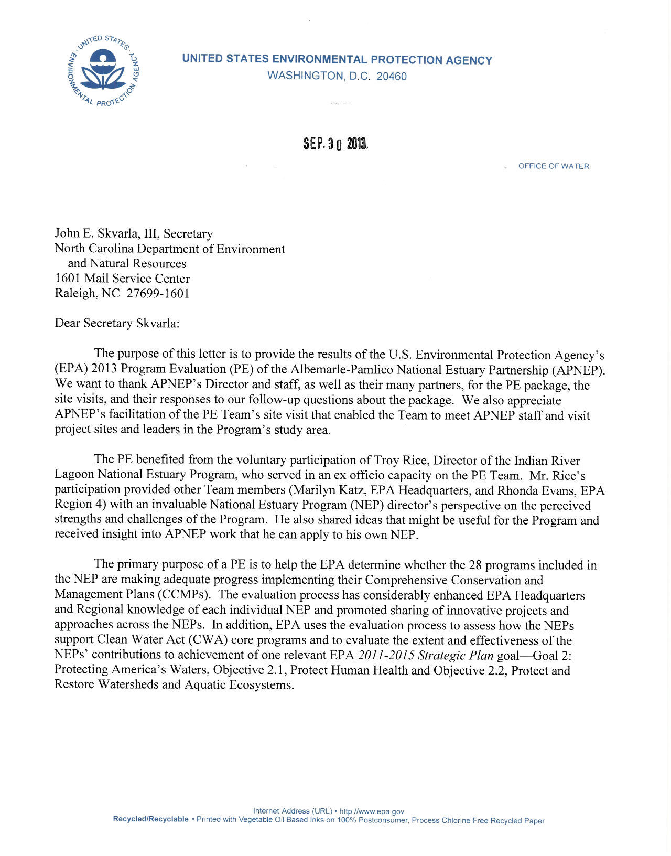
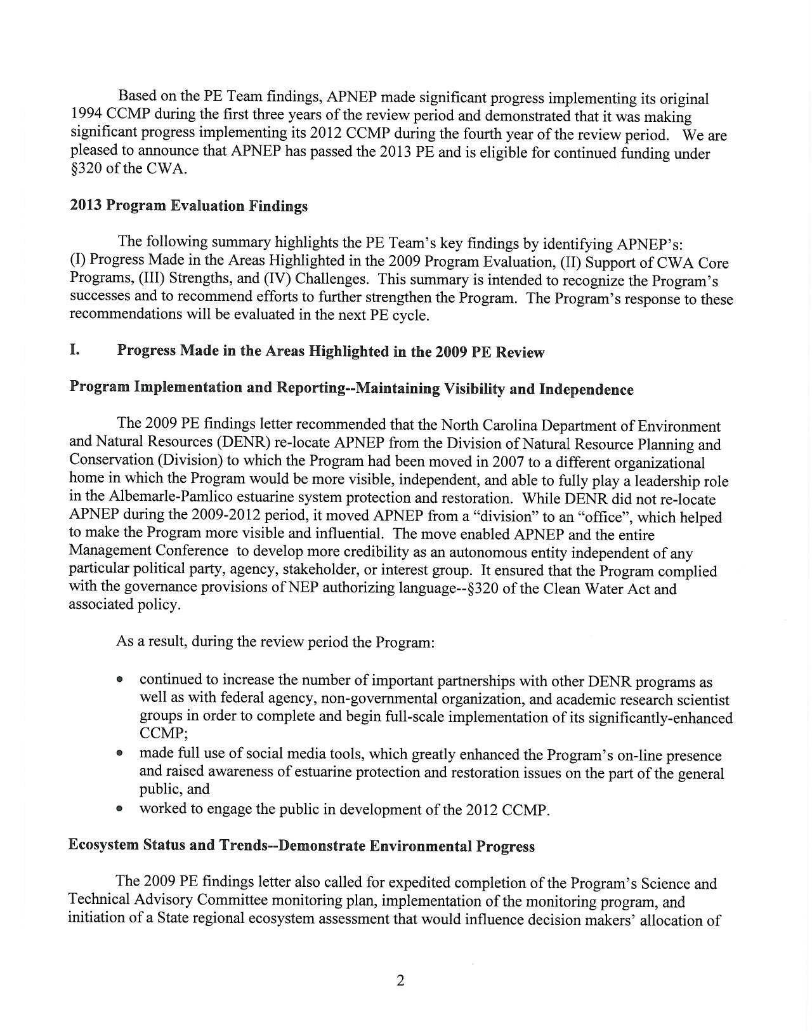

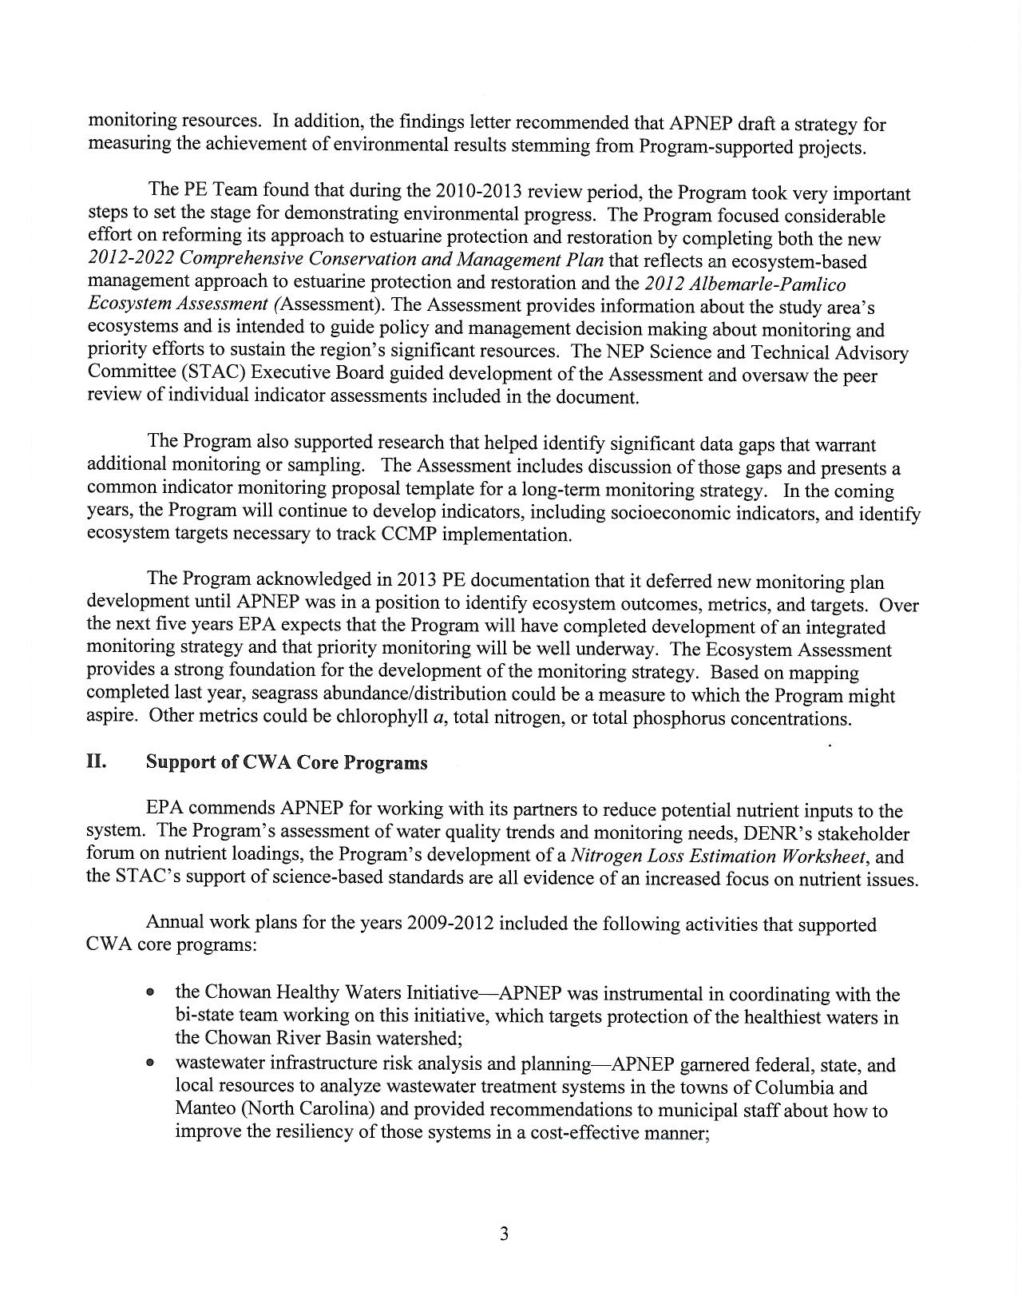

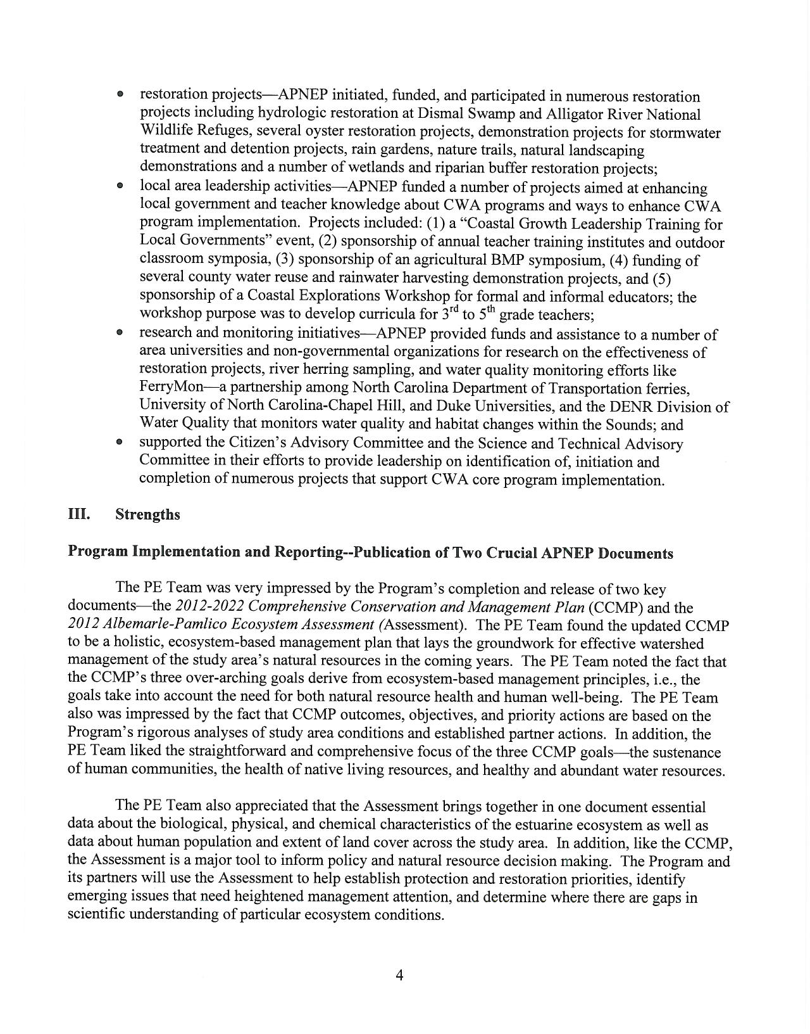

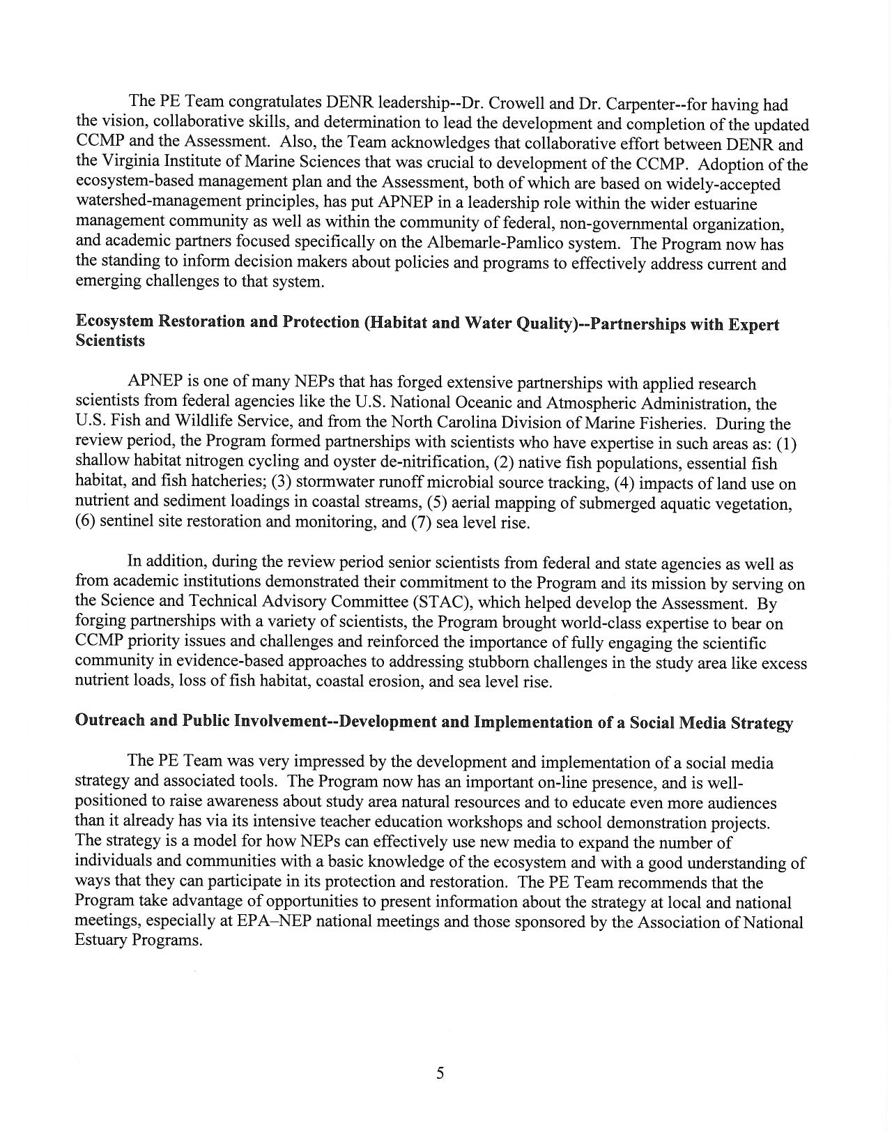

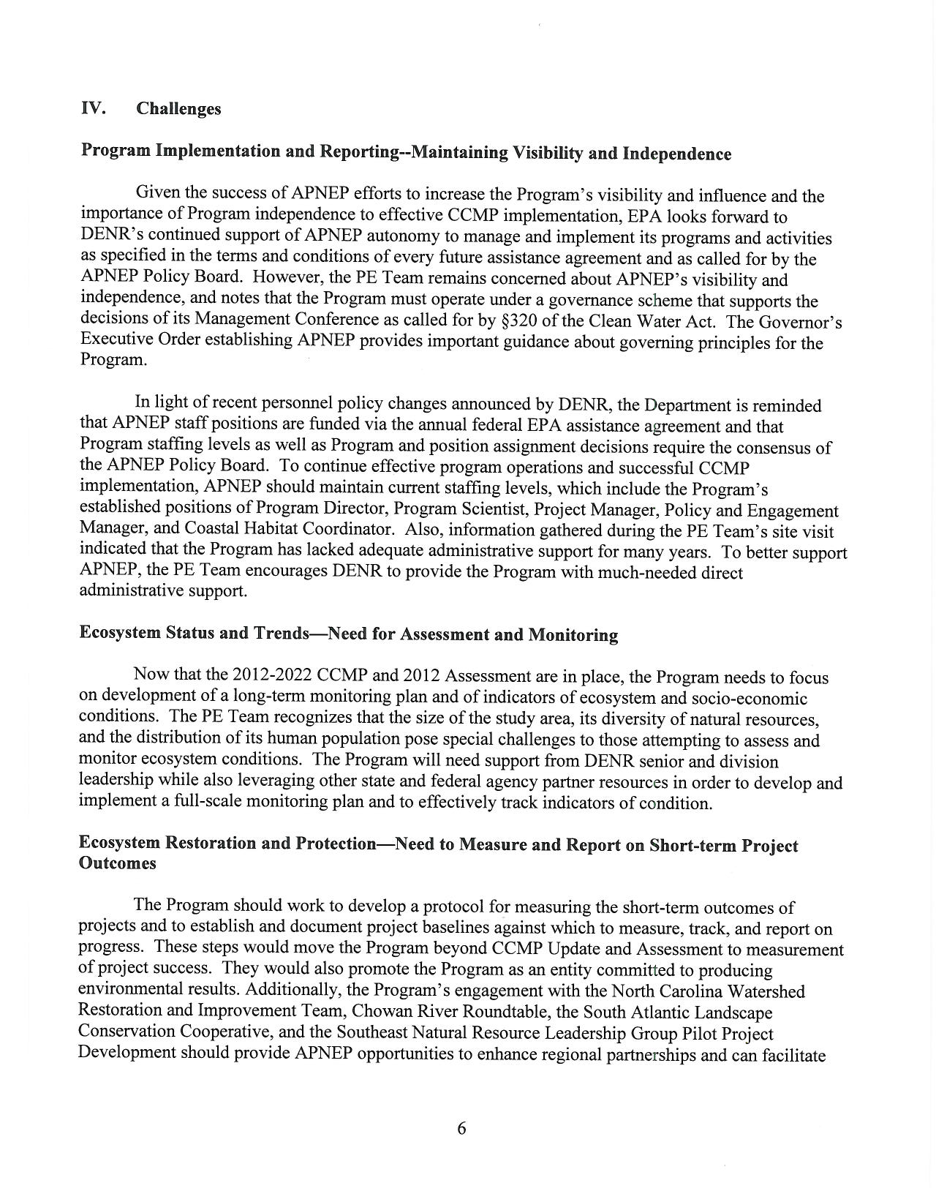

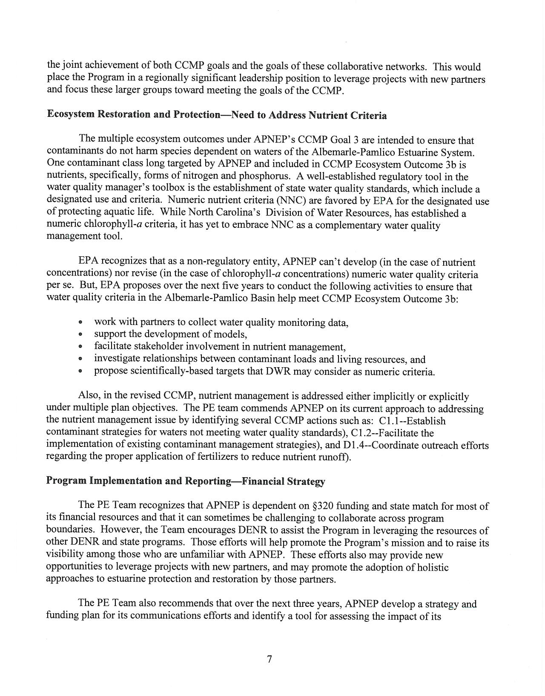

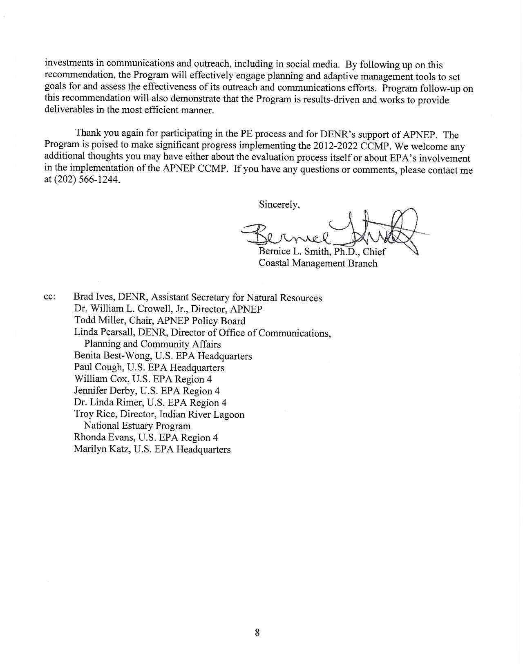

APPENDIX B: Giattina/NCDENR 2014 Memo
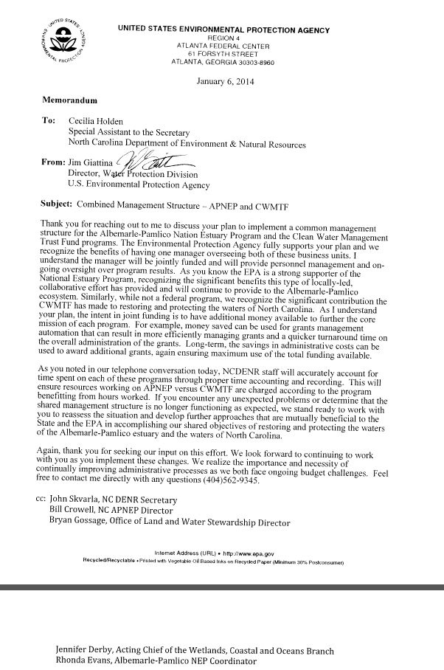

APPENDIX C: 2012 CCMP GOALS AND OUTCOMES

Goal 1: A region where human communities are sustained by a functioning ecosystem

Ecosystem Outcomes:
- Waters are safe for personal contact.
- Designated surface and ground water supplies are safe for human consumption.
- Surface hydrologic regimes sustain regulated human uses.
- Fish and game are safe for human consumption.
- Opportunities for recreation and access to public lands and waters are protected and enhanced.

Goal 2: A region where aquatic, wetland, and upland habitats support viable populations of native species

Ecosystem Outcomes:
- The biodiversity, function, and populations of species in aquatic, wetland, and upland communities are protected, restored, or enhanced.
- The extent and quality of upland, freshwater, estuarine, and near-shore marine habitats fully support biodiversity and ecosystem function.
- Non-native invasive species do not significantly impair native species’ viability or function, nor impair habitat quality, quantity, and the processes that form and maintain habitats.

Goal 3: A region where water quantity and quality maintain ecological integrity

Ecosystem Outcomes:
- Appropriate hydrologic regimes support ecological integrity.
- Nutrients and pathogens do not harm species that depend on the waters.
- Toxics in waters and sediments do not harm species that depend on the waters.
- Sediments do not harm species that depend on the waters.

Mission
To identify, restore, and protect the significant resources in the

Albemarle-Pamlico estuarine system.

