Basic Observation Buoy (BOB) Workshop, Construction, and Deployment for Secondary Schools in the Albemarle Pamlico Sound Region

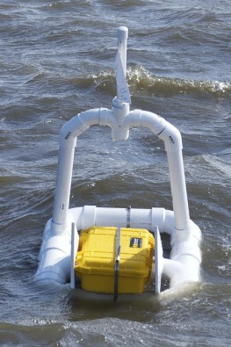

Final Project Report

Project Locations:
Pasquotank High School
Currituck High School
Mattamuskeet High School
Cape Hatteras Secondary School
Columbia High School

Prepared by
John McCord
UNC Coastal Studies Institute
217 Budleigh Street, Manteo, NC 27954
http://csi.northcarolina.edu

Funded by the Albemarle-Pamlico National Estuary Program

Project Description
The Albemarle and Pamlico Sounds are some of the largest estuarine systems in the nation, yet have relatively few observation sites providing real or near-real time data. This project, overseen by the UNC Coastal Studies Institute, successfully deployed five Basic Observation Buoys (BOB) at schools throughout the Albemarle/Pamlico Region. The schools involved in the BOB project included:
- Pasquotank High School
- Currituck High School
- Mattamuskeet High School
- Cape Hatteras Secondary School
- Columbia High School

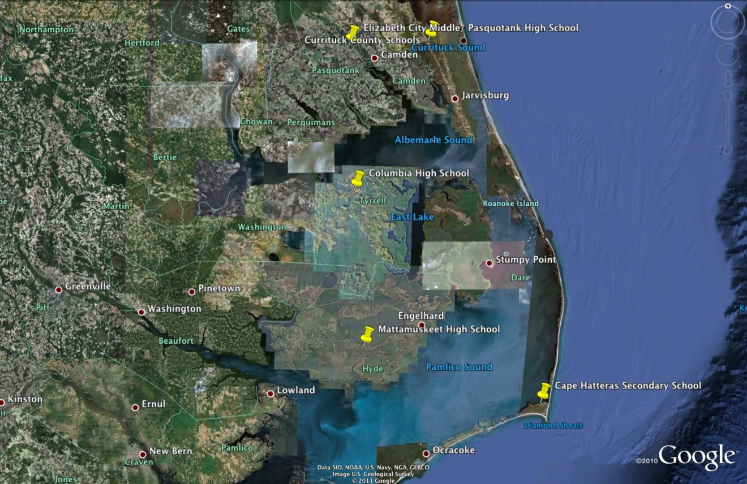
BOB Project School Locations

The BOB units carry a suite of environmental sensors and allow for the collection of meteorological and water quality data. Students deploy their buoy at a soundside location near their school and retrieve it weekly for maintenance and data retrieval. After downloading the data from the buoy, it is uploaded by the students to a project website. Participating schools can also log-in and view data sets from other schools throughout the region. While the BOB is an education-grade observing buoy, the program was developed by researchers from NOAA’s Integrated Ocean Observing System (IOOS) and is supported by the Southeast Coastal Ocean Observing Regional Association (SECOORA), therefore connecting local buoy data with regional, national, and international observing networks.

In addition to the deployment of buoys, the project also included a two-day Basic Observation Buoy (BOB) Workshop for 6-12 grade teachers in schools that surround the Albemarle- Pamlico Estuarine System. While planning for this project began in the Spring of 2011, a teacher workshop was held on September 19 and 20, 2012, at Jennette’s Pier in Nags Head, NC. Twelve teachers from five schools participated in the Basic Observation Buoy workshop and learned how to construct the buoys, collect water quality and meteorological data, and integrate the buoy and the project into their existing curriculum. This workshop provided teachers with the tools necessary to use real data within created lesson plans, making the scientific concepts more relevant and understandable for students.

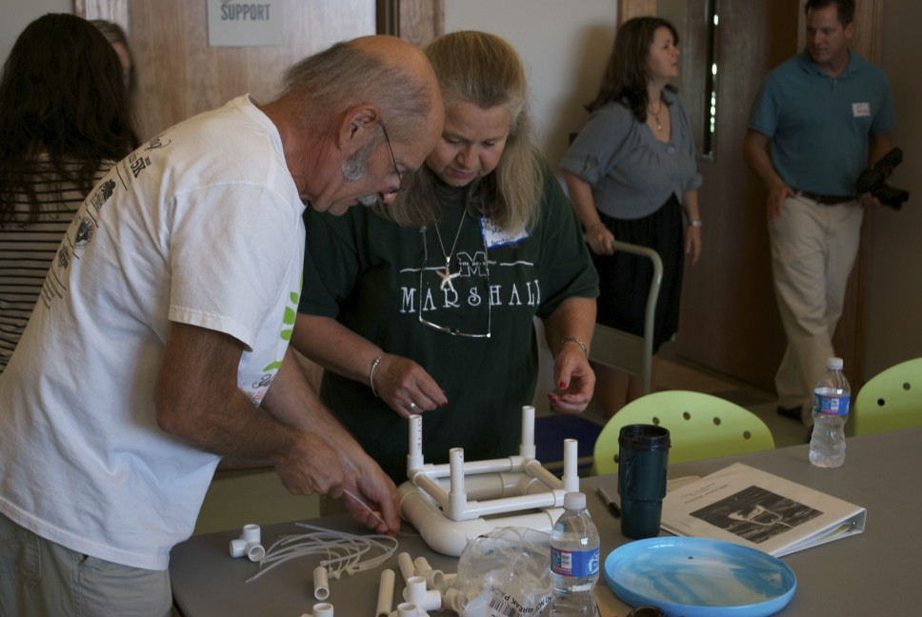
Teachers learn about buoy payload and design during the workshop

After the workshop, UNC Coastal Studies Institute staff and partners from NOAA’s Monitor National Marine Sanctuary and NC Sea Grant made individual site visits to the schools to construct the BOB units and assist with the buoy deployment. With guidance from project staff, students built the BOB units with sensors that measure temperature, pH, salinity, conductivity, and dissolved oxygen. In addition, the buoys included a meteorological package that provides air temperature, relative humidity, wind speed and direction. The data collected from these units was entered by the students and made accessible to other schools and the public via the Internet. The BOB data website can be found at: http://cormp2.das.uncw.edu/dev/. Additional site visits were made by project partners to assist with data retrieval and analysis.

While the project was faced with many challenges, including sensor package water proofing, buoy location siting and revised buoy designs for sites with high wave energy, the project staff, teachers and students overcame these challenges by employing real world trouble shooting skills. Student and teacher problem solving were needed for each school to successfully deploy and maintain their buoy. The development of 21st century job skills is critical to student success and this project provided real-world application of these skills in an engaging and challenging manner.

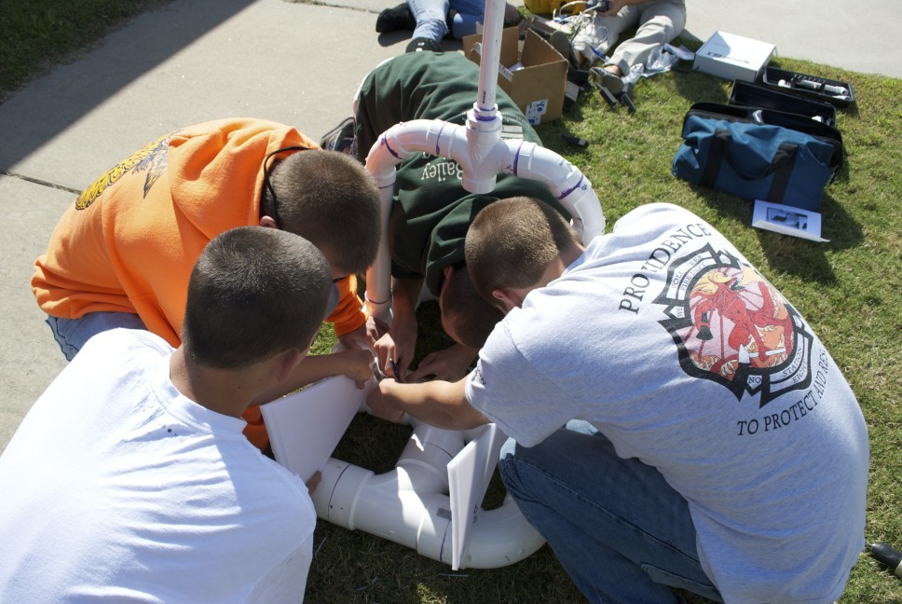
Students construct their buoy at Currituck High School

Project Importance
The creation of the Albemarle-Pamlico BOB network provides valuable data on this estuarine system, and exposes youth to the technology and importance of observing. The data obtained from the education-grade observing equipment has been added to existing BOB data networks and provides area teachers and students with insights into the biological and physical processes occurring in their surrounding estuarine systems. In addition to the data collected, this program expansion brought project-based learning opportunities to students in traditionally underserved areas. Curriculum created in conjunction with the project teaches important scientific concepts and terminology coupled with collecting real-time data. This project engages students in a manner that highlights STEM (Science, Technology, Engineering, and Math) education and encourages career paths in related fields.

The ongoing collection of data from BOB units deployed at schools surrounding the Albemarle and Pamlico Sounds will create a legacy project for students to contribute to year after year. Long-term data collection will allow students and teachers to identify trends in their local systems and relate them to national and global trends in climate change issues and ocean acidification.

The BOB units continuously collect water quality data and give students and the public insight into water quality parameters and physical conditions that may affect local habitats and fisheries. Access to data and the ability to interpret it in meaningful ways encourages classroom discussions on factors that may influence water quality and the impact they may have on natural systems.

By engaging the students in the collection and analysis of water quality data, the importance of this data and their values become more relevant. Throughout the project, students observed local changes in water quality parameters during rain events, drought conditions and major weather phenomena such as Nor’easters. Seeing these changes first hand gives students a better understanding of the impact of these events on receiving waters and how they may affect local ecosystems.

Project Expenses
The funds received by the grant were used to fund the workshop, buoy construction and classroom supplies for lesson plans and associated curriculum. A basic breakdown of these charges includes:

- $21,725.25 used to fund equipment and supplies for the workshop, buoy construction (including data loggers and sensors), and classroom instructional supplies.
- $2,554.20 used to fund travel for teachers, meals, housing and substitutes for the 2-day teacher workshop.

The cost for the BOB project totaled $24,279.45 .

Project Expansion
The grant received from APNEP was leveraged to receive an additional $5,000 from Towne Bank of Currituck to continue the project throughout the Winter and Spring of 2012. It is our intention to search for additional funding to continue the project and expand its reach to additional schools throughout the Albemarle-Pamlico region. In addition, we would like to upgrade the sensor packages on the BOBs to research grade equipment, making the data more accurate and useful to scientists, as well as teachers and students. The incredible student and teacher engagement, their excitement for the project and pride that they have in taking ownership of their BOB, has proven to be a rewarding experience that we would like to spread to other schools throughout coastal North Carolina.

