**APNEP 2011 Estuary Education and Awareness Campaign Final Report**

In the spring of 2011, the North Carolina Coastal Reserve and National Estuarine Research Reserve (the Reserve) received the Estuary Education and Awareness Campaign grant from the Albemarle-Pamlico National Estuary Program (APNEP). The APNEP region has an estimated 8,100 miles of estuarine shoreline and it is one of the top most threatened areas from sea level rise in the United States. The goal of this campaign was to teach the value and function of estuarine habitats, how these habitats may be affected by sea-level rise, and alternative methods (other than bulkheads) of estuarine shoreline stabilization.

This campaign was designed to educate coastal decision-makers, K-12 teachers and students, and the public, including estuarine-waterfront property owners. To reach educators the Reserve held a Coastal Explorations Workshop for formal and informal educators. Additionally, the Reserve staff developed two curricula for 3rd-5th grade teachers and students and they were presented at this workshop. To educate coastal decision-makers the Reserve’s Coastal Training Program presented the Estuarine Shorelines: Value, Regulations, and Stabilization workshop. To teach the public about the value of North Carolina estuaries, the Reserve held three field trips and implemented a social media public information campaign. The Reserve conducted all of the events for this campaign in the northern Outer Banks region, from Nag’s Head to Corolla, North Carolina. All of the events provided participants with an invaluable hands-on opportunity to learn about North Carolina estuaries, the Coastal Reserve system, and APNEP. This report includes a summary of the grant products, evaluations, and recommendations to improve these events for future implementation.

**Summary, Evaluation, and Future Recommendations for Products**

*Products for Educators*

The Reserve staff worked with North Carolina Sea Grant to hold a full day Coastal Explorations Workshop at the Outer Banks Center for Wildlife Education in Corolla. Eighteen formal and informal educators attended this hands-on workshop designed to teach educators about North Carolina’s estuaries and how to incorporate valuable information about estuaries by using unique lesson plans. This workshop offered renewal credits for teacher certification and North Carolina Environmental Educator Certification. The Reserve staff also developed two curricula for 3rd-5th grade teachers about the Albemarle-Pamlico Estuarine System (See Appendix 1). The educators received hands-on experience by doing these two lessons, in addition to a number of other curricula and exploring the Currituck Banks Reserve boardwalk (See Appendix 2).

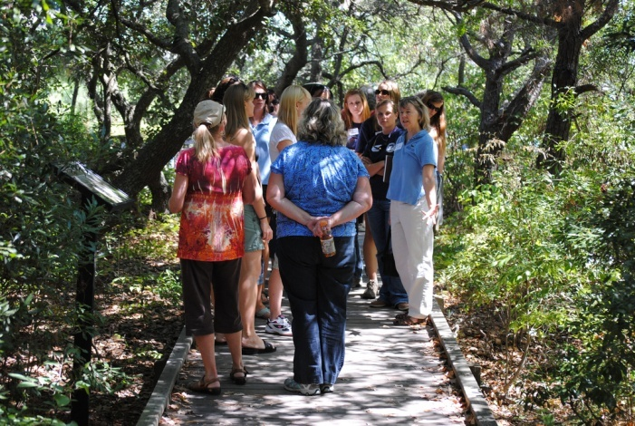 The Coastal Explorations Workshop was a great success, as conveyed by the workshop evaluations (See Appendix 3). Overall, the participants felt that the workshop was a great experience and facilitated by well-prepared instructors. They indicated they are likely to use the information they learned about estuaries in their future work. One educator commented, “I really enjoyed the interactive activities. Participating in the lesson plans helped me understand better techniques in teaching the material.” This statement summed up a number of other comments as well. There were no major changes recommended by the participants. A number of people requested for additional topics to be covered in the workshop such as, marine mammals, beaches and dunes, and barrier island movement. These topics will all be considered for future workshops by the Reserve’s staff.

**Educators on the field trip in the Currituck Banks Reserve.**

There are a couple of lessons learned the Reserve should keep in mind when offering similar teacher workshops in the future. First, it is a great idea to put on a teacher workshop with a partnering organization such as North Carolina Sea Grant. When the Reserve partners with other educators to develop a workshop, there are more resources available and they could potentially reach a larger audience than they would by working independently. Second, the Reserve staff should make it a point to promote books and other resources during the workshop that will help educators learn more about estuaries. North Carolina Sea Grant staff brought a number of resources to the workshop to share with the educators so they could take home ideas for places to look for additional information and lesson ideas. Many of the participants commented on the usefulness of these materials during the workshop and throughout the evaluations. Finally, it would be useful for the Reserve staff to provide participants with lesson plan alternatives so that they could adapt them for different teaching circumstances. For example, if Reserve staff teaches the educators about a 30 minute classroom lesson on estuarine habitats, they should also consider provided a shorter alternative or a way the teachers could easily adapt the lesson to an informal setting.

*Products for Coastal Decision-Makers*

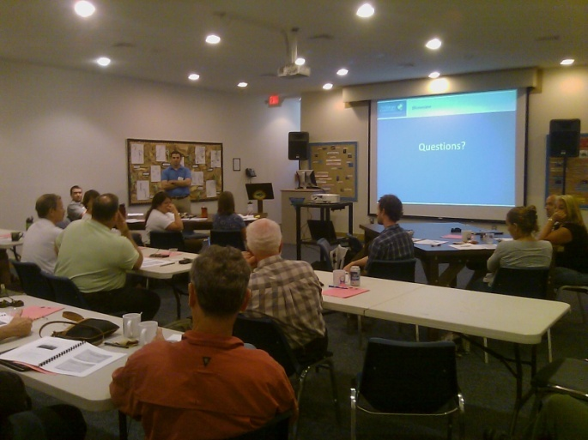 Coastal decision-makers are an important group to educate about the value of estuaries, estuarine shoreline stabilization methods, and sea-level rise. This group includes estuarine-front property owners, realtors and developers, marine contractors, environmental consultants and engineers, all of whom have an effect on the estuarine shoreline. Reserve staff developed a Coastal Training Program workshop titled, Estuarine Shorelines: Value, Regulations, and stabilization (See Appendix 4). The objectives of this workshop were: to explain the value and function of estuarine habitats; to discuss permitting requirements of all methods of estuarine shoreline stabilization, including alternative methods (i.e. marsh sill or living shorelines); to explain the techniques and design elements of all methods of estuarine shoreline stabilization, including alternative methods (i.e. marsh sill or living shoreline); and to explain how estuarine habitats and shoreline stabilization structures may be affected by sea-level rise. Originally, Reserve staff planned on two separate back-to-back workshops—one targeting marine contractors, engineers, and consultants, and the other for homeowners, realtors, and developers. However, as the registration deadline for the workshops approached, both workshops had a low number of registered participants. Therefore Reserve staff combined the two workshops into one larger workshop that 34 participants attended. A talented group of six experts spoke on estuaries, climate change, permitting, shoreline stabilization methods, and the process of making a living shoreline. The workshop was held at Jockey’s Ridge State Park and participants were able to go on a field trip to view an alternative shoreline stabilization project, the marsh sill restoration site that Jockey’s Ridge and the North Carolina Coastal Federation developed together on Kitty Hawk Bay.

**Participants learn about shoreline stabilization options.**

According to the workshop evaluation, all of the workshop participants felt that this workshop was useful and increased their ability to understand the value of estuarine habitats, different shoreline stabilization methods, stabilization regulations, and how sea-level rise may affect estuarine habitats (See Appendix 5). Sixty-seven percent of participants learned something new from this workshop that they are going to apply in future work or decision-making processes, especially in regards to estuarine shoreline stabilization. Six people commented on value of the diversity of workshop participants as well as exploring Jockey’s Ridge’s marsh sill restoration on the field trip. There were a couple of changes the participants recommended for future training workshops. These included trying to focus more on realtors and developers interests, reviewing funding options for shoreline stabilization projects, and to visit additional shoreline stabilization project sites on a field trip. Some of the valuable topics recommended for future training workshops included technical training for contractors, constructability details, and funding and partnership opportunities. Reserve staff will take all of these comments into serious consideration when planning for the next estuarine shoreline workshops, which are planned for spring 2012 in the southern and central parts of the North Carolina coast.

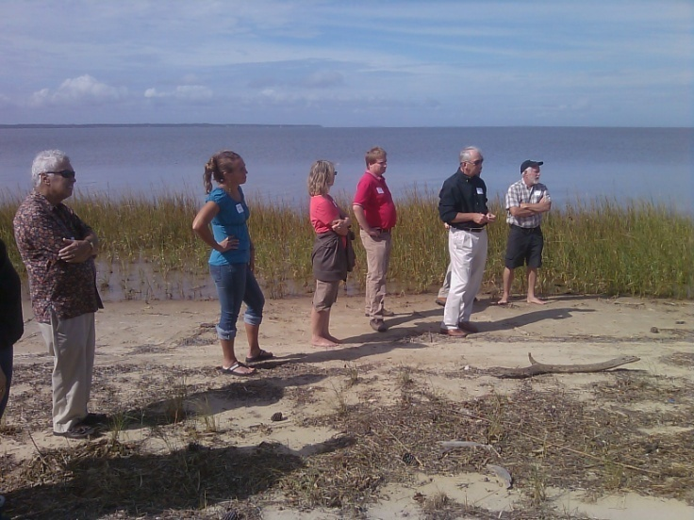There are a couple of lessons learned when planning for similar workshops in the future. First, the Reserve should have budgeted for postage for workshop advertising. Reserve staff found it difficult to reach estuarine-front property owners, as there are thousands of people listed in their contact database. It may have also been beneficial to have budgeted for advertising the workshop in the local newspapers that many property owners are likely to read. For a future estuarine shoreline workshop, a presentation focused on the different costs of shoreline stabilization projects and funding opportunities should be included, as it would be very beneficial for anyone, property owners and organizations alike, who are thinking about stabilizing a shoreline. A number of participants at this workshop said that this was a topic that needs to be addressed in future workshops. Finally, it would be helpful to have a marine contractor or consultant speak about the details of designing and building an alternative shoreline stabilization project so that they start to feel more comfortable with the newer methods.

**Participants explore Jockey’s Ridge marsh sill project.**

*Products for the General Public*

To educate the general public about estuaries and estuarine shoreline issues, Reserve staff developed public field experiences and a social media public information campaign. The Reserve staff held three public field experiences in early August throughout the Outer Banks. This included a kayak trip through Kitty Hawk Woods Reserve, a nature walk on the Currituck Banks Reserve boardwalk, and an estuarine exploration in Kitty Hawk Bay. Twenty-eight participants, including local residents and tourists, joined the Reserve staff for all of these free programs.

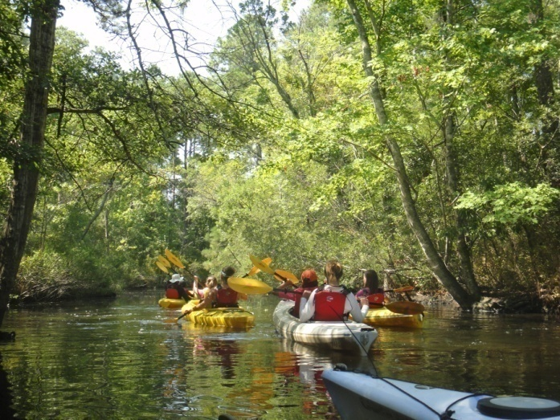 The field experiences were a great success and friends and families alike enjoyed getting out to the Reserve sites while learning about North Carolina estuaries. One participant posted this comment and a picture of the kayak trip on the North Carolina Department of Environment and Natural Resources (NC DENR) Facebook page: “Thanks to everyone for an AMAZING trip through the Kitty Hawk estuaries today! It was informative, fun, AND relaxing!!” For the kayak trip, the Reserve staff contracted the Coastal Kayak Touring Company for the kayaks, equipment, and guides. The Reserve staff led the content part of the trip and the kayak guides helped with paddling and additional information about the estuarine environment. Participants spent two hours in single or tandem boats, exploring the calm waters of the maritime forest in the Kitty Hawk Woods Reserve. They learned about the many plants and animals they saw living in the marsh and maritime forest habitats. The early evening nature walk took place on the boardwalk in the Currituck Banks Reserve. Participants were able to observe several critical estuarine habitats, including maritime swamp forest, maritime forest, and a salt marsh. Reserve staff set up participants with binoculars and a spotting scope at the end of the walk so that they could observe birds and other inhabitants of the salt marsh and Currituck Sound. The following day, Reserve staff met with participants on the Kitty Hawk Bay, where they observed an Osprey eating at its nest with the spotting scope and looked at the animals from the sound caught with a small seine net. These field trips provided a fun and interactive way for people to learn about the important estuarine habitats of the APNEP region and the plants and animals that live there.

**Participants kayak through maritime forest in the Kitty Hawk Woods Reserve.**

There are a number lessons learned to keep in mind when putting on free field experiences for the public in the future. Reserve staff may want to host field experiences in the tourist off-season. This may be a time when the Outer Banks residents are less busy and are looking for family things to do. Reserve staff may want to consider having field experiences in inland Dare or Currituck Counties instead of on the Outer Banks. Participation might increase in the future if the Reserve staff budgeted for advertising in the local newspapers. The Northern Sites Manager, staff at the Wildlife Resources Commission, or U.S. Fish and Wildlife Outer Banks offices may be able to help get more local residents involved. Overall, the Reserve staff felt these field experiences were a success, but it would be beneficial for the Reserve to try and reach out to more participants, especially locals who live near actual Reserve sites.

For the public information campaign, Reserve staff used the NC DENR’s Facebook and Twitter pages to reach the public through social media. The use of social media tools for interactive information sharing is on the rise and social media can help organizations reach a larger audience. It allows one to promote events or make announcements, solicit opinions or comments, and even recruit volunteers. Additionally, social media tools can help drive web traffic to an organization’s main web site or showcase products available on the web, such as lesson plans or newsletters. Reserve staff developed a 14-week work plan for a “Did You Know?” campaign for Facebook and Twitter that highlighted important events for the grant such as the workshops and field trips, as well as information about North Carolina’s estuaries (See Appendix 6). The information broadcasted on the “Did You Know?” campaign started with more general information about estuaries and worked up to current research on sea-level rise affecting estuarine shorelines. Every Wednesday and Friday morning, the public information officer of the Division of Coastal Management would post on NC DENR’s Facebook and Twitter sites and APNEP and the North Carolina Office of Environmental Education would re-tweet the information on their Twitter pages to reach a larger audience. The plan was a draft and was amended a few times throughout the 14 weeks.

Evaluating the effectiveness of the public information campaign is difficult. There is no real way to track the effectiveness beyond the number of NC DENR Facebook and Twitter followers. Currently, NC DENR has 781 followers on Twitter and 1230 people “like” their Facebook page. However, the “Did You Know?” campaign received 24 “likes” on Facebook and four direct comments, including one with a picture. Additionally, this public information campaign was well received by the other NC DENR public information officers and the NC DENR public affairs director. They really liked how carefully planned the campaign was and thought it was an extremely useful way for the Reserve to use social media to get their message out. Some of the other NC DENR Divisions are currently planning similar public information campaigns since they liked the Reserve’s one so much.

For future public information campaigns the Reserve should develop a similar plan ahead of time with all of the information laid out so that there is a clear direction for the campaign and the Reserve benefits as much as possible. Once the plan is developed, execution is simple and the Reserve can easily adapt the social media messages as new information becomes available. When developing the original plan, the Reserve should insert Internet links that lead people to their main web site or to other relevant products they have developed such as lesson plans or children’s activity books. This will help to increase the traffic on their web sites and promote their products to more people. It is also important for the Reserve to consider working with additional agencies or organizations that can re-post their social media messages, allowing them to reach a wider audience. In this case, two organizations re-posted the Reserve’s online messages, allowing the additional followers of the other organizations to also be notified of the Reserve’s “Did You Know?” campaign.

**Looking towards the Future**

Although this APNEP grant has ended, the Reserve is planning a number of future projects that build off of these initial grant products. First off, Reserve staff will be doing two Coastal Training Program estuarine shoreline workshops in the central and southern areas of coastal North Carolina in the spring of 2012. The workshops will be very similar to the one held in Nags Head, but will have some different speakers as well as a different field trip. Second, Reserve staff are working to develop another Coastal Training Program estuarine shoreline workshop specifically for realtors in North Carolina. This realtor workshop would be a continuing education course certified by the North Carolina Real Estate Commission and the participants would receive continuing education credits.

The Reserve will be using the knowledge gained from the social media campaign to inform future campaigns, such as one for Masonboro Island recreational users. The Reserve will also continue to use and distribute the curricula developed for this campaign. Lastly, the Reserve hopes to continue to foster its relationship with APNEP on education endeavors in the future.

**Funky Food Chains**

**Appendix 1: 3rd-5th Grade Lesson Plans**



**Grade Level**

3rd-5th

**Objectives**

* To learn about food chains and animals in estuaries.
* To discover the important roles of producers, consumers, and decomposers in estuaries.

**N.C. Standard Course of Study**

Grade 4

(1.01, 1.03, 1.04)

Grade 5

(1.01, 1.02, 1.05)

**Overview:**

This activity will teach students about the energy cycle within an estuary and how it travels from producers, to consumers and finally to decomposers via the food chain. Students will get to design their own estuarine creature and make up an estuarine food chain, as well as play an interactive game with their classmates.

**Materials:**

* imagination!!
* construction paper
* 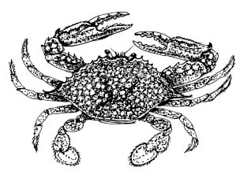large pieces of scrap paper (for food chains)
* scissors
* glue
* markers or crayons
* pipe cleaners
* googly eyes
* glitter
* feathers
* stapler
* tape

**Background:**

An **estuary** is a body of water mostly surrounded by land where salt water from the ocean mixes with the fresh water from rivers. North Carolina has 2.2 million acres of estuarine habitat, including the third largest estuarine system in the United States, the **Albemarle-Pamlico Estuarine system**. Estuarine systems in North Carolina are composed of a number of important habitats including salt marshes, maritime forests, oyster reefs, beaches and dunes, and mud flats. The water found in an estuarine system is **brackish**, meaning a mix of salt and fresh water.

Estuaries are an extremely important place for plants and animals and act as a nursery for many young animals. Ninety-five percent of North Carolina’s seafood species, such as shrimp, oysters, crabs, and flounder depend on the waters of our estuaries. They spend part of their life if not all of it, within estuarine habitats. Adult sea trout and red fish use estuaries as their feeding grounds as they swim along the edge of the salt marsh vegetation. Many kinds of birds, including migrating birds, live and feed

In all estuaries around the world and throughout North Carolina, plants and animals rely on one another for food as they are all part of a complex food chain. A **food chain** is defined as “a feeding hierarchy in which organisms in an ecosystem are grouped into trophic (nutritional) levels and are shown in a succession to represent the flow of food energy and the feeding relationships between them.” Multiple food chains connect to one another via a **food web**.

Essentially, a food chain is a simple way to see how energy flows throughout the estuary. Every animal or plant are critical to the estuary due to their role they play in the food chain, including producers, consumers, and decomposers. **Producers**, usually green plants, are at the base of the food chain and they make their own food. Green plants use photosynthesis to convert sunlight into food. **Consumers** eat producers or other smaller consumers lower on the food chain for energy. A **decomposer** is an organism that breaks down the remains of dead animals and plants, or consumers and producers. This provides food for the producers and consumers in the food chain and re-nourishes the environment.

Some of the **producers** of estuaries include salt meadow hay, cordgrass, and glasswort. All of these plants provide important habitat for juvenile fish, crabs, worms, and other animals. The plants intricate root system holds the mud and sand of the estuary together to stabilize the shoreline. Also, the plants help to filter the water and trap excess nutrients and harmful chemicals that could enter from the river water upstream.

The **decomposers** of the estuary are bacteria, flies, snails, tube worms, and fiddler and blue crabs. They all help to break down dead plant and animal matter.

The **consumers** of the estuary, including shorebirds, fish, diamondback terrapins, snakes, rodents, red foxes, dolphins, and raccoons, all eat smaller consumers or producers. When they die, they feed the decomposers as well. All the levels of the food chain depend on one another, so if there is a disturbance in one level it can negatively affect another level.

The following are some examples of estuarine food chains to share to your students:

* Copepods, striped mullet, spotted seatrout, Atlantic bottlenose dolphin
* Phytoplankton, bay scallop, cownose ray, scalloped hammerhead shark
* 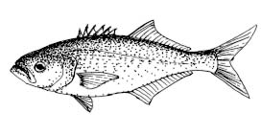Amphipod, pinfish, osprey
* Phytoplankton, bay anchovy, Atlantic brief squid, bluefish

**Activity:**

***Create an estuarine creature***

Students should use their imagination to develop an estuarine creature that is a producer, decomposer, or consumer. Knowing what they know about the different types of plants and animals that live in the many habitats of the estuaries, students can use any materials provided to make their estuarine creature. They must decide what the creature eats, where it lives, and how it uses its habitat to survive.

Questions to ask the students to think about before they get started:

-Is your creature a producer, consumer, or decomposer?

-Where do they live in the estuary?

-Do they have legs, fins, a tail, pinchers, or teeth?

-How many eyes do they have?

-What do they eat to survive in the estuary?

Hand out the following worksheets to your students, and they can work individually or in pairs. Tell your students to fill out the worksheets to help them plan before their build their estuary creature. They can also draw their creature first before making it.

Once the students have created their new estuarine creature, they should develop a simple food chain that includes their made up creature. This food chain should have at least three levels in it and they can draw it (with their new creature included) out on a large piece of scrap paper to share with their classmates. Students can work together to use all of their new estuarine creatures in one food chain. After creating their estuary creature, the students should tell their classmates one by one a couple of facts about the new estuary creature.

**An example of an estuarine food chain:**

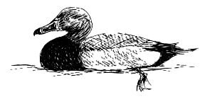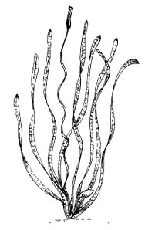

**Redhead Duck**

**(Consumer)**

**Aquatic Vegetation**

**(Producer)**

**Your estuarine creature is named**  .

**It is an (circle one):**

**Decomposer (**an organism that breaks down the remains of dead animals and plants, or consumers and producers)

**Producer (**usually green plants, are at the base of the food chain and they make their own food from sunlight)

**Consumer (**eat producers or other smaller consumers lower on the food chain for energy)



**Optional: Draw the creature you are going to build.**

**Where does your estuarine creature fit into the food chain?**

***The Food Chain Game***

Set- up: Students need to spread out over the designated area (classroom, outside field, etc.), seated in a crawling position.

How to play: Upon the teacher’s starting signal students approach one another via crawling as a piece of detritus, whereupon they conduct a game of rock-paper-scissors. The winner of the game stands up to jump as he or she becomes a grass shrimp. A grass shrimp may only challenge another grass shrimp. The winner gets into crab walking position and now becomes a blue crab. Blue crabs may only challenge other blue crabs. The winner stands, arms stretched out front to resemble jaws and becomes a red drum. Red drums may only challenge other red drums. The winner remains standing arms stretched out in front, as they are fishing. Fishermen may only challenge other fishermen. The winner remains a fisherman while the loser falls back to the previous step in the food chain. The goal is to remain at the top of the food chain for as long as possible. Therefore, students move up and down the food chain depending on whether they win or lose.

**Discussion Questions:**

1. What is more important in the food chain—a decomposer, a producer, or a consumer?

*They are all equally important—without one of them the food chain would collapse!*

1. What benefits do the plants of the estuary provide all others that live there?

*Their root systems help to trap sediment from runoff and rivers. They also help filter out toxic chemicals and excess nutrients that could disrupt the estuarine system as a whole.*

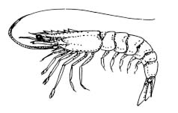**Extension:**

Have students create their own food chain to play in the food chain game.

**Vocabulary:**

* Estuary
* Albemarle-Pamlico Estuarine System
* brackish
* food chain
* food web
* producer
* consumer
* decomposer

**References:**

http://www.biology-online.org/dictionary/Food_chain

National Estuarine Research Reserve System. 2008. http://www.estuaries.gov/

Seachange Consulting. 2010. Weighing Your Options, How To Protect Your Property from Shoreline Erosion: A handbook for estuarine property owners in N.C.. 51 pgs.

**National Science Standards:**

*Content Standards Science as Inquiry [1-4]*

*Life Science [1-4 & 5-8]*

**Ocean Literacy Principles:**

*Essential Principle #5 The ocean supports a great diversity of life and ecosystems.*

*(Fundamental Concepts – d, i)*

**The Albemarle-Pamlico Estuarine System: Birds & Habitats**



**Grade Level**

3rd-5th

**Objectives**

* To learn about and identify the birds that use the diverse habitats of the Albemarle-Pamlico Estuarine System.
* To learn and describe ways humans can affect the different estuarine habitats.
* To identify how animals survive in a habitat and ways they have to adapt if that habitat is lost.

**N.C. Standard Course of Study**

Grade 4

(1.02, 1.03, 1.04)

Grade 5

(1.03, 1.06)

**Overview:**

This activity will teach students about the different habitats found in the Albemarle-Pamlico estuarine system and the birds that live in them. Students will learn about different types of birds, their lifestyle, and how they use their habitat wisely. They will also learn how these habitats are being threatened by humans and climate change and how that has a major impact on the birds that live there.

**Materials:**

* Pencils
* Lined paper
* Scissors
* Glue or tape
* Paper (for habitat drawings)
* Markers or crayons

**Background:**

The **Albemarle-Pamlico estuarine system** is the second largest in the lower 48 states of the United States. With over 3,000 square miles of open water, this important habitat supports a wide abundance of plants and animals. This estuarine system is composed of a number of sounds and major rivers. **Sounds** are bodies of water similar to bays and inlets, but larger. This estuary is a very important habitat for many of North Carolina’s fish and shellfish. In fact, ninety-five percent of the state’s seafood species, such as shrimp, flounder, crabs, and oysters depend on estuarine waters for their survival. **Salt marshes** are a critical estuarine habitat as they act as ocean nurseries for many fish, birds, and other animals.

There are a variety of different habitats that make up the **Albemarle-Pamlico estuarine system** and provide food and refuge for the birds that live there. Maritime forests, salt marshes, dunes and beaches, mudflats, and submerged aquatic vegetation areas are a number of different habitats that make up the estuary. Water birds live in all of these habitats and use different habitats for different needs—whether it’s nesting or looking for their next meal. Also, **barrier islands** are an important component of the Albemarle-Pamlico estuarine system and many birds use this land as a stopover location to rest and feed on their migrations down south for the winter.

*Maritime forest*

**Maritime forests** grow on **barrier islands** around the **Albemarle-Pamlico estuarine system**. They are usually protected from the wind and harsh salt spray of the ocean. These forests are dominated by a number of trees including, live oaks, wax myrtle, red cedar, red maples, loblolly pines, sweet gums, and many others. Birds of prey, such as hawks or owls can be found living amongst the canopy of these rare forests. Owls feed on small mammals such as mice and snakes. In the forest many animals take shelter during storms. One can find raccoons, foxes, otters, snakes, and different kinds of turtles and lizards. Ospreys and kingfishers may also be found in the forest since their main source of food is fish.

*Salt marsh*

**Salt marshes**, although a salty and harsh environment, are one of the earth’s most fertile ecosystems. They are usually found on the calmer, sound side of barrier islands and serve as critical nursery habitat for many animals, such as a wide variety of fish species. In the **Albemarle-Pamlico estuarine system** there are both brackish and fresh water marshes. **Brackish** means a mix of fresh and salt water. Many herons, egrets, ibises, and shorebirds can be found foraging and living around these marshes. The herons and egrets will actively hunt small fish in the shallow marsh waters and spear them with their sharp beaks. Ibises usually feed in packs and use their curved beaks to find burrowing crabs for food.

*Dunes and beaches*

**Beaches** and **dunes** are open sand spaces found along the east coasts of the **barrier islands** of the **Albemarle-Pamlico estuarine system**. They are shaped and are constantly changing due to wind and water. The roots of American Beach Grass, sea oats, beach panic grass, and salt meadow cordgrass help to hold the dunes together. On our beaches however, there is little vegetation, but a lot of animals feed and live in both habitats. Ghost crabs and mammals such as foxes can be found hunting around for food. Many shorebirds like gulls, terns, plovers, and sandpipers use the dunes and beach areas to nest and find food. As these areas are constantly changing, shorebirds have to keep up with their environment and try to find the most protected spots for their nests. Plovers feed at the water’s edge on small crustaceans, worms, snails, and insects. Gulls will eat almost anything including fish, shellfish, small mammals, or garbage and nest in colonies in grasses. Terns however, eat fish and usually dive into the water while they’re flying.

*Mud flats*

Large **mud flats** are exposed in different parts of the **Albemarle-Pamlico estuarine system** when there is a strong northeast wind, which literally pushes the water out into the ocean. This habitat is made of rich mud and sand and exposes many kinds of invertebrates such as shellfish and tube worms. A variety of shorebirds, such as gulls and terns, can be found on any exposed mud flat, feeding until they’re content. One can also usually find pelicans resting on the ground and flying off to dive for fish nearby.

*Submerged Aquatic Vegetation Areas*

Many beds of **submerged aquatic vegetation** (SAV) or underwater vegetation (different kinds of seagrass) are found in the low-salinity waters of the shallow Currituck Sound. This vegetation provides food and protection for a variety of small fish, crabs, aquatic insects, turtles, and other animals. The plants that you find growing underwater here are usually widgeon celery, sago pondweed, wild celery, and Eurasian water milfoil. The previously mentioned variety of grasses are essential feeding grounds for the many wintering waterfowl that live in this estuarine system for four months a year. A variety of geese, swans, and loons can be found in these waters during the winter, but throughout the year one can find mergansers, buffleheads, grebes, and redhead ducks feeding among these grasses. Loons feed on a variety of small fish species. Redheads are a diving duck that eat the roots, stems, and leaves of the SAV.

*A changing, threatened environment*

The many important habitats of the **Albemarle-Pamlico estuarine system** are home to a lot of different birds; however estuaries all around North Carolina are being threatened daily by humans and climate change. North Carolina has 2.2 million acres of estuaries, but the largest system, the Albemarle-Pamlico, is especially threatened as the land is sinking lower (**subsidence**) and the ocean height is increasing (**sea level rise**) over time. The shorelines of the Albemarle and Pamlico Sounds are one of the top three most threatened areas from sea-level rise in the United States. Birds are sensitive to environmental change and serve as good indicators of pollution and climate change.

**Subsidence**, **sea level rise**, **pollution**, **excess nutrients** and **sediment**, **coastal development**, and **marine debris** are just some of the challenges organisms of the estuaries have to deal with. **Pollution**, **excess nutrients**, and **sediment** all enter the estuary from the rivers that supply the freshwater. Too many nutrients, which can be caused from fertilizer running off of farms and yards, can harm the waters of the estuary. **Coastal development** is a major problem on the Outer Banks of North Carolina that causes a lot of significant habitat loss for the many birds that use the estuary. As more shoreline is developed with docks, buildings, and roads, more habitats are lost and the birds have fewer places to feed and nest. Additionally, as humans live closer to the birds in the estuary, there is also an increase in trash that enters the water, also known as **marine debris**. This is very hazardous to all animals as the trash can resemble food and the birds could eat it and get sick or die. It is very important to be aware of the affect we are having on the different habitats of the estuary, and we should try to have as little impact as possible. Since 1987 the Albemarle-Pamlico Estuarine System has been designated as “an estuary of national significance” in the National Estuary Program by the Environmental Protection Agency. This reflects just how important these habitats are to the people and animals that rely on them.

**Activity:**

Before starting the activity, instructors may show a PowerPoint presentation to their students that relays the background information in a simple, useful way. Notes are provided for each slide, but the instructor may add their own information depending on their class and interests. Visit here for a PDF of the presentation: http://bit.ly/oTaODX. Instructors can email Lori Davis at lori.c.davis@ncdenr.gov for a copy of the actual PowerPoint presentation.

Divide the class into small groups (3-4 students) so that they can do the two following activities.

***Many Birds!***

Instruct your students to cut out the birds and their food sources or just their food sources. After the students have cut everything out, they can match the birds to their estuarine food source. Groups can compare their different answers with each other. Additionally, have the students can draw the five estuarine habitats (maritime forest, salt marsh, beaches and dunes, mud flat, submerged aquatic vegetation) the birds feed or live in, and then place the birds and food on top of their picture.

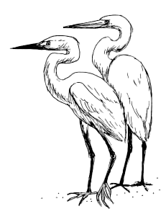

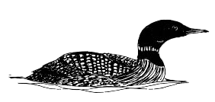

**Common Loon**

**Snowy & Great Egrets**

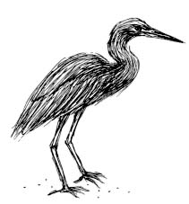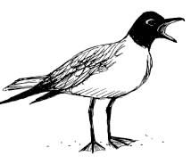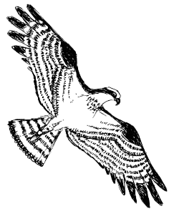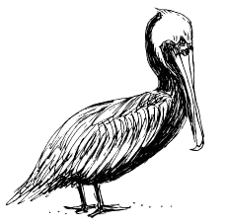

**Little Blue Heron**

**Osprey**

**Laughing Gull**

**Brown Pelican**

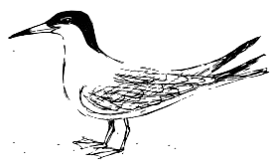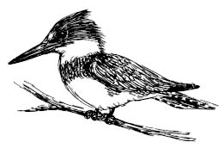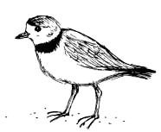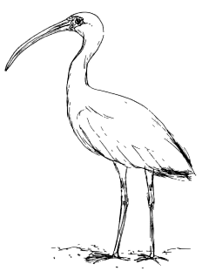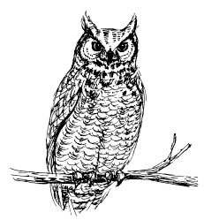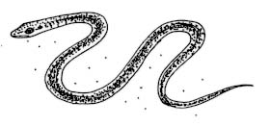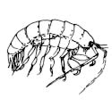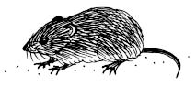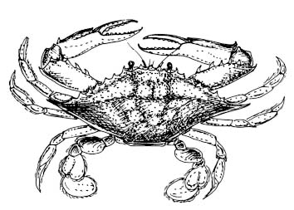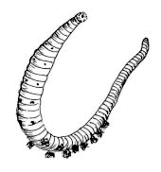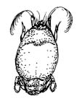

**Least Tern**

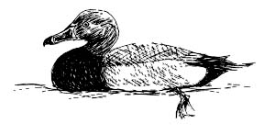**Redhead**

**Redhead**

**Great Horned Owl**

**White Ibis**

**Piping Plover**

**Kingfisher**

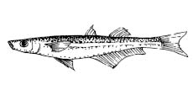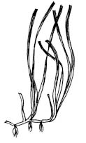

***Answer Key***

There are a variety of food sources for many of the birds that will work. Here is a list of the birds and the types of food they consume:



**Fish**: Snowy and Great Egrets, Laughing Gull, Little Blue Heron, Common Loon, Osprey, Brown Pelican, Least Tern, Kingfisher

**Shrimp**: Snowy and Great Egrets, Laughing Gull



**Crab**: Snowy and Great Egrets, Laughing Gull, White Ibis



**Snake**: Snowy and Great Egrets, Owl



**Aquatic Vegetation**: Redhead



**Mice**: Great Horned Owl

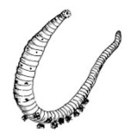 **Beach Flea**: Piping Plover



**Marine Worm**: Piping Plover



**Mole Crab**: Piping Plover

***Lost Habitat***

Human impacts on estuary habitats can have drastic effects. How do the birds adapt if they lose their home? In the same groups as above, have students consider each of the following scenarios and write down what they think would happen for each. After they have talked about each of the scenarios, have a larger discussion with all groups about how the birds will adapt to their changing environment and ways the students can help conserve these critical habitats.

*-The plovers cannot nest on the dunes since they have been destroyed by the development of large beach homes. Where do they go?*

*-Sea-level rise has caused the ocean water to flood the marsh, making it impossible for some of the ibises, piping plovers, and egrets to feed. Where do they go for food?*

*-There is trash (marine debris) in the sound that’s blown in from restaurants and houses on the barrier island. How will this affect different birds that feed and live there?*

*-A large dock and boardwalk was built near a hotel—causing some critical marsh habitat to be destroyed. What will the herons and egrets do?*

**Discussion Questions:**

1. How does a habitat help an animal survive?
2. How do animals adapt if they lose their home?
3. As humans, how do we affect habitats?
4. How can we help to conserve estuarine habitats?

**Extension:**

Have your students bring in something from home that could become marine debris.

**Vocabulary:**

* Albemarle-Pamlico Estuarine System
* sound
* salt marsh
* barrier island
* maritime forest
* brackish
* beach
* dune
* mud flat
* submerged aquatic vegetation
* subsidence
* sea level rise
* pollution
* excess nutrients & sediment
* coastal development
* marine debris

**References:**

Albemarle-Pamlico National Estuary Program. http://portal.ncdenr.org/web/apnep

The Albemarle-Pamlico Conservation and Communities Collaborative & The Albemarle-Pamlico National Estuary Program. 2009. Public Listening Sessions Report: Sea Level Rise and Population Growth in North Carolina. 68 pgs.

Seachange Consulting. 2010. Weighing Your Options, How To Protect Your Property from Shoreline Erosion: A handbook for estuarine property owners in N.C.. 51 pgs.

Stokes, Donald and Lillian. 1996. Stokes Field Guide to Birds: Eastern Region. Little, Brown and Company. 471 pgs.

**National Science Standards:**

*Content Standards Science as Inquiry [1-4]*

*Life Science [1-4 & 5-8]*

*Science in personal and social perspectives [1-4 & 5-8]*

**Ocean Literacy Principles:**

*Essential Principle #5 The ocean supports a great diversity of life and ecosystems.*

*(Fundamental Concepts – d, i)*

*Essential Principle #6 The ocean and humans are inextricably interconnected.*

*(Fundamental Concepts – b, e, f,g)*

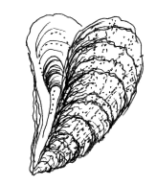**Appendix 2: Coastal Explorations Workshop Agenda**

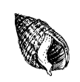**Coastal Explorations Workshop**

**The Outer Banks Center for Wildlife Education**

**August 23, 2011**

**Agenda**

9:00-9:15am Welcome and Introductions

9:15-9:30am Matching Activity

9:30-10:00am Introduction to the North Carolina Coastal Reserve and

North Carolina Sea Grant

10:00-10:15am Break

10:15-10:45am The Albemarle-Pamlico Estuarine System: Birds and Their Habitats (NC Coastal Reserve)

10:45-11:15am NC’s Amazing Coast: Classify This (NC Sea Grant)

11:15-12:00pm Funky Food Chains (NC Coastal Reserve)

12:00-1:00pm Lunch (provided)

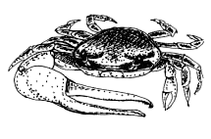1:00-1:30pm NC’s Amazing Coast: BINGO (NC Sea Grant)

1:30-2:00pm Marsh Mystery Water (NC Coastal Reserve)

2:00-2:15pm Break

2:15-2:45pm Estuary Keeper (NC Coastal Reserve)

2:45-3:00pm Wrap-up & Evaluations

3:00-4:00pm Currituck Banks Reserve Field Trip

Workshop presented by the NC Coastal Reserve and the NC National Estuarine Research Reserve and NC Sea Grant. Funding made possible by an APNEP grant.

Lori Davis, Education Specialist

Caitlin Hamer, Coastal Educator

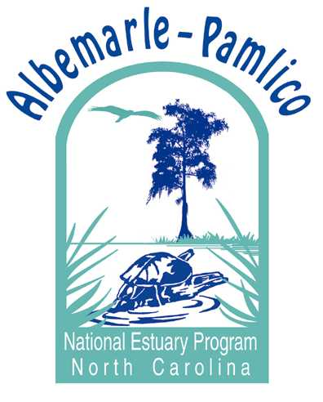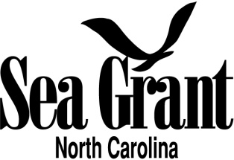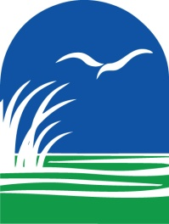Terri Kirby-Hathaway, Marine Education Specialist

**Appendix 3: Coastal Explorations Workshop Evaluations Summary**

***North Carolina Coastal Reserve***

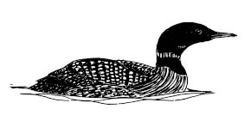***Coastal Explorations***

**Workshop Evaluation**

*Each participant should evaluate the following statements by circling the appropriate qualifier:*

**Strongly Agree Undecided Disagree Strongly**

**Agree Disagree**

1. Materials, supplies and equipment were ready at the 5 4 3 2 1

beginning of each training activity. **5**

2. Participants were introduced to the specific learning 5 4 3 2 1

objectives and materials for each activity. **4.7**

3. The content of the workshop reflected careful planning 5 4 3 2 1

and organization. **4.8**

4. The presenter(s) were well prepared. **4.9**  5 4 3 2 1

5. The visual aids and handouts were useful and understandable. 5 4 3 2 1

**4.7-book is well laid out and good resource tool-easy**

6. Adequate provisions were made for participant comfort. **4.8** 5 4 3 2 1

7. I will most likely use the information learned in today’s

workshop sometime in the future (either in a formal or informal 5 4 3 2 1

setting). **4.6**

8. Overall, this workshop was a good experience for me. **5** 5 4 3 2 1

**Great location/facility. Wonderful lunch! Very nicely done!**

1. What did you like best about the workshop?

-I liked the activities that we got to work together with and use crafts!

-I really enjoyed the interactive activities. Participating in the lesson plans help me understand better techniques in teaching the material.

-I really enjoyed doing the activities. All were something I’d consider using in the future.

-Worthwhile activities

-The Earthquake!-Haha!

-The ease of some of the activities make them work with an audience you may only have 10 minutes with. I like that for the aquarium.

-Actually DOING the activities presented. Great take home workbook.

-The programs were phenomenal! Really loved the marsh mystery water activity-definitely my favorite!! The presenters did a great job and I’m very thankful to have been a part of it.

-Very good teachers

-The fellowship and giveaways.

-The purpose of hands on activities, activities were great as were the hands on shell/crab/fish i.d. activity.

-Book and overall atmosphere

-Having my first coastal environmental education workshop.

-Simple tasks for participants with high activities

-Very organized

-The salinity activity and bingo!

-The experiments.

-All of the presenters were prepared and nice.

1. What changes would you make to this workshop?

-I would like some additional scientific information.

-Nothing. This was a great workshop.

-Tell us alternatives/changes of lesson plans/activities

-Various suggestions were taken during the workshop and staff wrote them down. Nothing major.

-Minor-less a.c. and need chocolate

-Nothing-maybe include some ice cream at the end. ☺

-Not much. It was well done!

-It was great!

-Nothing! I liked the different organizations working togeth

1. What topics would you recommend for future workshops?

-More in depth background info. for those not familiar with topic

-More on the difference/similarities of coastal environments.

-Maybe something geared toward secondary students. Maybe something mammal oriented.

-Outdoor experiences

-Beach/dunes

-Marine mammals

-More info. on oceans rather than just estuaries

-i.d. for dragonflies, fish and plants

-island movement

-outside activities

-specific coastal plants, animals, birds, fish (names and pictures)

-ocean interactions with marshes

-erosion

**Additional comments:**

-This workshop was great! The presenters were very effective!! Thank you!

-Provide candy after lunch

-Great event, thank you

-My vegetarian sandwich was great

-It was great!!

-This was fun-thanks for holding it!!

-Lunch was fantastic

-The first lesson plan (birds & prey) one is too hard for 3rd and 4th grade. Add more background to plan so that students actually know what they’re putting together.

**Appendix 4: “Estuarine Shorelines: Value, Regulations, and Stabilization” Workshop Agenda**

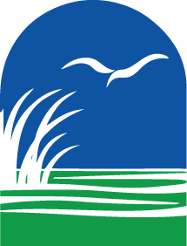

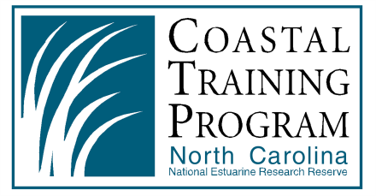

**The North Carolina National Estuarine Research Reserve’s Coastal Training Program Presents:**

*Estuarine Shorelines: Value, Regulations, and Stabilization*

**Tuesday, September 20, 2011**

Jockey’s Ridge State Park, Nags Head, NC

**Agenda**

**8:30am Registration and Coffee**

**9am Welcome and Introduction**

**9:10am Estuary Value and Functions**

Dr. John Fear, Research Coordinator, NC Coastal Reserve

**9:40am Introduction to the Jockey’s Ridge State Parks Marsh Sill Restoration Site**

Justin Barnes, Jockey’s Ridge State Park & Erin Fleckenstein, NC Coastal Federation

**10:00am Break before field trip and travel to field trip**

**10:25am Field Trip: Jockey’s Ridge State Park Marsh Sill Restoration Site**

Justin Barnes, Jockey’s Ridge State Park & Erin Fleckenstein, NC Coastal Federation

**11:25am Estuarine Shoreline Stabilization Design and Techniques**

Dr. Brian Boutin, Climate Adaptation Project Director, The Nature Conservancy

**12:15am Networking Lunch** (provided)

**1:00pm NC Division of Coastal Management’s Estuarine Shoreline Stabilization Regulations**

Ted Tyndall, Assistant Director of Permits & Enforcement, NC Division of Coastal Management

**1:45pm Climate Change Issues Facing North Carolina Estuaries**

Dr. Lindsay Dubbs, UNC-CH Institute of Marine Sciences

**2:30pm Wrap-up and Evaluations**

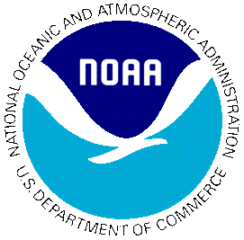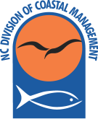

The N.C. National Estuarine Research Reserve is a partnership between the

N.C. Division of Coastal Management & the National Oceanic Atmospheric Administration

**Appendix 5: “Estuarine Shorelines: Value, Regulations, and Stabilization” Workshop Evaluations Summary**



*Estuarine Shorelines: Value, Regulations, and Stabilization*

**WORKSHOP EVALUATION**

1. What would best describe your current position (check the most appropriate)?

_____Local Elected/Appointed Official _____Local Government Staff

__5___State Agency Staff __6___Federal Agency Staff

___2__University/College ___2__Citizen Organization/NGO

___4__Business/Consulting __1___Realtor

___4__Other (land owner, marine contractor, planner/landscape designer)

1. Participating in this event was a good use of my time (circle one):

|  |  |  |  |  |
| --- | --- | --- | --- | --- |
| Strongly Agree  7 (29%) | Agree  17 (71%) | Neutral | Disagree | Strongly Disagree |

1. How much did this training increase your ability to understand the value of estuarine habitats, different shoreline stabilization methods, stabilization regulations, and how sea-level rise may affect estuarine habitats? Circle one:

|  |  |  |  |  |
| --- | --- | --- | --- | --- |
| A Great Deal  1 (4%) | A Lot  9 (38%) | Some  13 (54%) | A Little  1 (4%) | Not At All |

* + 1. If you chose a **‘A Little’** or **‘Not at All’** above, why did you make this choice?

_2__ I already know a lot about this subject

_1__ The training was too basic

___ The training was too advanced

___ The training was not effective

___ Other (please specify)

1. Did you learn something new that you will apply in your work or future decisions? Circle one:

|  |  |  |  |
| --- | --- | --- | --- |
| Yes  16 (67%) | No  1 (4%) | Maybe  7 (29%) | Prefer not to answer/Not Applicable |

* + 1. **If yes**, where would we look in the future to see evidence of that application?
* Additional permit options for land development applicants/clients with major shoreline footage
* Sound side, Cape Hatteras National Seashore
* Shoreline rehabilitation
* Permitting matters with CAMA
* New ways to control shoreline erosion
* Marsh sill
* GP. 2700
* Trying to make living shorelines more easily permittable
* Working with agencies involved in the permitting process
* Coastal reserve program
* Type of shoreline protection and how to fund them
* In my classes
* Water quality BMP design
* In permit application
  + 1. Are there specific obstacles you foresee to applying this information?
* Constructability (available contractors and resources)
* Funding limitations
* Unknown at this time
* Yes, cost
* Utility with single property owners
* Elevation of sill/breakwater
* Federal jurisdiction in the process
* Reluctance to use approaches
* Public perception
* Education and cost
* Funding, stakeholders with conflicting interests
* No
* Budget decreases
  + 1. What additional training or assistance would help address these obstacles?
* Increased public exposure to examples of more non-traditional stabilization methods
* Brief seminar on available funding sources and partnership opportunities
* Education of political entities
* Ability to communicate with agency personnel, university researchers, regulators, on ideas for problem solving
* Consensus on a datum for sill/breakwater ?NWL; BFE; MSL?
* Provide the training for county and town elected officials who seem to think politics prevails over law and science
* Education of local government officials

1. Please rate the following aspects of this workshop on their overall quality and usefulness:

|  |  |  |  |  |  |
| --- | --- | --- | --- | --- | --- |
|  | Very Satisfied | Satisfied | Neither Satisfied nor Dissatisfied | Dissatisfied | Very Dissatisfied |
| Speakers | 12 (52%) | 9 (39%) | 2 (9%) |  |  |
| Training Content | 9 (39%) | 11 (48%) | 3 (13%) |  |  |
| Training Format | 7 (30%) | 13 (57%) | 3 (13%) |  |  |
| Organization of Training | 10 (43%) | 13 (57%) |  |  |  |
| Field Trip | 11 (48%) | 12 (52%) |  |  |  |
| Networking Opportunities | 14 (61%) | 6 (26%) | 3 (13%) |  |  |

* Speakers were very knowledgeable!!!

1. What was the most valuable thing you learned today?

* Multiple types of shoreline stabilization techniques
* Various available permitting strategies and success stories
* I was particularly interested in Ted Tyndall’s (CAMA) presentation. As a new property owner his talk answered many of my CAMA concerns
* Dr. Boutin and Dr. Dubbs were very informative
* See first-hand a project and hear about the trials in doing it
* Meeting the participants
* GP. 2700
* CAMA regs/ permitting info.
* Seeing examples and locations of specific shoreline structures and types
* Permit options under GP.
* How different agencies are working together
* Many agencies and property owners are faced with similar challenges
* More ways to think about climate change networking
* Specifics about stabilization techniques
* Gathering with people from lots of organizations
* Different sill and construction techniques
* Shoreline stabilization methods
* Loved the diversity of participants

1. What changes would you make in this type of training?

* I would like to see this workshop expanded to be focused on realtor/developers interests. I think we could have gone more in depth on permitting process and what to expect, how to navigate through it. We didn’t touch on homes at all which would be nice.
* Private consultants/contractors as part of the panel
* Offer suggestions for funding
* No suggestions
* Be sure to walk the field trip beforehand. Today could have been difficult for certain people.
* None
* Organization of speakers
* More step by step examples of what works and what doesn’t work
* Include a list of attendees with contact info.
* Provide information on agencies involved and provide contact information
* Too general
* Provide list of participants (emails and titles)
* More site visits—diversity of shoreline stabilization options

1. What topics would you recommend for future trainings?

* Riparian buffers in construction with stabilization
* Hybrid shoreline protection solutions
* Invasive species mgmt.
* Funding and partnership opportunities
* More on “living shorelines”
* Application of shoreline stabilization
* Phragmites—what is known about eradication/control? Is it worth trying to control-a waste of resources? Native genotype? Why should we care?
* Funding opportunities SLR
* Rain gardens, native planting or gardening, landscaping for natural habitats
* Constructability, costs, identification of design aids and objectives
* Public private partnerships
* More field trips to see actual construction and completion of projects
* Detailed training for contractors—get them to feel comfortable designing and building hybrid stabilization techniques

**Appendix 6: Social Media Public Information Campaign**

Albemarle-Pamlico National Estuary Program ***2011 Estuary Education and Awareness Campaign:***

***Public Information Campaign***

**Twitter and Facebook Posts**

**(July 6)** The NC Coastal Reserve (#NCS2RY) is starting a Did You Know (DYK) campaign about NC estuaries, shoreline stabilization, and sea-level rise

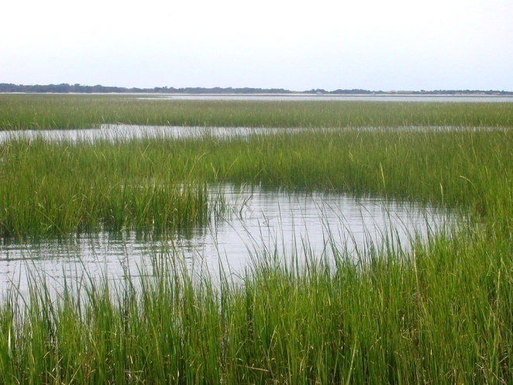The NC Coastal Reserve (<http://bit.ly/jiThaZ>) is starting a Did You Know (DYK) campaign about NC estuaries, shoreline stabilization, and sea-level rise. This is part of the 2011 Estuary Education and Awareness Campaign, funded by the Albemarle-Pamlico National Estuary Program (APNEP).

**(July 8)** DYK? APNEP is one of the 1st national estuary programs established by the EPA in 1987-check out their website <http://bit.ly/hlfVSk> #NCS2RY

DYK? APNEP was one of the 1st national estuary programs established by the EPA in 1987. Jointly sponsored by NCDENR and the EPA with VA Dept. of Conservation and Recreation—check out their website <http://bit.ly/hlfVSk> and click here for the counties and river basins in the APNEP region <http://bit.ly/iWHZQE>.

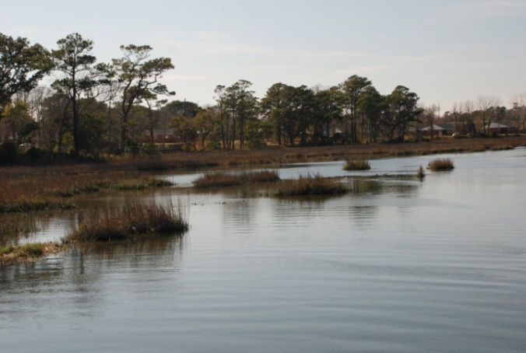

**(July 13)** DYK? An estuary is the coastal ecosystem where fresh water from rivers meets ocean water; NC has 2.2 million acres of estuaries! #NCS2RY

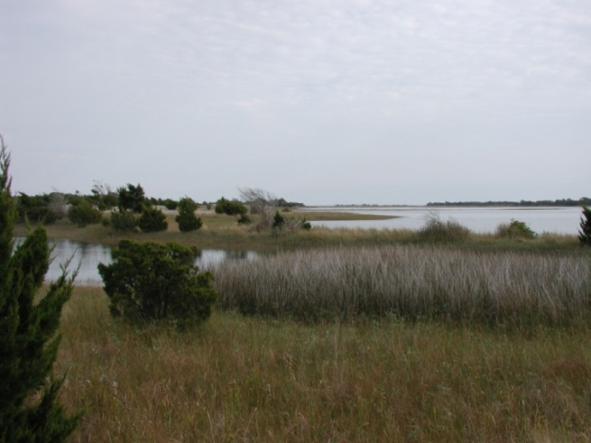DYK? An estuary is the coastal ecosystem where fresh water flowing from the rivers meets the salty ocean water. In NC we have 2.2 million acres of estuarine habitat! Click here for more info <http://1.usa.gov/imi45k>

**(July 15)** DYK? NC estuaries are made up of many different shoreline habitats—see for yourself at <http://bit.ly/ml0xGh> #NCS2RY

DYK? NC estuaries are made up of many different shoreline habitats, including swamps, marshes, beaches, and oyster reefs. See for yourself at <http://bit.ly/ml0xGh>

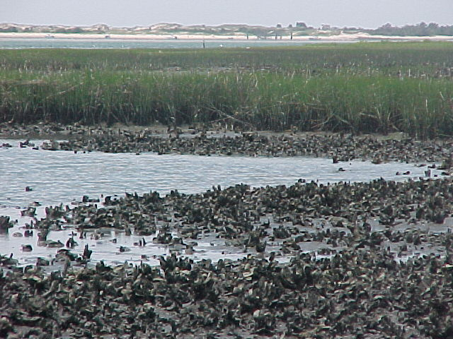

**(July 20)** Come join us on a free field trip! August 11 & 12 kayaking, a nature walk, & an estuary exploration <http://bit.ly/q9RE1D> #NCS2RY

Come join us on a free field trip in the estuaries of the Outer Banks! August 11 is kayaking and a nature walk for the whole family; August 12 is your chance for an estuary exploration. You can find more information here <http://bit.ly/q9RE1D>

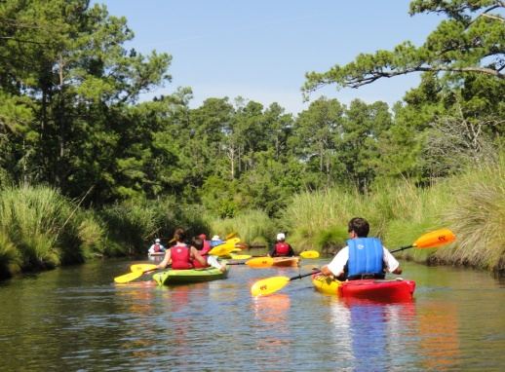

**(July 22)** Calling all educators! Come to the NC Coastal Reserve and NC Sea Grant’s Coastal Explorations Workshop Aug. 23 <http://bit.ly/m0xsoS> #NCS2RY

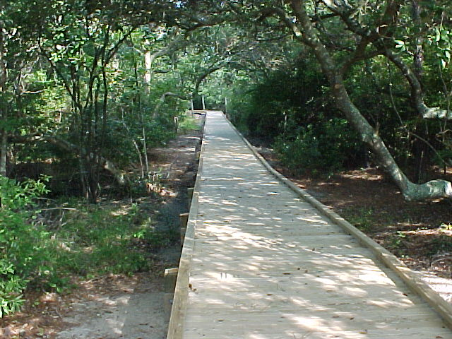Calling all educators! Join us at the NC Coastal Reserve and NC Sea Grant’s Coastal Explorations Workshop on Aug. 23. Get teacher renewal credits and environmental educator credits for free! <http://bit.ly/m0xsoS>

**(July 27)** DYK? 95% of NC’s seafood species, such as shrimp, flounder, oysters & crabs depend on estuarine waters for growth and survival. #NCS2RY

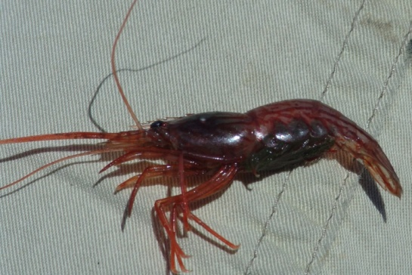DYK? 95% of NC’s seafood species, such as shrimp, flounder, oysters, & crabs depend on estuarine waters for growth and survival. There is a direct link between the amount of salt marsh cordgrass found in our estuaries and the health of our fisheries. Adult fishes, such as sea trout and red drum, prowl the edges of the marshes feeding on shrimp and other prey that live in the vegetation. See the Reserve’s lesson plan (<http://bit.ly/lrHlbb>) to see the major salt marsh players!!

**(July 29)** DYK? What can your estuary do for you? Go to <http://bit.ly/kyDOfp> to learn how estuaries help humans and why we should conserve them! #NCS2RY

DYK? What can your estuary do for you? Worldwide, estuaries store 7200 teragrams of carbon a year—that is 3-7% of all human-produced emissions! Go to <http://bit.ly/kyDOfp> to learn how estuaries help humans and why we need to conserve them!

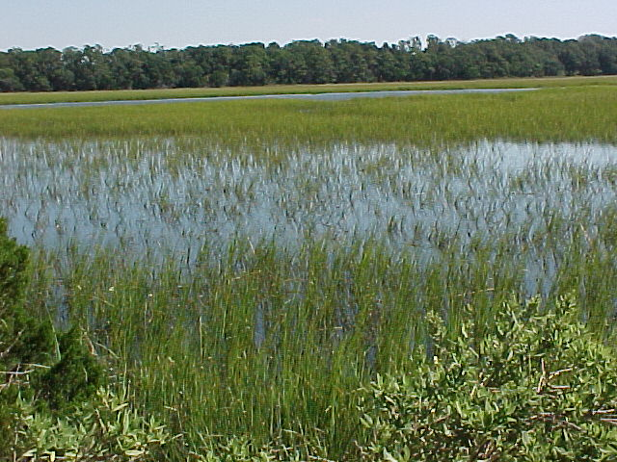

**(August 3)** DYK? Marshes are one of the most productive areas on earth and there are around 200,000 acres on the NC coast! <http://bit.ly/iVjvaR> #NCS2RY

DYK? There are around 200,000 acres of salt marsh along the NC coast! The coastal marsh is one of the most productive areas on earth, producing up to 70,000 lbs of plant material per acre per year. Check it out—a small but critical habitat <http://bit.ly/iVjvaR>

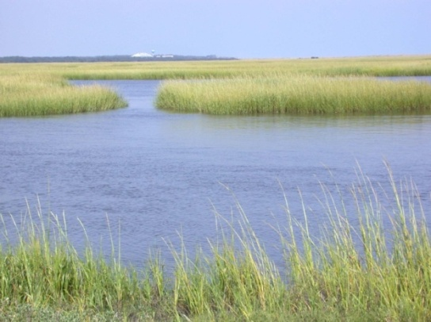

**(August 5)** DYK? Wetlands (<http://1.usa.gov/e9RA36>) remove 20-60% of metals in the water & retain 80-90% of sediment from runoff from the shore #NCS2RY

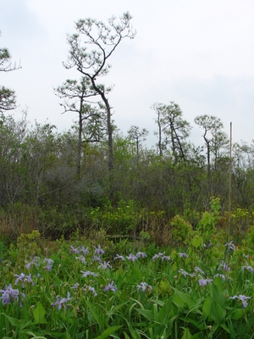 DYK? Wetlands remove 20-60% of metals in the water, trap and retain 80-90% of sediment from runoff, and eliminate 70-90% of entering nitrogen. Find out more about wetlands here <http://1.usa.gov/e9RA36>

**(August 10)** DYK? There are5 reserve sites in the APNEP watershed (<http://bit.ly/pgcz6Q>). See pictures of them here <http://bit.ly/iV2Me3> #NCS2RY

DYK? There are5 reserve sites in the APNEP watershed (Currituck Banks, Kitty Hawk Woods, Buckridge, Buxton Woods, & Rachel Carson) <http://bit.ly/pgcz6Q>. See pictures of them here <http://bit.ly/iV2Me3>

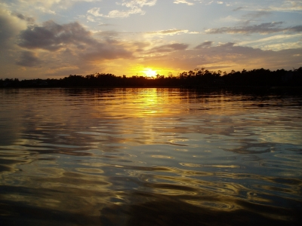

**(August 12)** DYK? 12 NC rivers flow into the ocean-7 of these empty into estuaries. What APNEP river basin do you live in <http://bit.ly/iWHZQE>? #NCS2RY

DYK? 12 NC rivers flow into the Atlantic Ocean—7 of these empty into estuaries. Think about what you do in your yard, your home--what you do upstream affects the estuary downstream. What APNEP river basin do you live in? <http://bit.ly/iWHZQE>

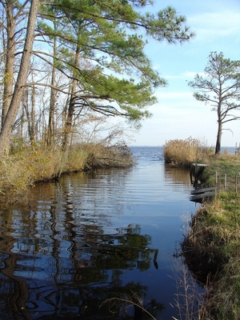

**(August 17)** DYK?Plants that grow underwater are an important estuarine habitat. Look here to find out more <http://bit.ly/mBGS74> #NCS2RY

DYK?Plants that grow underwater are an important estuarine habitat. Submerged Aquatic Vegetation, also known as SAV, is a critical nursery for our oceans. Look here to find out more <http://bit.ly/mBGS74>

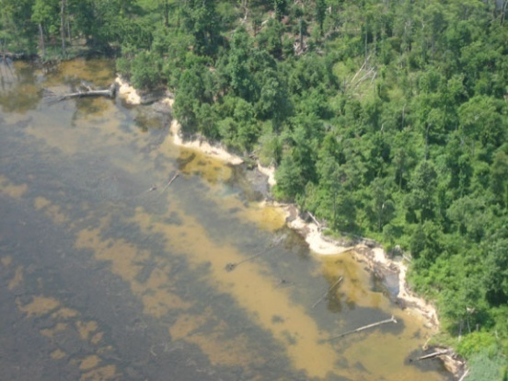

**(August 19)** Join us at the Estuarine Shorelines: Value, Regulations, and Stabilization Workshop, Jockey’s Ridge Sept 20 <http://bit.ly/oFP3yB> #NCS2RY

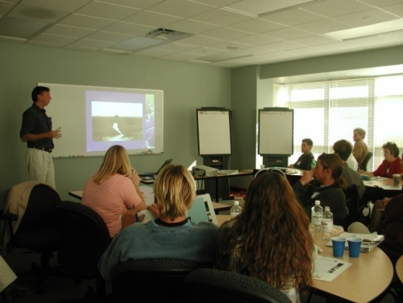 Calling all marine contractors, environmental consultants, estuarine-front property owners, developers, and realtors!! Join us at the Estuarine Shorelines: Value, Regulations, and Stabilization Workshop held at Jockey’s Ridge State park on Sept. 20th. For registration click here- <http://bit.ly/oFP3yB>

**(August 24)** DYK? We held 3 wonderful public field trips to create estuary awareness-including kayaking Kitty Hawk Woods & a Currituck boardwalk #NCS2RY

DYK? We held 3 wonderful public field trips to create estuary awareness-including kayaking through Kitty Hawk Woods & a Currituck boardwalk trip. Thanks for joining us!

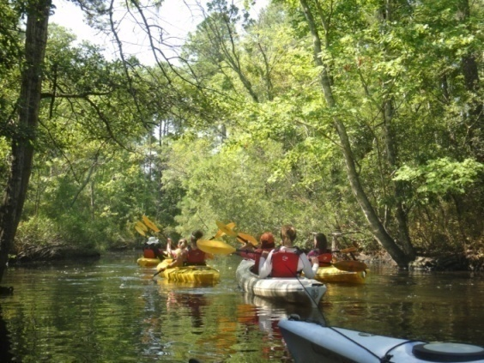

**(August 26) Delayed post due to hurricane**

**(August 31)** DYK? Shoreline stabilizationis used to provide protection from erosion. Check out your options here-- <http://bit.ly/ksAYg8> #NCS2RY

DYK? Shoreline stabilizationis very site specific and is the use of structures, vegetation, or land management practices to provide protection of a shoreline from future or existing erosion. Click here to see your stabilization options-- <http://bit.ly/ksAYg8>

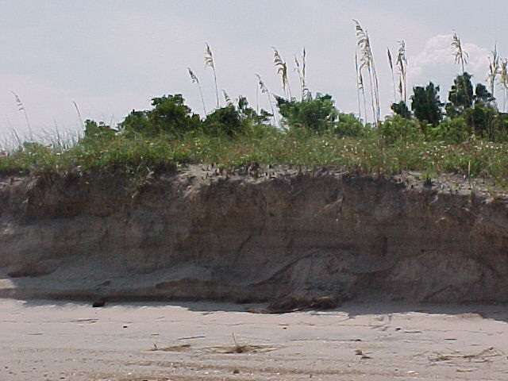

**(September 2)** DYK? Living shorelines use natural habitat to protect shorelines from erosion AND provide habitat for wildlife <http://bit.ly/jAa2Hm> #NCS2RY

DYK?Living shorelines are shoreline stabilization techniques that use natural habitat elements to protect shorelines from erosion while also providing critical habitat for wildlife. For more information <http://bit.ly/jAa2Hm>

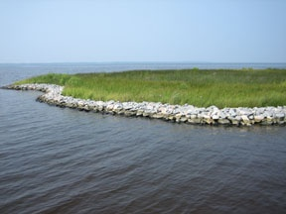

**(September 7)** DYK? We had a great turnout of educators for our Coastal Explorations Workshop. See pictures taken by APNEP <http://bit.ly/qn3Gcy> #NCS2RY

DYK? We had a great turnout of educators for our Coastal Explorations Workshop. See the pictures taken by APNEP during the workshop here <http://bit.ly/qn3Gcy>

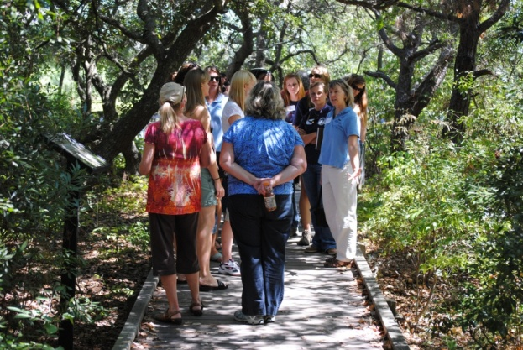

**(September 9)** DYK? 1 adult oyster is capable of filtering 15-35 gallons of water each day and they stabilize shorelines! See <http://bit.ly/lMtvg1> #NCS2RY

DYK? A single adult oyster is capable of filtering 15-35 gallons of water each day! See <http://bit.ly/lMtvg1> to watch oysters filter water. Oysters can also be used to stabilize estuarine shorelines—read about living shorelines here <http://bit.ly/jAa2Hm>

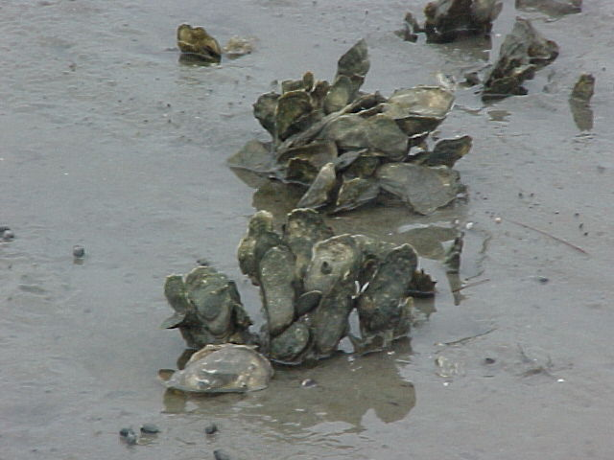

**(September 14)** DYK? Sept 24 is National Estuaries Day! See what you can do to get involved [http://1.usa.gov/msIaac](http://1.usa.gov/msIaac%20%20)  or locally <http://bit.ly/nGyuBJ> #NCS2RY

DYK? Sept. 24 is National Estuaries Day! Check here to see what you can do to get involved--[http://1.usa.gov/msIaac](http://1.usa.gov/msIaac %20) or for eastern North Carolina locals <http://bit.ly/nGyuBJ>.

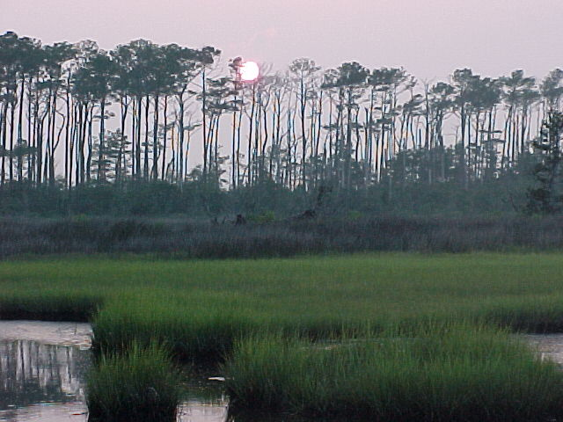

**(September 16)** For more information on sea-level rise and how it may affect NC check out the Div. of Coastal Mgmt’s webpage <http://bit.ly/kEqzRj> #NCS2RY

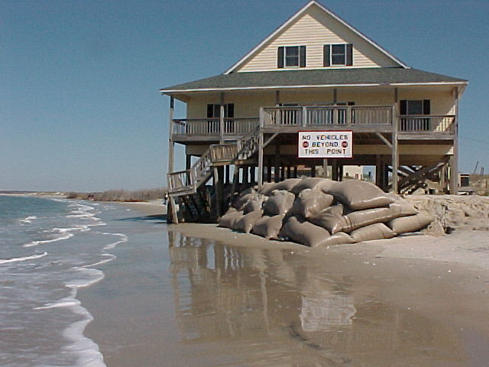What is sea-level rise? Is it going to affect NC? Why should I care about sea-level rise? For more information on sea-level rise and how it may affect you in NC check out DCM’s webpage <http://bit.ly/kEqzRj>

**(September 21)**  Please comment on the **Coastal Resources Commission’s draft sea-level rise policy statement. Go to** <http://bit.ly/meguLC> #NCS2RY

Please comment on the **Coastal Resources Commission’s draft sea-level rise policy statement. Go to** <http://bit.ly/meguLC> **and read the report so you can offer your valuable input to policies affecting our beautiful coast!**

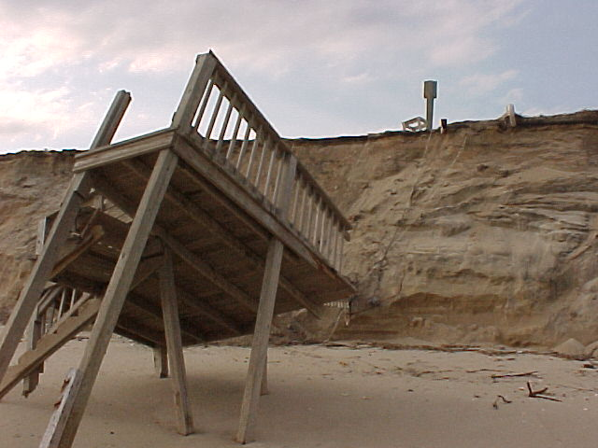

**(September 23)** Do you visit the Outer Banks?What will sea level rise mean for barrier islands? Check out this article-- <http://bit.ly/k3YtWZ> #NCS2RY

Do you live on orvisit the Outer Banks?What will sea level rise mean for barrier islands? Check out this article-- <http://bit.ly/k3YtWZ>



**(September 24)** DYK? Today is National Estuaries Day! Check here to see what you can do to get involved--[http://1.usa.gov/msIaac](http://1.usa.gov/msIaac%20%20) #NCS2RY

DYK? Today is National Estuaries Day! Check here to see what you can do to get involved--[http://1.usa.gov/msIaac](http://1.usa.gov/msIaac %20)

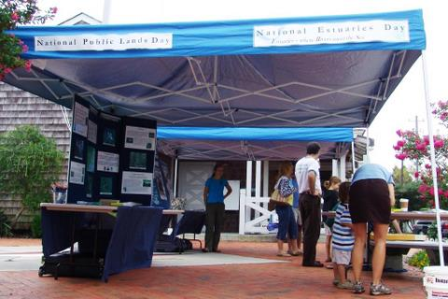

**(September 28)** DYK? We had a great turn out for the Coastal Training Program’s <http://bit.ly/rgGsWF> Estuarine Shorelines Workshop at Jockey’s Ridge #NCS2RY

DYK? We had a great turn out for the Coastal Training Program’s Estuarine Shorelines Workshop at Jockey’s Ridge. Look here <http://bit.ly/rgGsWF> for this workshop to be held in central and southern North Carolina this spring.

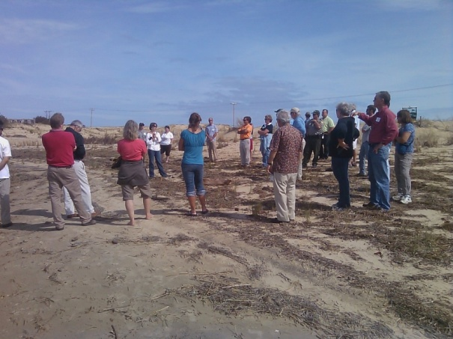

**(September 30)** DYK? Living shorelines weather strong storms. This photo <http://bit.ly/rpi2C2> compares Jockey’s Ridge marsh sill pre and post Irene #NCS2RY

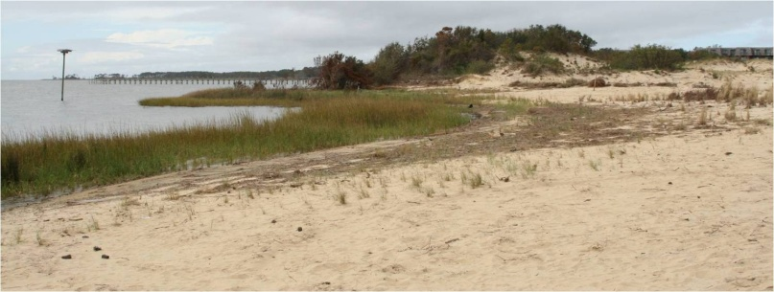DYK? Living shorelines weather strong storms. This photograph (<http://bit.ly/rpi2C2>) compares Jockey’s Ridge State Park’s marsh sill restoration project before and after Hurricane Irene. As you can see, the living shore held up very well through the storm.