Elizabeth City Middle School
Created Wetland

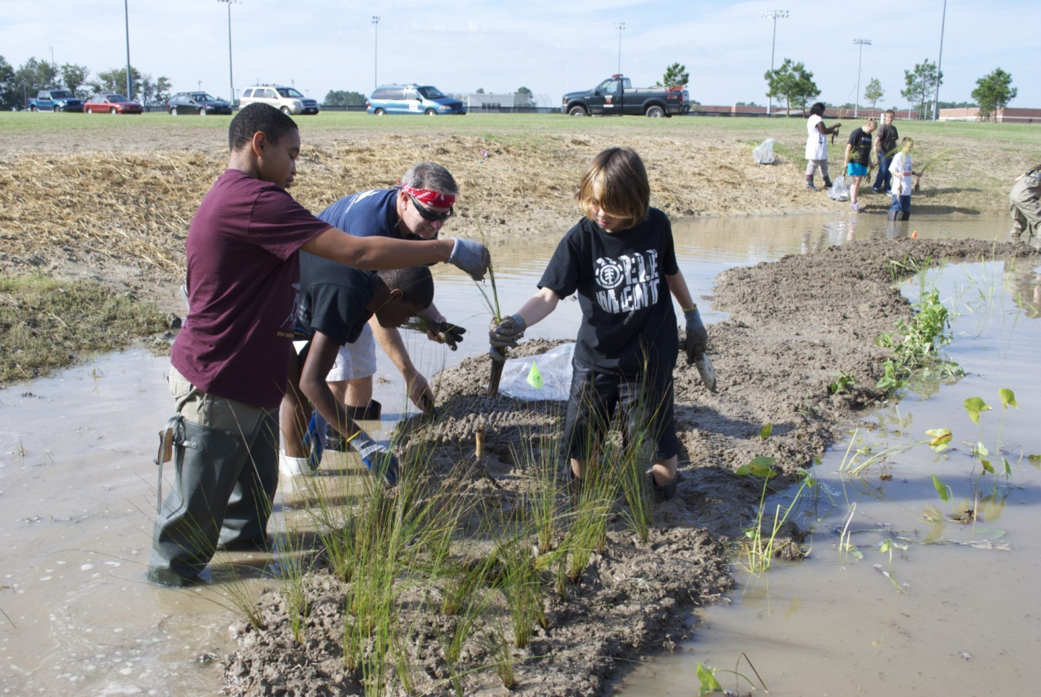

Final Project Report

Project Location:
Elizabeth City Middle School
1066 Northside Road Elizabeth City, NC 27909
Pasquotank River Basin

Prepared by
Robert McClendon
UNC Coastal Studies Institute
217 Budleigh Street, Manteo, NC 27954
csi.northcarolina.edu

funded by the
Albemarle-Pamlico National Estuary Program
Project Description

The Elizabeth City Middle School campus is built adjacent to the Pasquotank River with a buffer of forested wetlands between the school and the river. Where a soccer field ends – a significant cypress swamp forest begins. Stormwater from the school buildings and parking lots is conveyed to open ditches and swales that come together at a single point before exiting the upland portion of the property into the swamp forest of the Pasquotank.

This project received funding to construct a wetland on the upland portion of the school property at the point where the ditch and swale systems come together – to intercept the school’s stormwater before it enters the natural wetland systems of the Pasquotank River. The new created wetland assists with sediment reduction, reduced water velocity and reduced nutrients and other toxicants from the stormwater before it enters the natural wetland. This project provides a learning environment for students and faculty of Elizabeth City Middle School as well as for the adjacent elementary and high school populations. Parents and visitors to the campus now have access to the wetland learning environment as well. Future plans include projects to construct a boardwalk into the natural wetland and more extensive educational signage.

The created wetland engages the students and faculty to better understand the natural environments at the land – water interface and involves the students directly in improving water quality from non-point sources in the Pasquotank River Basin. The students and faculty currently have no access to the natural forested wetland because the buffer area is heavily vegetated and wet. This physical separation of the students from these natural ecosystems prevents an understanding of the direct cause-and-effect relationship of development – specifically stormwater runoff – and natural systems. The created wetland project provides direct access to a learning environment that demonstrates the land-water interface for students and visitors.

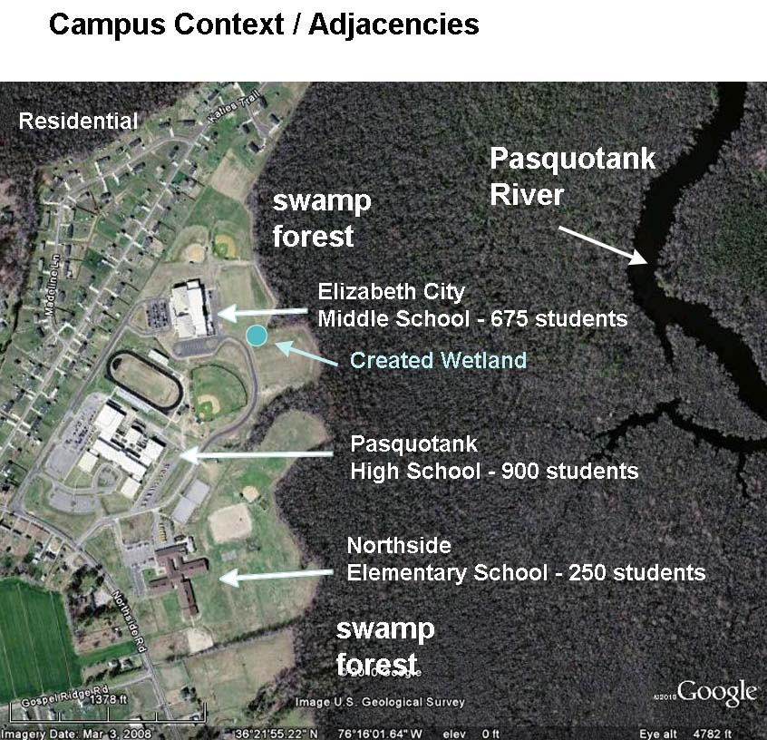
1 Campus context and adjacency to other schools and the Pasquotank River
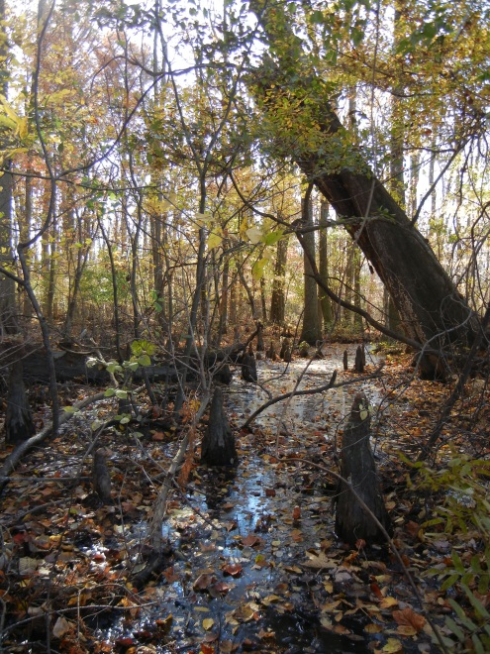
2 Natural wetland area adjacent to school soccer fields.
This constructed wetland project was a collaborative effort between several local organizations to physically connect to the natural environment for observation, education and water quality testing. The Albemarle RC&D Council supervised wetland construction. The UNC Coastal Studies Institute provided landscape design, the planting plan and coordinated planting activities with the students. UNC-CSI also works closely with middle school science teachers and students to develop and implement wetland education and water quality monitoring curriculum activities. The Natural Resources Conservation Service provided technical assistance during construction of the wetland. Elizabeth City State University has volunteered to partner with the school to engage students in lessons relating GIS tools and how they can be used to promote better stewardship through community education of environmental systems.

Environmental Benefits

Improved water quality and increased wildlife habitat are the primary environmental benefits of this project as students continue to learn about water quality and testing. One hundred percent of the conveyed stormwater on the Elizabeth City Middle School campus is treated by the created wetland. The constructed wetland allows suspended sediments to drop out of the water column and slows the velocity of stormwater conveyance. The plants in the wetland take up nutrients and fix other pollutants to prevent them from entering the natural wetland and the Pasquotank River. Native plants were used in the wetland, contributing to increased wildlife habitat.

Educational Outreach

The created wetland and boardwalk have attracted many public visitors to the school campus during sports events at the nearby athletic fields.

The teachers of 8th grade science at have engaged their students in the natural environment surrounding the school. Educators from the UNC Coastal Studies Institute and from Elizabeth City State University have visited the classes and provided lessons on watershed point and non-point source pollution, GIS and science & technology lessons.

UNC-CSI educators have had direct contact with students in their classroom with curriculum including wetland introduction and pre-construction site visit with the students. Classroom topics have included impervious surfaces, run-off, wetland characteristics, etc. On the planting day student teams were assigned a specific plant and learned the botanical and common names as well as the environmental parameters and then planted their assigned planting area.
Lectures by UNC-CSI educators have included the importance of water quality and included field work in the site taking water quality measurements.

Students continue to collect water quality data from the wetland on their own, about once a month. Parameters tested: pH, DO, Nitrogen, Phosphates, Water Temperature, Air Temperature, Turbidity and Alkalinity. Students regularly visit the wetland and continue to make observations and gain an understanding of what types of organisms are found in the school's surrounding environment.

New curriculum has been developed using the wetland as a focal point in the areas of science, math and language arts. Students have calculated the amount of stormwater the campus produces during a given rain event and learned about the relationship between stormwater runoff, wetlands and water quality. To promote improved reading and writing skills, students have been given reading assignments that focus on wetlands and natural habitats. Assignments have included poetry and story composition around these themes with the created wetland available as a point of creative inspiration.

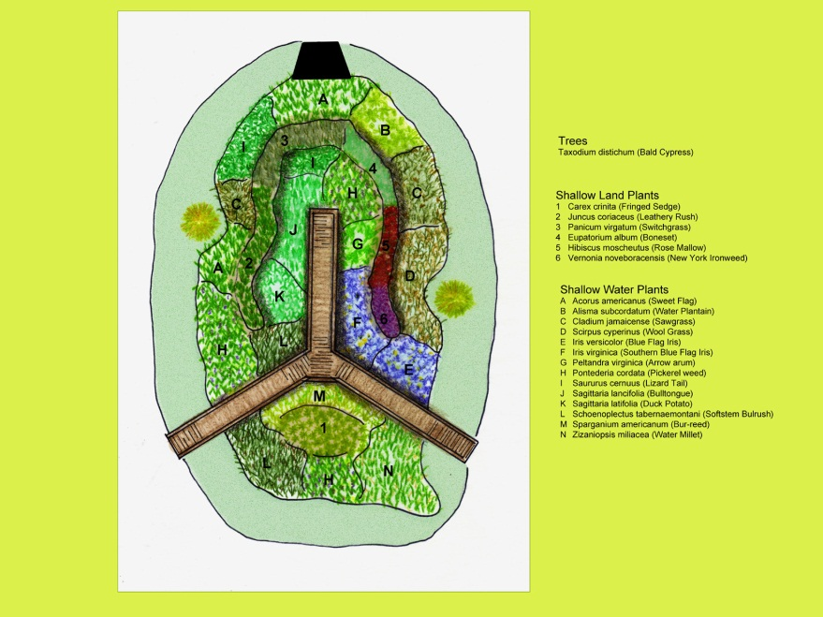
3 The wetland planting plan creates a botanical garden of native wetland vegetation for student education activities.
Students enjoyed participating in the design, construction and planting of the wetland and gained the additional educational benefit of learning about professions and trades involved in environmental design, coastal science, conservation, construction and education careers.

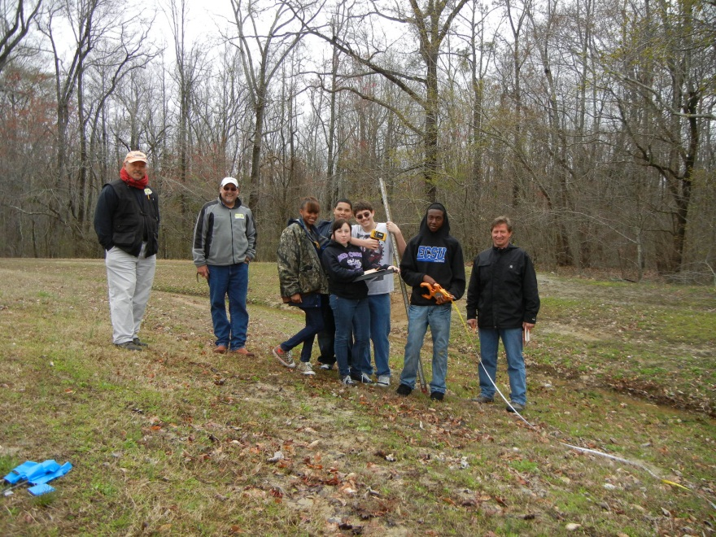
4 Students learned about land surveying techniques and equipment when laying out the wetland location.

Climate Change

One potential effect of climate change is the expectation of more frequent and intense weather events for the APNEP region. The created wetland at Elizabeth City Middle School intercepts and reduces the velocity of stormwater runoff resulting from weather events.

Reducing non-point source water pollution helps protect the viability of the swamp forest along the Pasquotank River. Forested lands account for about 56% of the state’s land area and are an important resource for carbon dioxide sequestration. Carbon dioxide is sequestered in forest carbon pools such as live trees, debris on the forest floor, and in forest soils.

Additional wetland acreage helps accommodate storm surges resulting from more frequent and intense weather events in the Pasquotank River Basin.

Water Quality

Installation of the wetland as an on-site stormwater best management practice (BMP) has provided a demonstration opportunity as well as the mechanism for the reduction of nonpoint source pollution. The BMP installed at Elizabeth City Middle School is a created stormwater wetland. One hundred percent of the conveyed stormwater on the Elizabeth City Middle School campus passes through the created wetland. The wetland allows suspended sediments to drop out of the water column and slows the velocity of stormwater conveyance. The plants in the wetland take up nutrients and fix other toxicants to prevent them from entering the natural wetland and the Pasquotank River.

Students have been equipped with water quality testing kits and monitor water quality before and after storm events.

Transferability

The UNC Coastal Studies Institute has implemented water quality demonstration sites at Manteo High School, First Flight High School, Nags Head Harvey Soundside access and Cape Hatteras Secondary School. Each of these demonstration projects has had a significant public outreach component with educational signage and press coverage. The school projects have ongoing educational activities associated with curriculum matched to State of NC learning objectives.

The Albemarle RC&D Council and local partners have constructed wetlands and outdoor environmental education classrooms at River Road Middle School in Elizabeth City, Winfall Elementary School, and Perquimans County High School in Hertford. A stormwater wetland in Edenton serves as an outdoor classroom for High School science students and the general public. The wetland/outdoor classroom at Perquimans County High School was constructed with two grants from APNEP.

The Albemarle RC&D Council and local partners design wetlands that are appropriate for the unique hydrology and ecology of northeastern North Carolina. NC State University has monitored and documented the efficacy of some of these wetlands for many years. The design of outdoor environmental education classrooms requires significant input from school administrators, teachers and students and is unique to each school. Involving stakeholders in the planning, design and construction process is a key component of all projects.
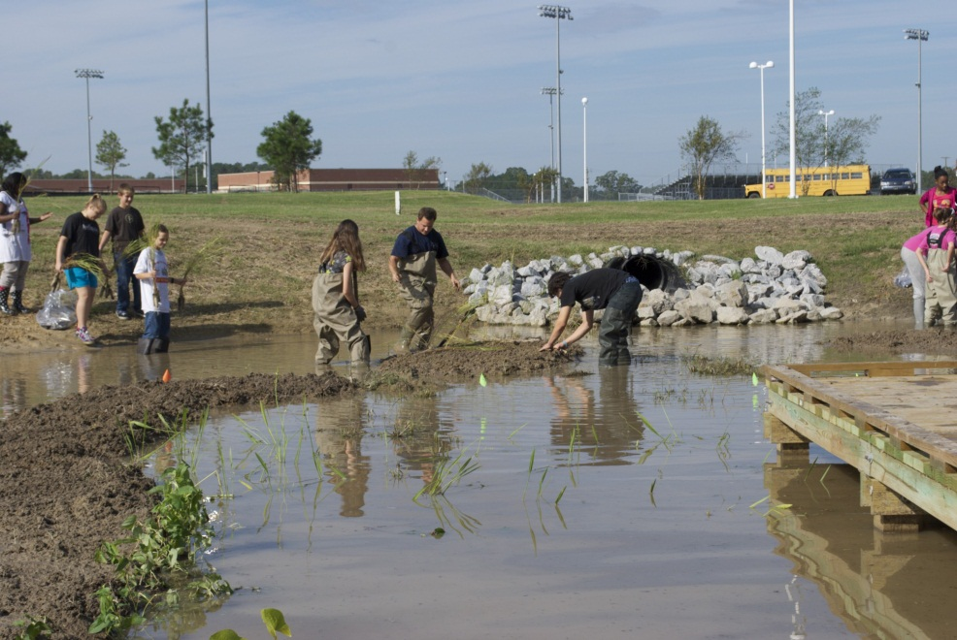
5 John McCord of UNC-CSI (center) assists students during the wetland planting.

Monitoring Activities

Students were given a survey prior to the wetland installation to measure their understanding of wetlands ecology and environmental function. After the lessons and educational activities surrounding the wetland were delivered, the students were re-tested to measure how well the wetland education activities improved their understanding of water quality and the effects of stormwater on the environment.

As part of the wetland education activities, students were supplied with water quality testing kits that stress the importance of using analytical methods and encourages proper field investigation techniques by use of representative sampling, careful observation, accurate record keeping, and systematic measurement to plot changing conditions.

Students have been testing seven basic water quality test factors including: pH, nitrate-nitrogen, phosphate, dissolved oxygen, alkalinity (total), turbidity, and temperature.

The UNC Coastal Studies Institute has developed an ongoing teaching relationship with instructors at the school and continue to assist with monitoring flow of the wetland and the success and growth of the native plant species in the wetland for the coming years. Success will also be measured based on capacity of the wetland to accommodate average and above average storm events and the viability of the wetland plant species installed.

Equipment and supplies purchased with grant funds ensures the school will be able to continue the education and monitoring activities established by UNC-CSI educators. Some of the equipment and supplies provided to the school include: boots and waders; a flex camera and projector (which allows Mr. Walker to display computer images and microscopic organism on the board); water quality testing kits; nets for organism collection; lab aprons and gloves for water quality lab; microscopes; magnifying glasses for field observations; basic tools such as shovels, trowels and gloves for outdoor activities.

Albemarle-Pamlico CCMP

This project addresses APNEP’s CCMP Water Quality Goal (Objective B) to Reduce Sediments, Nutrients and Toxicants from Nonpoint Sources. The CCMP Stewardship Goal to Promote Responsible Stewardship of the Natural Resources of the Albemarle-Pamlico Sounds Region is addressed (Objective C) to Ensure that Students, Particularly in Grades K-5, are Exposed to Science and Environmental Education.

