APNEP Citizen Advisory Committee: 2024 Member Questionnaire
Including in this report are the results from the questionnaire staff and co-chairs facilitated to get feedback and input from members to identify gaps in the committee’s representation and defining the CAC’s role in guiding APNEP’s effort for supporting planning and implementation work in the region.
This summary includes graphics for multiple choice questions and summarizes results of overarching trends in members feedback related to topic areas, along with individual responses if you wish to see more specific answers for context.
We encourage all members and APNEP staff to review these results to be on the same page to better direct our efforts for the coming year, particularly as the NEP leadership decides where federal and date resources (EPA BIL and 320 funding) will be allocated. Our hope is that this exercise will bolster some energy and focus for what the committee can discuss at an in-person and virtual meeting and inform the work staff does, and the decisions the Leadership Council will decide support in the near and long-term.
The survey is still accessible via website and QR code in the header.

Questionnaire Results
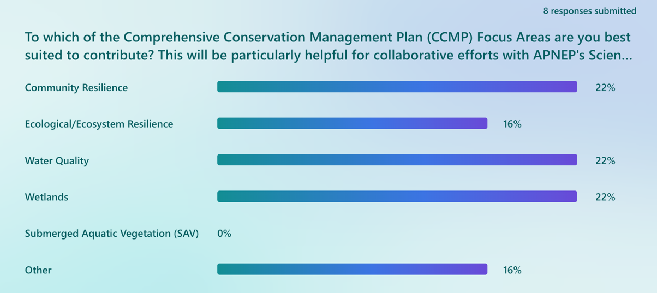Note: CAC Members who responded “Other” mentioned: Land-use (ag, forestry, solar, zoning); Collaborating with local governments, community planning, stakeholder engagement, partnership building, ideation, floodplain management.
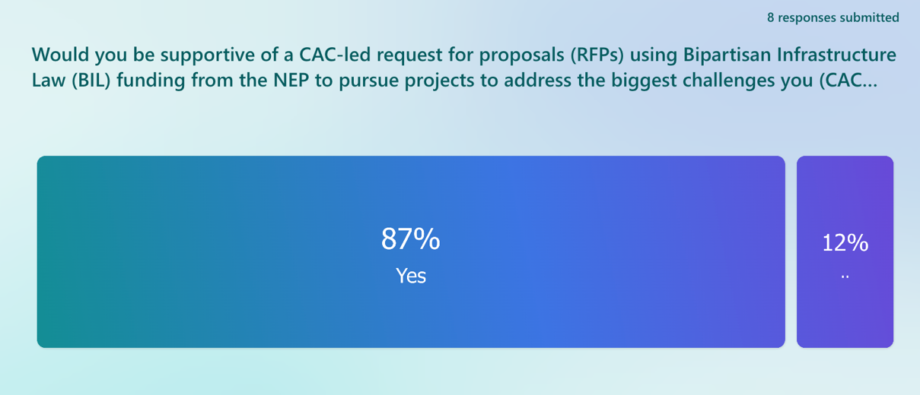
If you answer to Question #7 is "No", what information could staff provide that would find helpful to you?
- I know most of the APNEP staff, but sometimes, I am not clear about all the possible ways that APNEP staff could support us with the local environmental/educational work we do.
- Would like to help but recent staffing issue has put a limitation on my time.
- I am still fairly new to the CAC and figuring out how I can be useful.
- What are the specific ways CAC members can engage and participate? What do we do? How do would we go about getting an item on the agenda for discussion?

Note: Our hope is that the results of this questionnaire, and our discussions following, will move all members towards defining the role of the CAC for mutually understanding of what the committee does, and how what it’s focuses are.
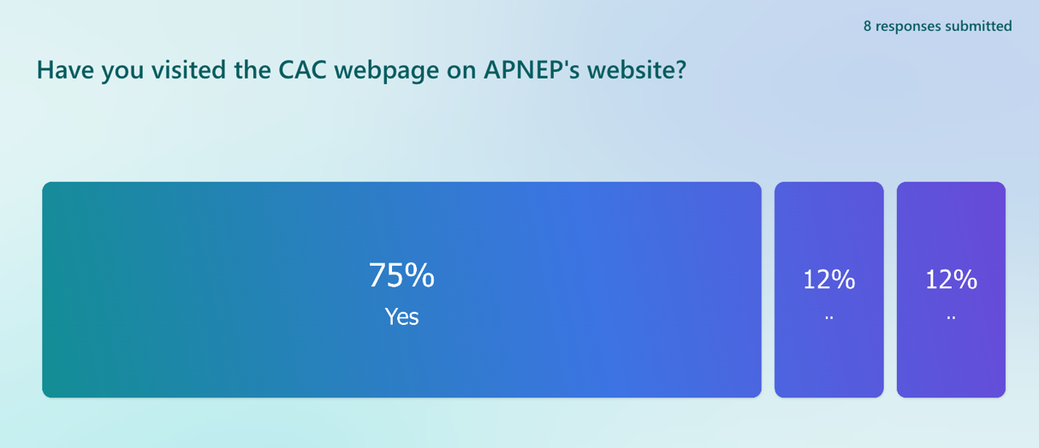
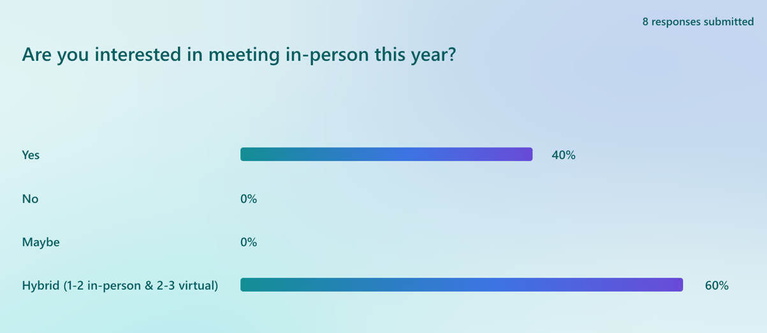
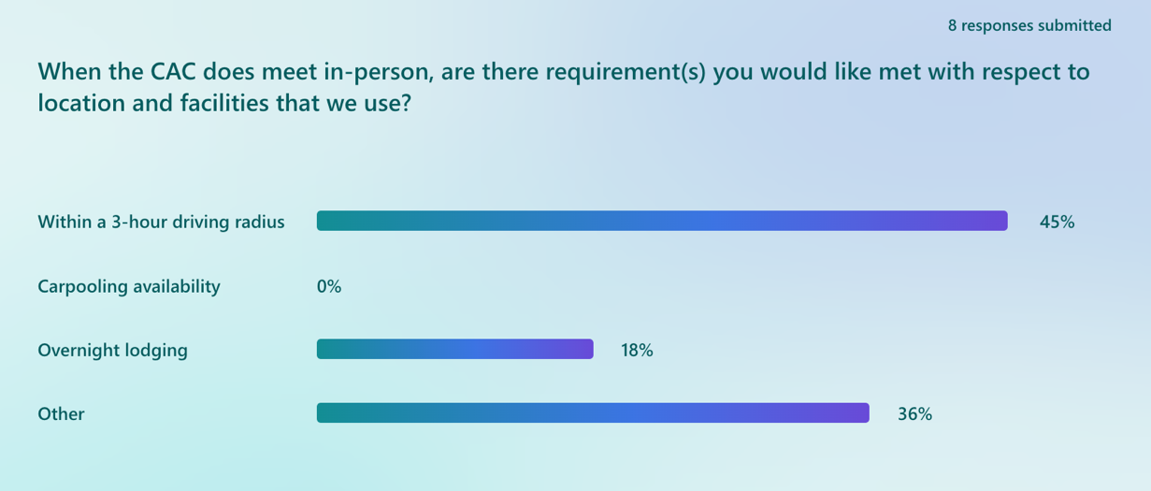
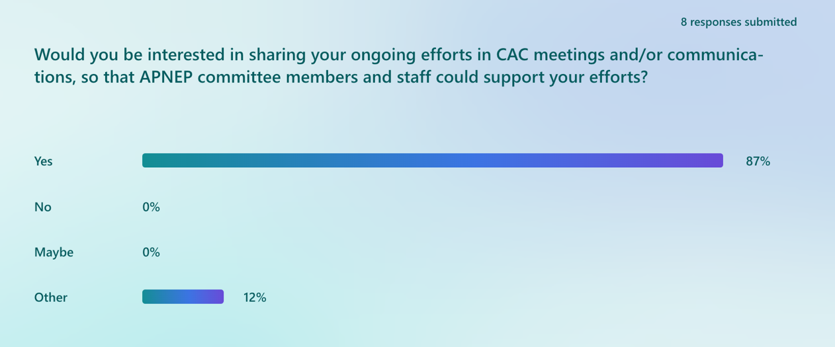Note: Those who responded other mentioned not currently being involved in any ongoing efforts in the region; however, these are good members for offering historical insights into approaches they have seen that work or are not as successful.
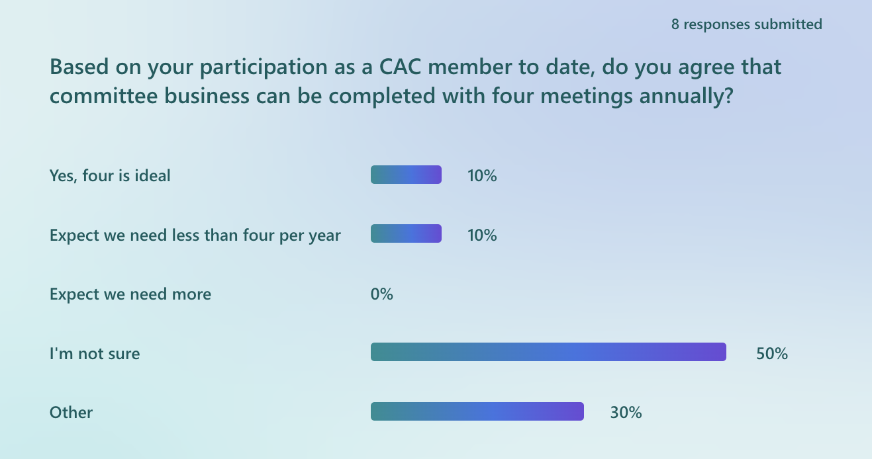Note: Several comments from members regarding meeting frequency
- Expect we need more that 4 initially, if you can get everyone to agree. Then fall back to 4 when things are on track
- Expect we need less than four per year;3-4 max but more sooner to kickoff and gel is good given BIL.
- If we try to encourage more discussion or involvement of committee members, we may need more meetings.

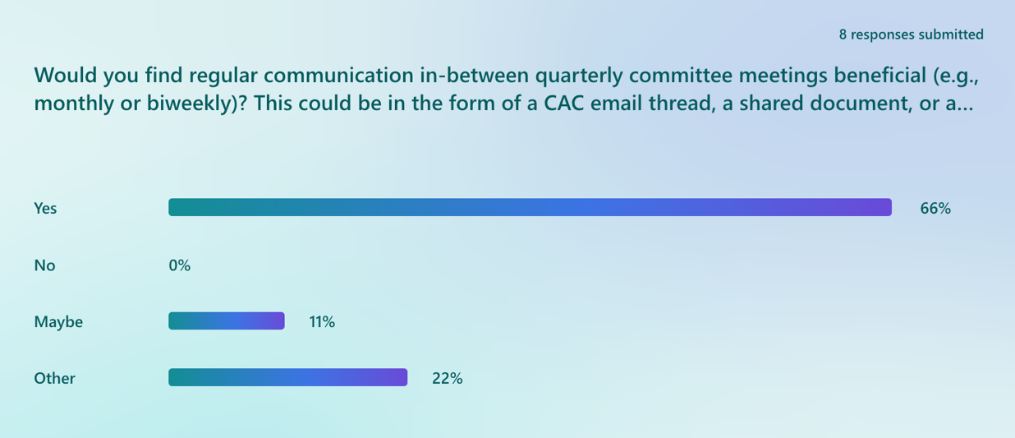Note: Additional input from members: A shared document with some modifications could also be a designated section in the APNEP newsletter; Brief video presentations would be efficient.
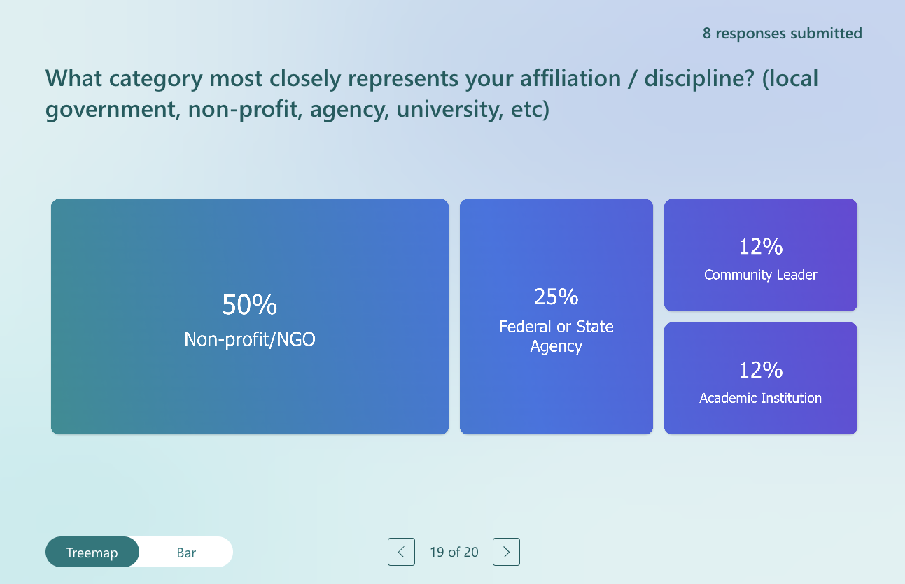
Note: In the future, we need to put more emphasis on Private landowners and community members who have a major impact on land cover, current and future land-use, and can bear a brunt of costs if not compliant with regulations.

What are the biggest challenges communities and ecosystems face in the Albermarle-Pamlico region and where should APNEP focus its resources within the focus areas?
Result: List of overarching topics
- Climate change, flooding, sea level rise, and saltwater intrusion
- Water quality degradation in streams, rivers, and estuaries
- Land-use change and habitat loss
- Wetland loss/protection
- Planning for and adapting to climate change
- Climate retreat
- Environmental justice impacts exacerbated and not resolved
- Vulnerable under-resources communities that are overburdened by environmental change (rural and urban)
- Industrial practices (development, forestry, farming, transportation) and the lack of accountability
- Capacity and funding of local governments to implementation projects
- Political will to adopt regulations needed to address these pressing issues
- Public education
- Moving from plans to implementation
Individual Responses: (see bold)
- In my opinion, the following, not in any particular order, are the challenges APNEP faces: climate change impacts on communities and ecosystems (including retreat options), degrading water quality in the rivers, sounds, lakes and estuaries caused by land use practices and saltwater intrusion.
- Loss of significant wetlands due to clear cutting, channeling, new construction, etc., which is resulting in degraded water quality throughout the region.
- Sea level rise, flooding from extreme weather, loss of wetlands for habitat and protection; development and poor regulations and enforcement, EJ impacts are growing not resolving
- The biggest challenges include coastal development, climate change impacts, and water quality.
- APNEP funding that supports projects that provide research or actions that improve water quality like septic treatment on the coast, improved stormwater treatment within the APNEP watershed, and restoration of coastal habitats.
- Planning for and adapting to the effects of climate change, more frequent storms, higher sea levels, and more precipitation, are our biggest challenges. Many valuable ecosystems are at risk including our wetlands and maritime forests, as well as our human coastal communities.
- Waste water treatment and the viability of septic systems with high ground water levels pose great risks to water quality as well as some of the farming practices including pig and chicken waste storage issues. And there is always a need to educate the public and provide assistance in the adoption of best management practices. In all of these areas collaboration between the two states is critically important.
- Rich natural resources/poor people. This region in its rural parts is essentially colonialized.
- Coastal hazards (flooding, climate change, degradation of ecosystem vitality). Hazards are spatially variable (storm surges, wind tides, pluvial flooding and extreme rainfall), and responding to their increasing risk and impacts poses economic and existential challenges.
- Making hard political decisions for pressing issues (political will), land-use changes that impact water quality/water quantity issues, moving projects identified in plans into action, capacity/funding of local governments to impalement projects that can make positive change on the ground, finding the political will to adopt regulations needed to address community problems.
Would you share specific concerns or challenges that are occurring in your networks related to APNEP’s four focus areas (Resilience, Water Quality, Wetlands, and Submerged Aquatic Vegetation)?
Result: See word-cloud representing reoccurring themes that includes all members respondes to this question. Several major outcomes emerge including the following:
- Water quality, and wetland loss
- Land-use, stormwater, flooding, and resilience (which is related to all of the above!)
- Capacity (local government and community bandwidth more specifically), forest-loss, funding, climate change, nutrients, algal blooms, planning, riparian buffers, and water.
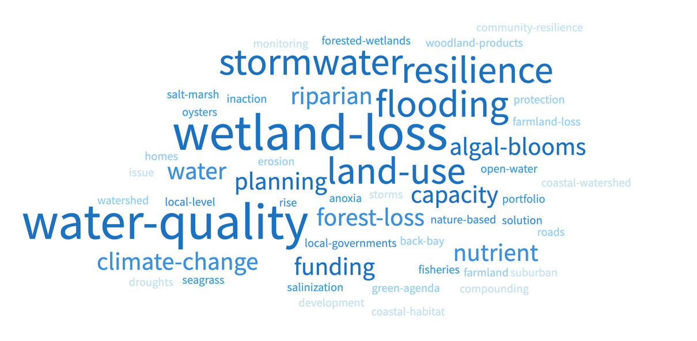
Individual Responses:
- Availability of funding/capacity of local governments, algal blooms, stormwater, how to incorporate nature-based solution projects into stormwater planning at the local level, RISE portfolio identified projects, understanding the consequences of taking no action (i.e. there is a cost to doing nothing)
- Water quality - stagnant to degrading quality, increasing algal blooms, anoxia and constraints to restoration of SAV, oysters, and fisheries. Wetlands - salt marshes are at risk to loss to open water. Forested wetlands are dying back with salinization. Barrier is. are chronically flooding.
- One major shift potentially occurring...loss of processing for woodland products tied to the green agenda in the EU. See recent forbearance given Enviva (a presence in Northampton County.) This sector has bottomed out badly in recent months.
- In the Back Bay watershed, erosion, loss of wetlands and loss of farmland to flooding are all concerns. Flooding is a constant problem and raises concerns about the safety of some of the roads and the long-term viability of some of the farms and homes. In the North Landing watershed, the biggest concern is land use planning and protecting the valuable forested areas on both sides of the river from suburban sprawl.
- Resilience is a very challenging and intangible focus is it community resilience or coastal habitat resilience that APNEP is focusing on? Water quality on the coast and in our watershed is a compounding issue with climate change-droughts and larger storms so good monitoring in the basin as well as advancing technology and treatment for those known pollutant sources - septic, agriculture, and stormwater are critical.
- nutrient and sediment pollution in piedmont streams, rivers; loss of wetlands, especially now post Sackett decision and NC Farm act; lots of money right now for infrastructure and resilience, but still not going to the places most needed
- Loss of wetlands and riparian buffers. Many small tributaries and larger bodies of water have excessive nutrient imbalances that precipitates poor water quality. State DEQ is doing what they can with limited resources for monthly testing and analysis, but clearly, we are not capturing the total picture of how quickly our water and surrounding land environment is changing.
- Water quality degradation impacts wetlands, SAV and community drinking water resources. Incompatible land use practices are a major factor impacting these resources along with the impacts of climate change.
Are there efforts or projects going on in your region that are related to APNEP’s focus areas, and may benefit from NEP support? If so, share.
Result:
- Water quality planning and mitigation (Hyde Co.)
- Local grassroots research, monitoring, and data generation efforts by/among community, organizations, waterkeepers, and academics
- Infrastructure (green infrastructure) funding and grant management for small, rural, distressed areas (Aurora, COGs)
- Water protection particularly related to public health
- Funding to identify, upgrade, and communication about homeowner septic tank failure. Bacteria and nutrient pollution growing prevalence from failing septic (data and planning efforts in Havelock and Simpson, Nags Head with NC Sea Grant)
- Restoration of wetland/peatland areas through hydrological and planting efforts
- SAV and marsh restoration in Back Bay
- Land conservation in the North Landing watershed has been successful, but current development pressures.
- Public access to the river and greater awareness in North Landing (VA)
- Large-scale solar development in the VA region
- Identify ways to use GIS products from CCAP land cover (e.g. population mapping, rainfall runoff models in sub-watersheds, better projections of future wetland changes with sea level)
- Support wider community participatory GIS efforts in SE Virginia (King tide mapping, water quality and community asset or challenge mapping.)
- Education on why topics like algal blooms, nature-based solutions, resiliency and nature-based solutions are so important.
Individual Responses:
- I no longer work in the APNEP region (am retired in the Sandhills) but I do know that there are ongoing projects in Hyde County to investigate and to some extent begin planning to ameliorate water quality issues in specific areas, Pocosin Lakes and Mattamuskeet NWR's for example
- Local research projects (need many more of these) are beneficial to both communities and researchers (publications) by using solid research data help drive local environmental decisions. Work with environmental groups, riverkeepers and grassroots groups to provide support for specific local doable projects that inform with good data and have the potential to bring positive actions and change to that location. It will take many many small steps in that direction to offset the challenges facing this ecosystem.
- Helping to secure funding for small, rural, distressed areas for infrastructure-- helping places like an Aurora, plan for, apply for and then manage grant projects. -- extension of COG work. Maintenance of existing SW and looking for areas to be more resilient with green infrastructure; getting harmful industry out of the floodplains (waste lagoons, municipal waste plants infrastructure)--Identifying on risk base scenario places that are in most need of removal to protect waters and public health. Funding to ID needs and upgrade homeowner septic tanks-- we are finding more and more bacteria pollution (and likely nutrients) from failing septic (data from Havelock and Simpson currently).
- I believe Town of Nags Head in partnership with NC Sea Grant was studying the impact of septic. Helping to communicate those findings would be good. Focusing on communicating across the region on success stories of communities who have tackled stormwater not just drainage/management but also for water quality treatment would be helpful especially if they have been successful leveraging municipal funds with grant funding. Supporting restoration of peatland areas through not just the hydrological restoration but the planting to restore these wetlands systems would be a good place for NEP support.
- There are some fledgling efforts to restore SAV that have been successful but need to be expanded. The Marsh Island restoration plan in Back Bay is moving forward and will be interesting to follow and possibly replicate in other areas. Land conservation in the North Landing watershed is exemplary, but there are currently development pressures, and we desperately need greater public access to the river and greater awareness of the North Landing.
- I have already brought up the factor of large-scale solar development in the region. That's about the only involvement I am pursuing at present.
- There may be increased use of GIS products from CCAP land cover (e.g. population mapping, rainfall runoff models in sub-watersheds, better projections of future wetland changes with sea level). NEP could support some wider community participatory GIS efforts such as in my area (King tide mapping, water quality and community asset or challenge mapping.)
- Communication education on why topics are important: Algal blooms in the water, how to implement nature-based solutions in communities, education on resiliency and nature-based solutions.
In your opinion, what has been, or would be, most helpful for you to feel engaged in bringing your expertise to the table as a CAC member?
Result:
- Identify ways to engage and use the expertise of the CAC: Members provide THREE important issues occurring in their geographic, or area of expertise - list/prioritize them, and locate a project, or create a project, that would fall in these focus areas.
- CAC help facilitate how communities could use, or are using, existing data and information that APNEP and partners produce (e.g., high salinity SAV change) and identify approaches for adapting research, monitoring, or mapping that best suits communities need for applying this information at the local-level.
- Consistent communication from APNEP staff
- In-person interaction to leverage collective knowledge and expertise, allowing urban and rural to connect.
- Sub-committee groups for topic-based discussions
- A better understanding of the current purpose for CAC and the goals for the next year
- Continue to provide proposal review support as a CAC member to stay connected to the grant funding and work the NEP seeks to support.
- Learning a lot at each meeting about ongoing work across state lines (NC and VA)
Individual Responses:
- I believe a full day face-to-face meeting is crucial in getting everyone up to speed and on the same page as to our responsibilities and to learn directly about each other's expertise and how to leverage all knowledge to contribute to APNEP goals.
- Once you have some of the survey results, perhaps arranging CAC members together in smaller groups based on their interest areas and expertise might be helpful for discussions. We all need to know more about the specific issues are most relevant to each community - what might be a large problem in my neighborhood, might not be as important to someone else.
- I guess a better understanding of the current purpose of the CAC and the hopes for its work and outcomes in the next year or two
- I value reviewing proposals as a CAC member makes me feel connected to the grant funding and work APNEP is trying to support.
- I am happy to be a part of the committee and learn a lot at each meeting. I understand you have a relatively recently completed Pasquotank River Basin Watershed plan which I would like to review. I would also like to pull out the Green Sea Plan done by Virginia Beach with Currituck County and the City of Chesapeake and see if there are some initiatives/recommendations in it that we can move forward.
- I am marginally connected, for purposes of participation. I think this is an aspect that those in cities take fully for granted...yet the majority of the area of the APNEP is rural, largely not served well for online interfacing.
- Steve's emails and prompts to chairs
- Need to find a way to better engage and use the expertise of the CAC. I think each CAC member should identify 3 important issues occurring in their geographic area or area of expertise. We should list/prioritize them and then locate a project or create a project that would fall in these focus areas. Meaning, are there projects going on with APNEP STAC, Leadership Council, and staff where CAC expertise itself or the CAC could be a connection to the community? For instance, is there ever a desire to learn more about how communities are using the SAV data that APNEP produces and see if there is tweaking to the research or mapping that could better help communities apply this information on the group. Maybe the CAC could help in facilitating or answering those questions.
What kind of content would you find helpful to add to the CAC webpage?
Key Results: The CAC webpage is a good place for meeting minutes and agendas, but could also be a great location for expanding on focus areas of the membership and what the CAC is working in. It could also include some external links to resources related to the focus areas based on discussion the committee has been having since it re-established in early 2023. This topic could be revisited when the committee meets in person to ensure it is meeting the needs of the Leadership Council, committee members individual efforts, and the initiatives the committee seeks to support and advertise.
Individual Responses:
- This would be a great topic for an in-person meeting of the CAC. Brainstorming how to get information out to the public in an easily digestible way, and to advertise the webpage are good brainstorming topics.
- Provide more links to current estuarine research specifically addressing APNEP's four focus areas. Some of this might be already posted on the pulldown menu on the main APNEP website, however most of these documents appear to be related to specific APNEP funded research. I know I subscribe to several newsletters that provide links to current research publications on specific topics such as cyanotoxins.
- Unsure
- I have looked at the website in the past, but not recently.
- I will check it out
- I would like to see some mapping of renewable energy facilities...solar in particular.
- Good as is
- Meeting minutes/agendas, areas of focus for the CAC, what is the CAC doing, contact info for the CAC
What disciplines do you believe are underrepresented by the current CAC membership?
Key Results: Farming (Farm Bureau), Forestry industry, Forestry agency rep, Education, Human Health, Arts, NGO’s (disaster services, civic engagement, and environmental justice), Engineering and development sector, Private landowners, Fisheries, Tourism/Ecotourism, ...
Other considerations from members:
- Offer Diversity Equity, Inclusion, and Justice (DEIJ) training and meeting facilitation to ensure the committee is being inclusive and welcoming (e.g., UNC EJ Clinic).
- Add at least one other representative from Virginia, preferably from the western and central parts of the AP watershed in Virginia.

